**Digital Forensics**

**Lab Final Submission**

**Submitted to: Sir Mustafa Khattak**

**By: Irum Imtiaz**

**Final term Project Digital Forensics**

|  |  |
| --- | --- |
| **Task #** | **Title** |
| **1** | **Examining a Forensic Image with Autopsy** |
| **2** | **Network Forensic using Wireshark** |
| **3** | **Rhino Hunt with Autopsy** |
| **4** | **Rhino Hunt with Wireshark** |
| **5** | **Memory Analysis with Autopsy** |
| **6** | **Memory Forensics of LastPass and Keeper** |
| **7** | **Capturing and Examining the Registry** |
| **8** | **Examining a Windows Disk Image** |
| **9** | **Email forensics** |
| **10** | **Android Studio Emulator** |
| **11** | **Rooting Android Studio's Emulator** |
| **12** | **Forensic Acquisition from Android** |
| **13** | **Android Analysis with Autopsy** |
| **14** | **Making a Rooted Android Emulator** |
| **15** | **iPhone Analysis with Autopsy** |
| **16** | **Windows and Linux Machines** |
| **17** | **Velociraptor Server on Linux** |
| **18** | **Investigating a PUP with Velociraptor** |
| **19** | **Investigating a Bot with Velociraptor** |
| **20** | **Investigating a Two-Stage RAT with Velociraptor** |

1. **Examining a Forensic Image with Autopsy**

**Creating a new case**

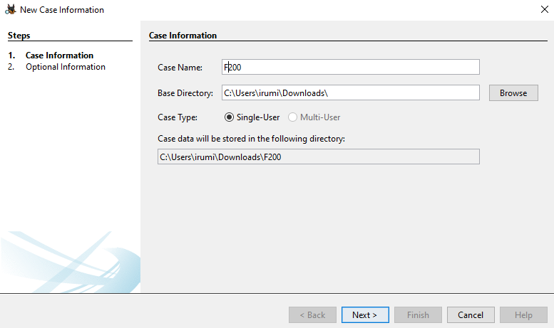

**Data source added**

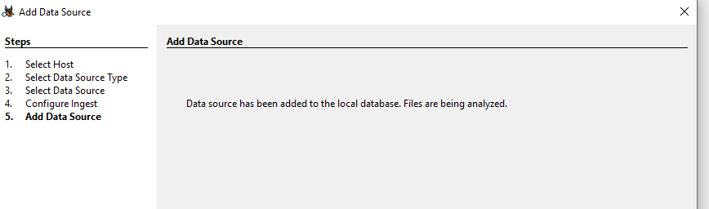

**Find it and capture an image showing the flag**

Found the flag in flag1.bmp file

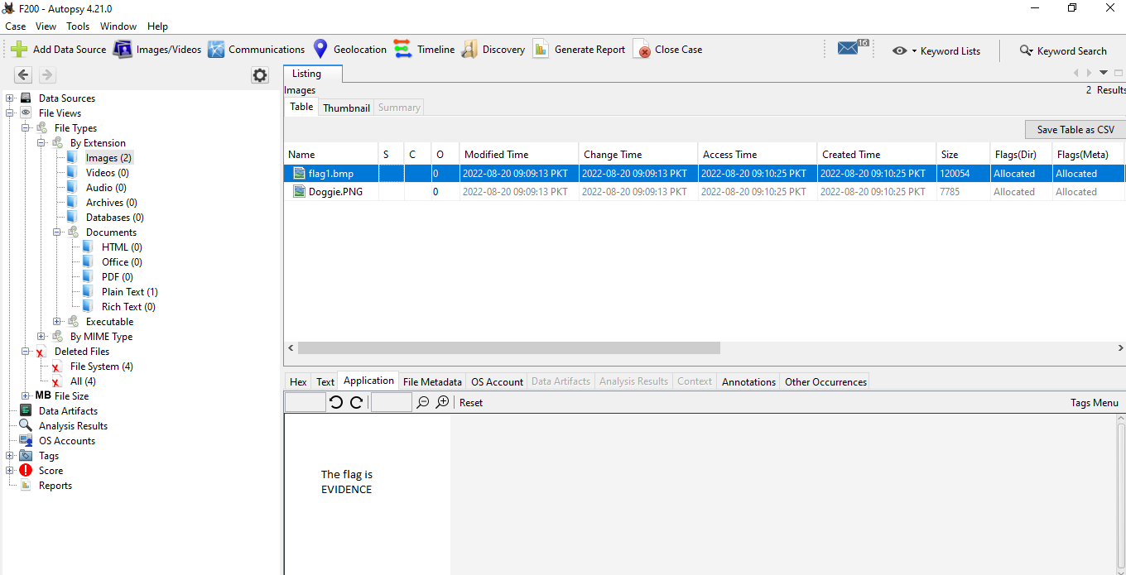

1. **Network Forensic using Wireshark.**

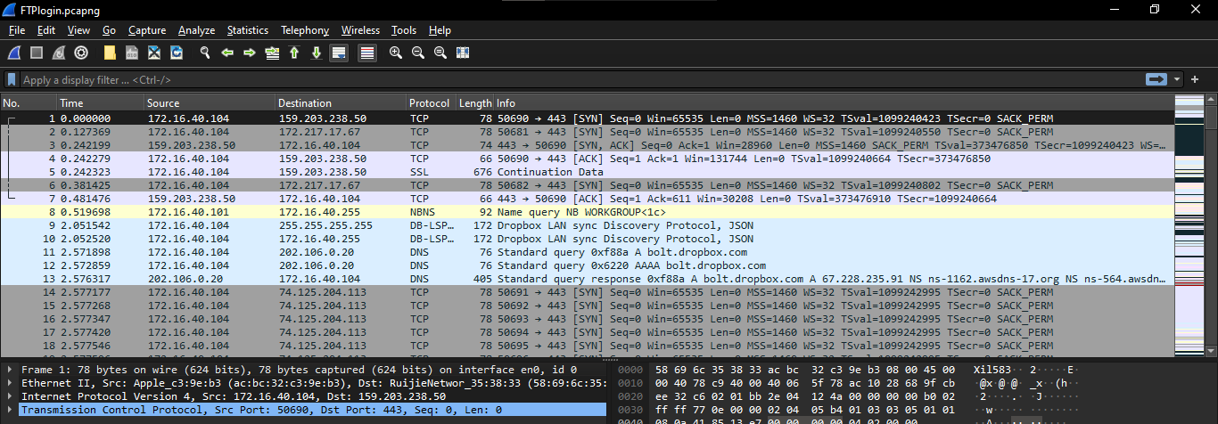open pcapng file in Wireshark

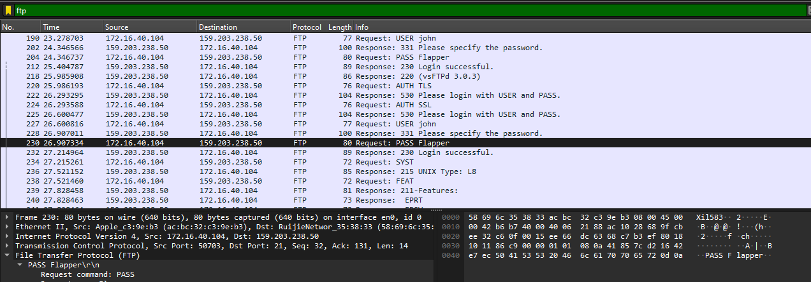

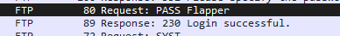

The flag is flapper.

Opening httplogin. pcapng file and applying filter http

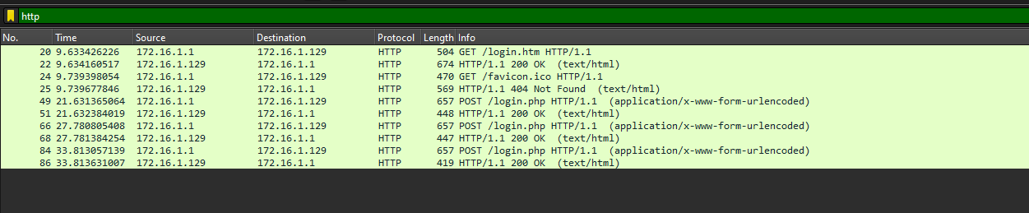

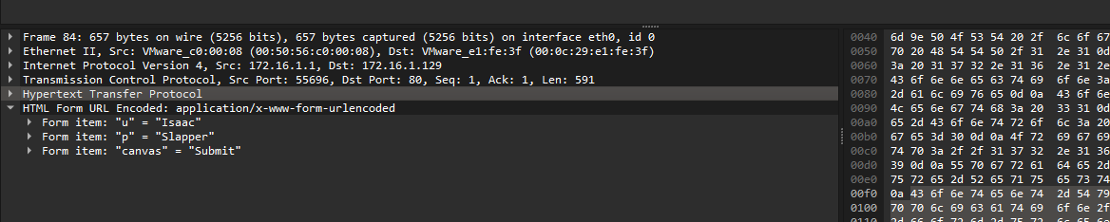

Issac password: The flag is slapper.

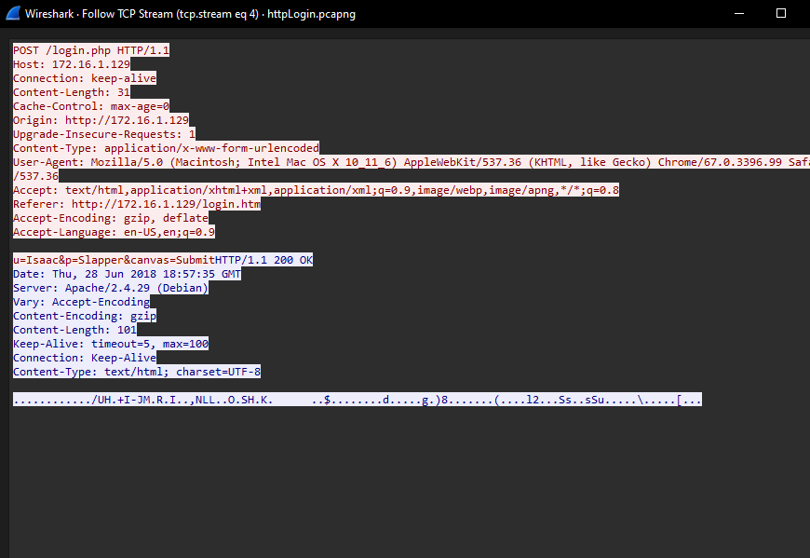

**HTTP Basic Authentication**

Open file in wireshark apply http filter and follow the stream

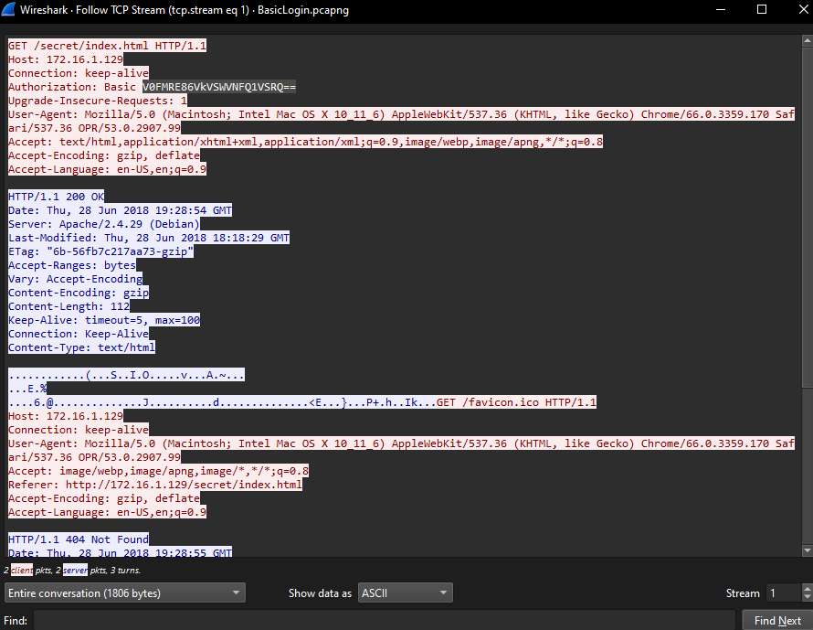

Found this base64 coded pass



Decode it using cyberchef and got the password

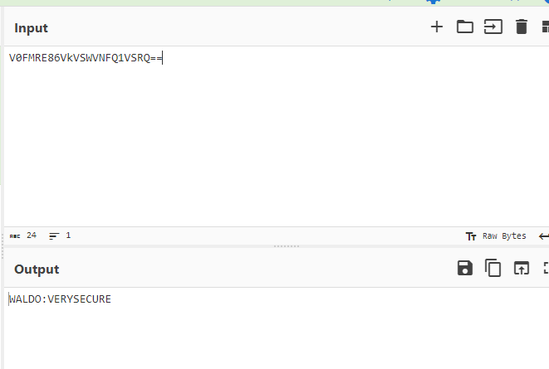

The flag is VERYSECURE

**APT Capture**

Encrypted Transmission

Opening apt-capture file in wireshark

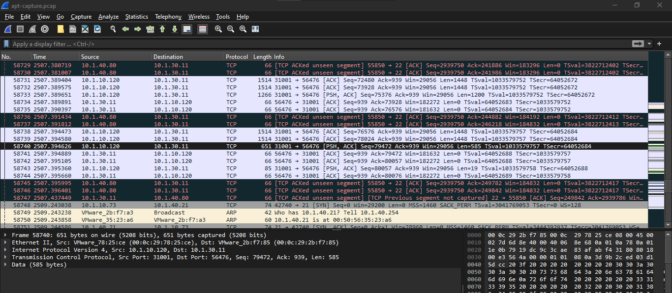

Viewing protocol hierarchy

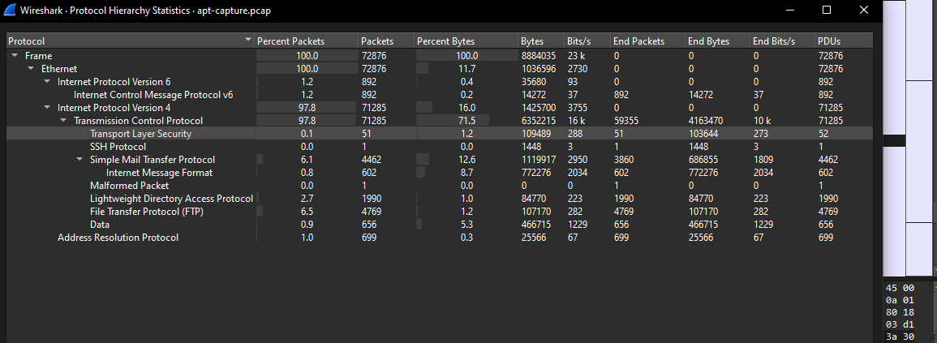

Applying filter tls

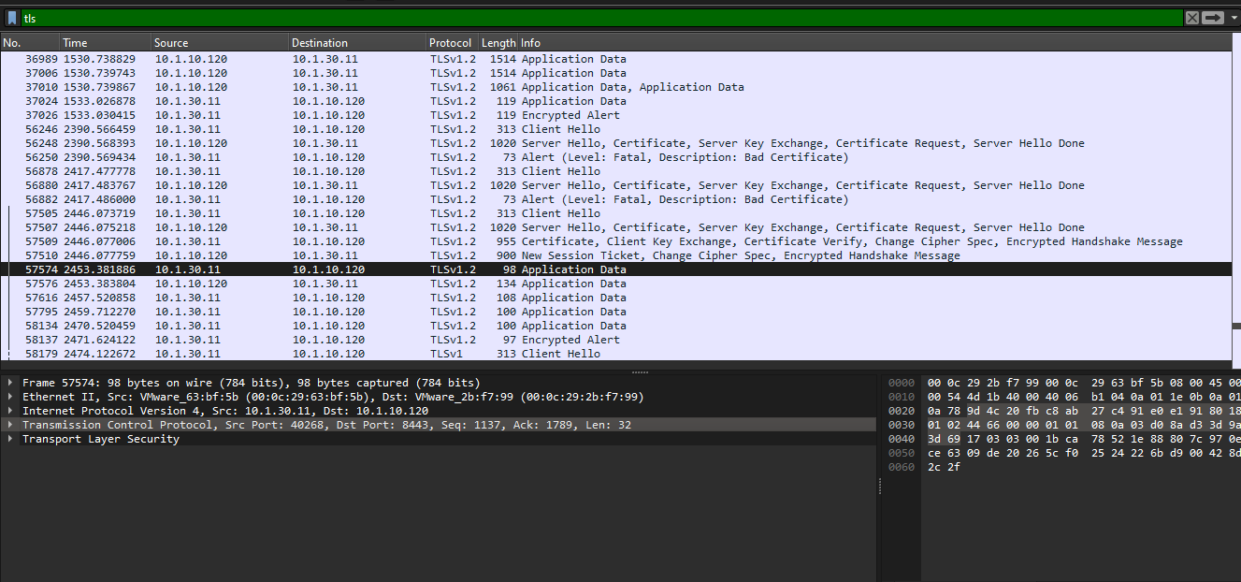

Des port no I found.

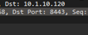

The flag is 8443.

**Tool**

Applying filter to find packets with port no 8443.

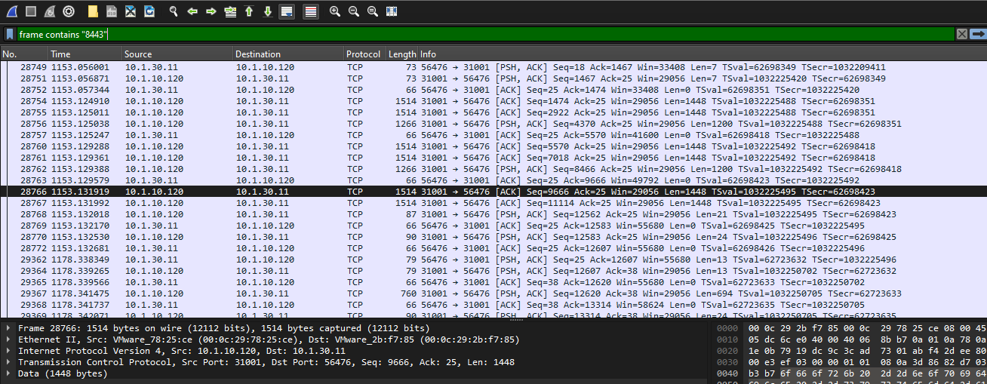

Opening the packet in tcp stream

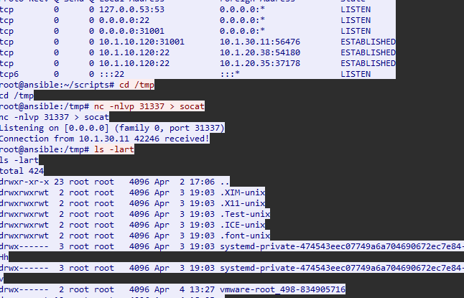

Found the tool names socat .The red text are the commands attacker executed

The flag is socat.

**Hash of Tool** found the executable file ELF

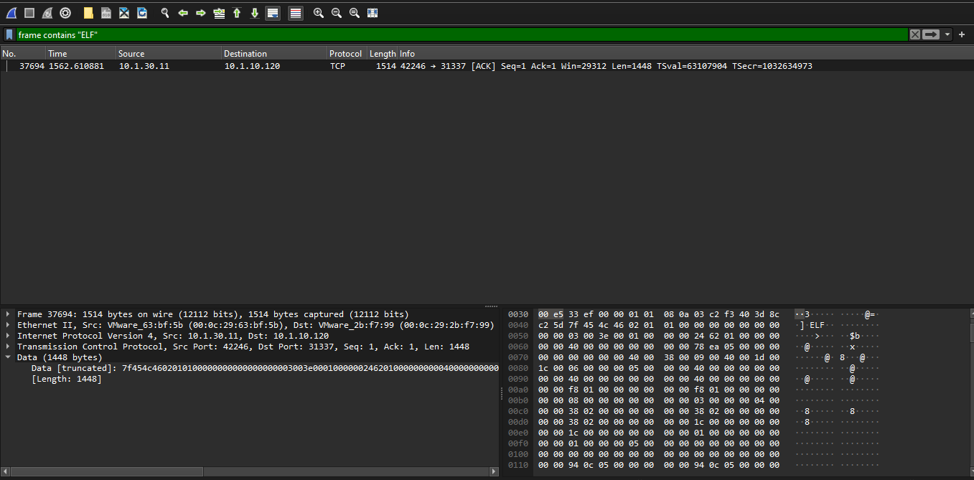

Opening the packet with. ELF in tcp stream

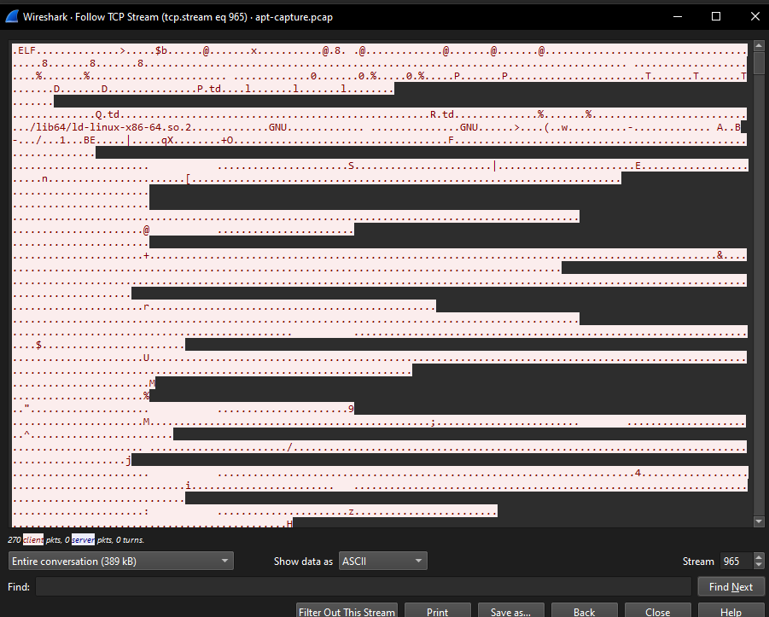

Save it as a socat



Calculating hash of tool

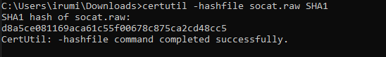

**Decrypt**

Found packets with private key

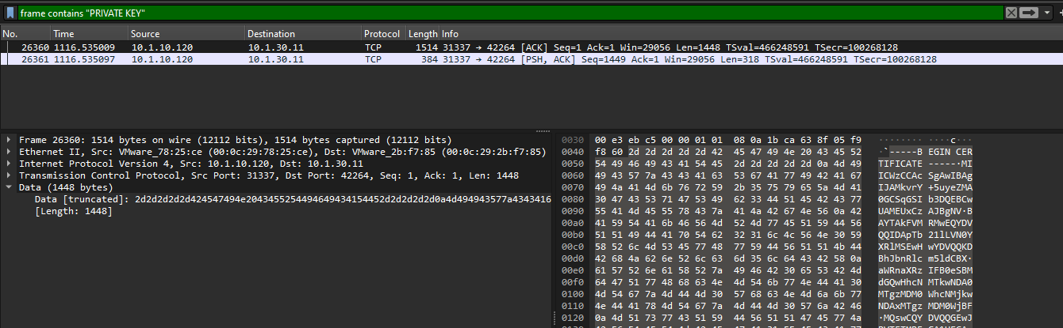

Opening the stream

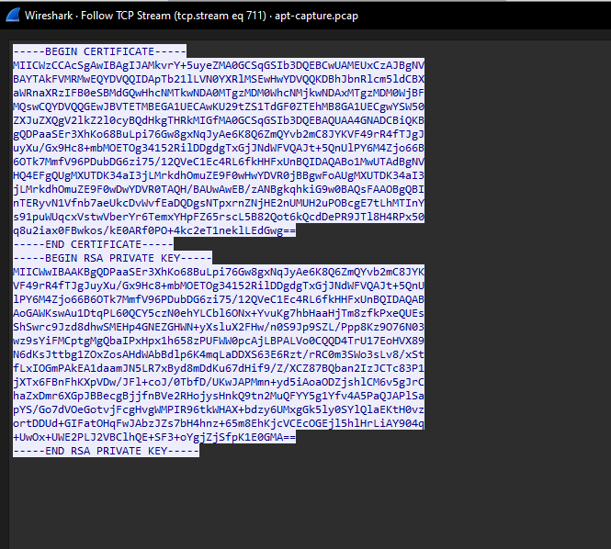

Added the private key in tls protocol.

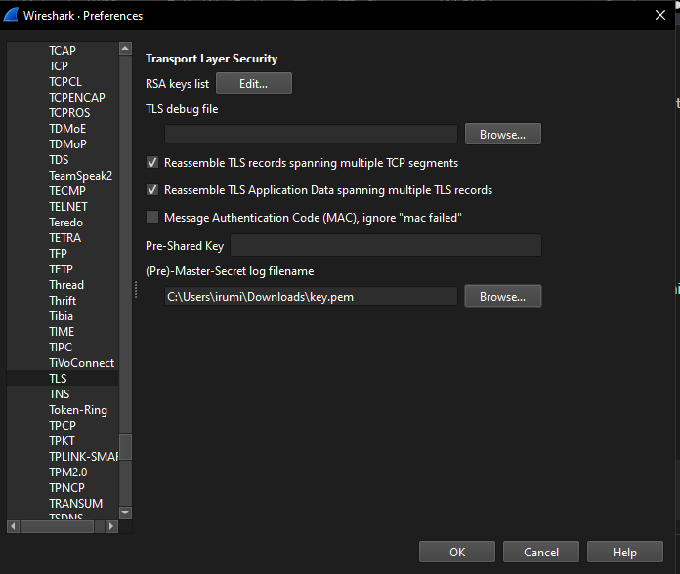

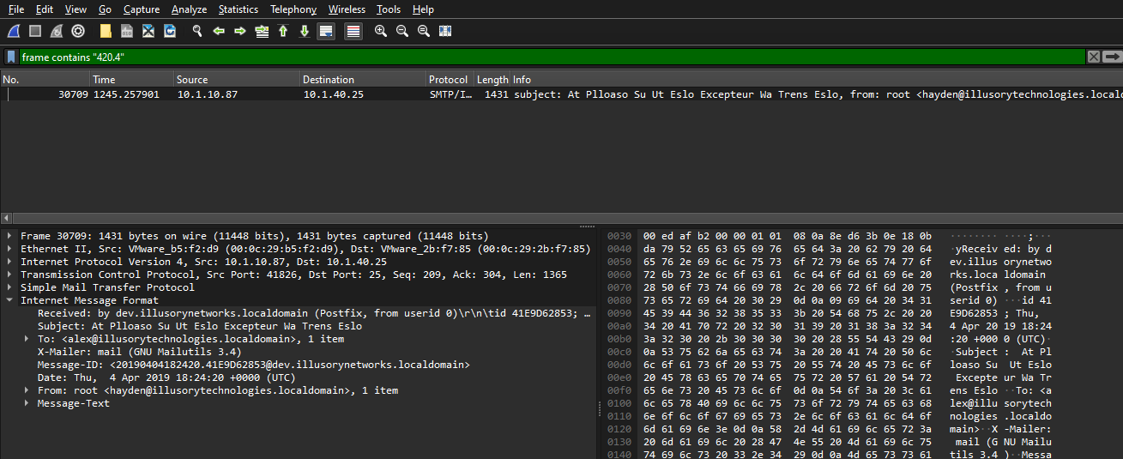Apply filter 420.4.

Saving the file

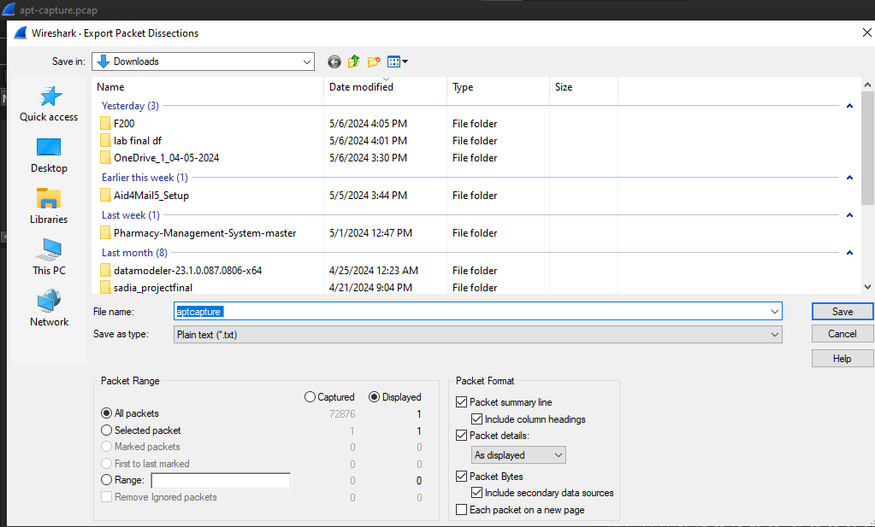

Flag

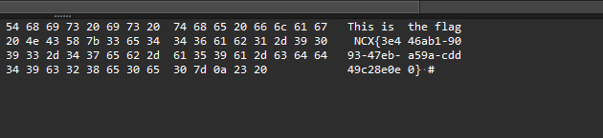

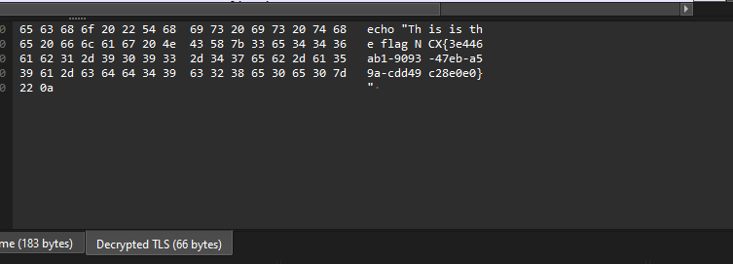

**Port Knocking**

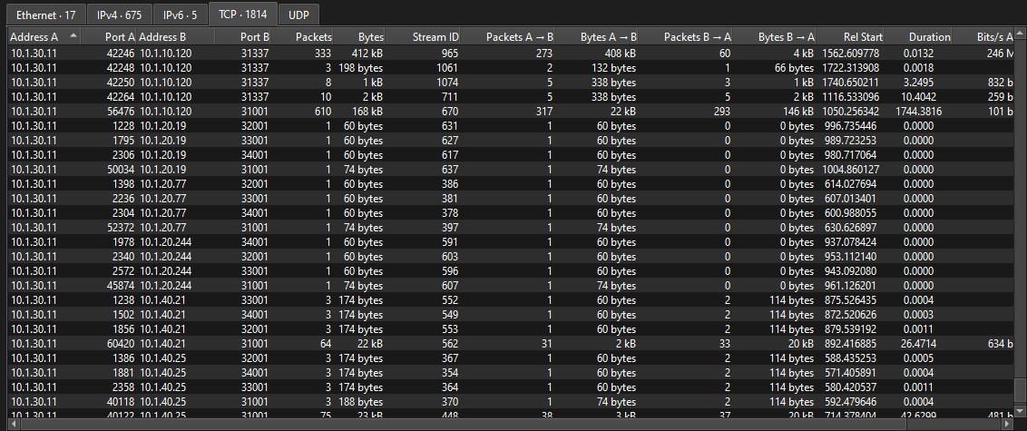



1. **Rhino Hunt with Autopsy**

**Verifying Hash Values**

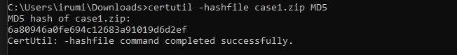

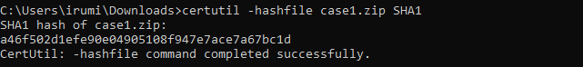

The flag is a46f

Creating new case in autopsy

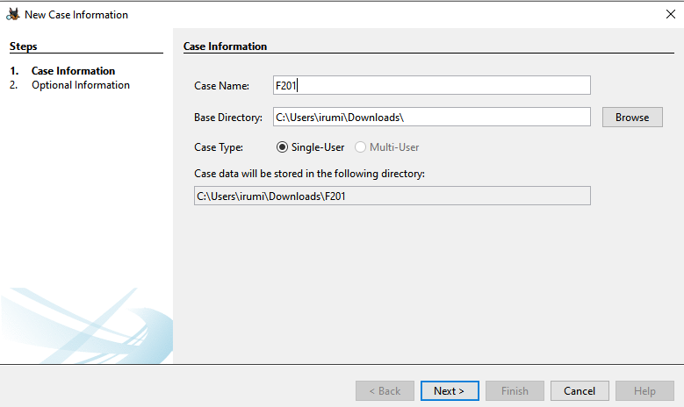

Adding data source

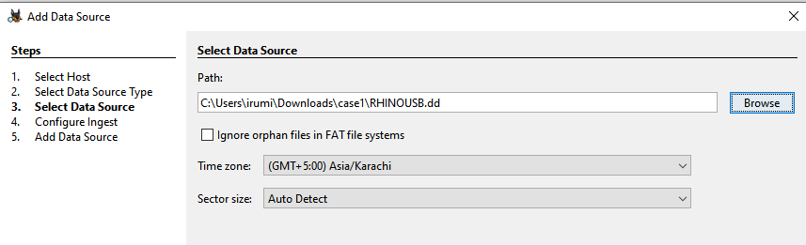

Finding the flag from deleted files

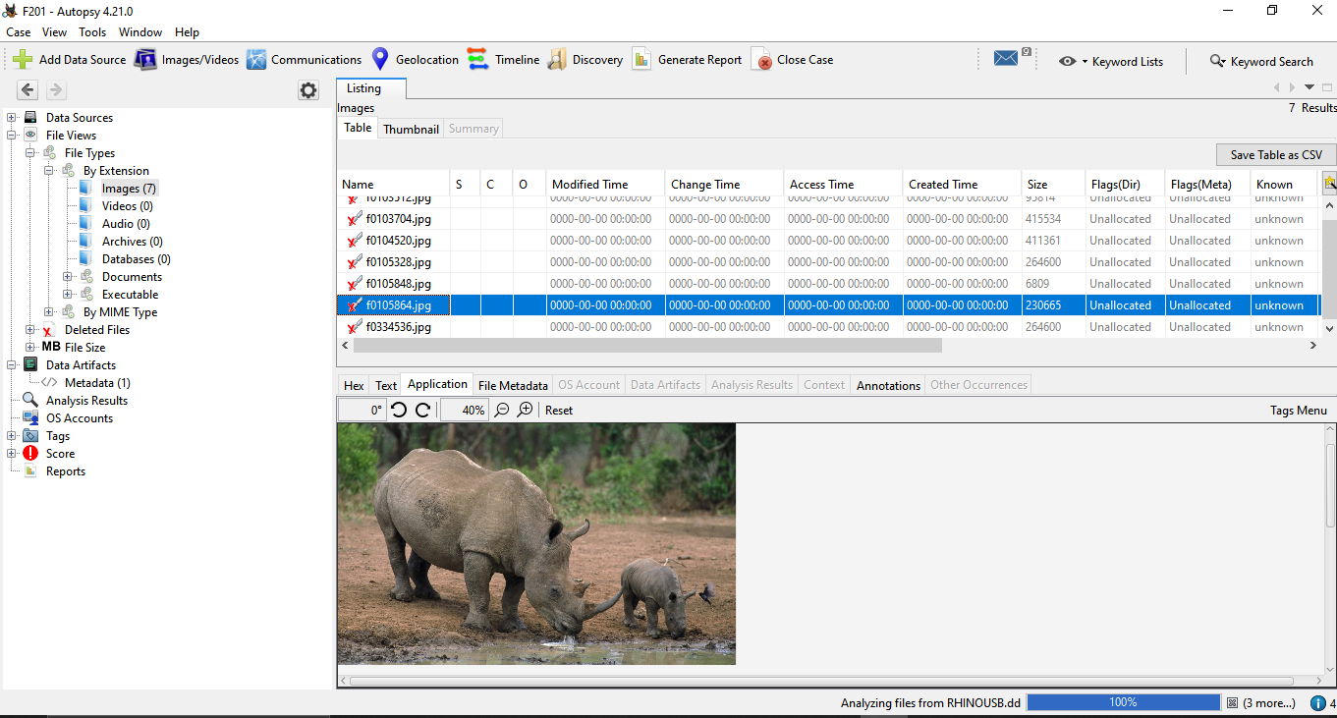

**Hard Drive**

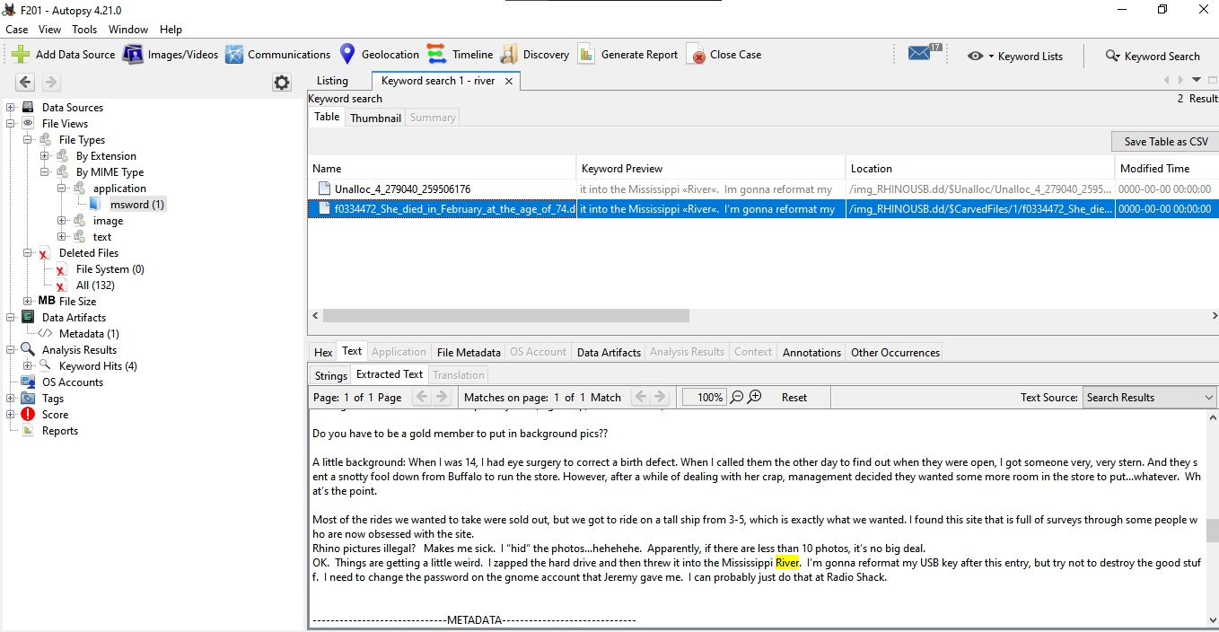



The flag is: "Mississippi River."

**Email Address**

I searched for keyword mit two file appeared with email. flag is f0103512.jpg

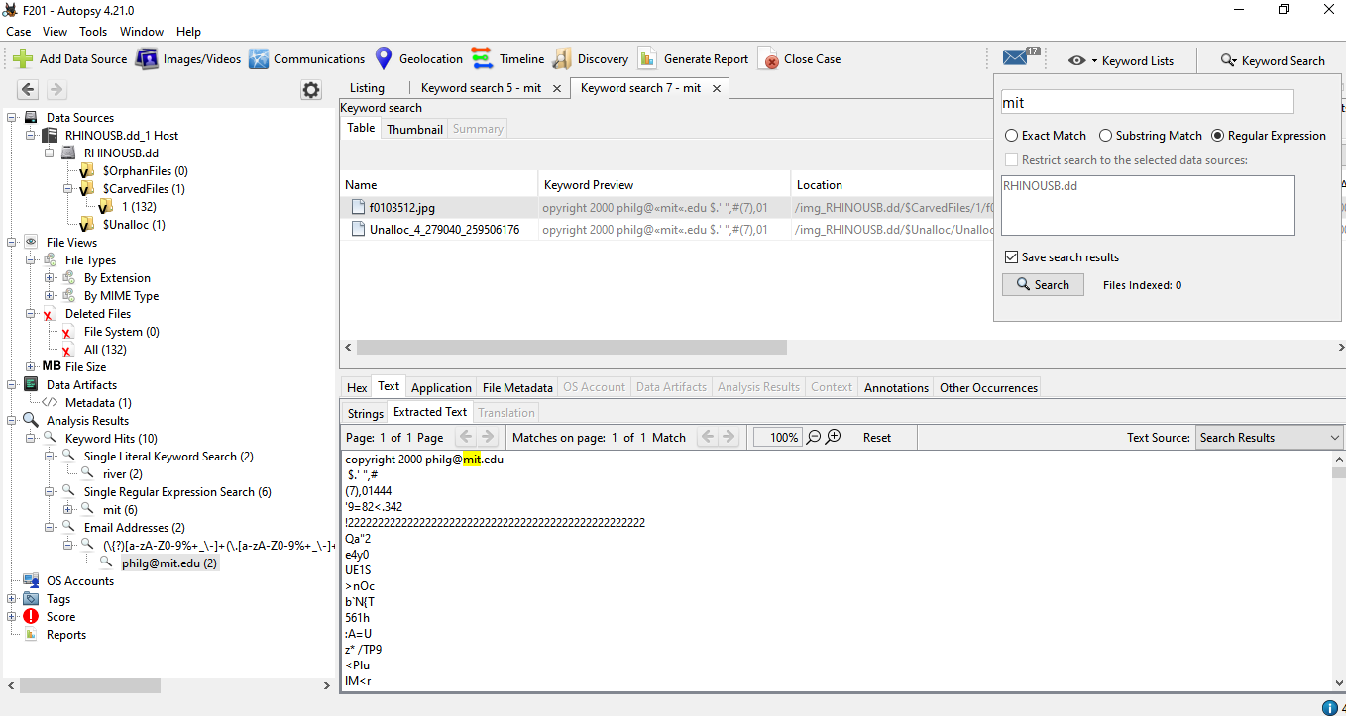

1. **Rhino Hunt with Wireshark**

Applying filter telnet

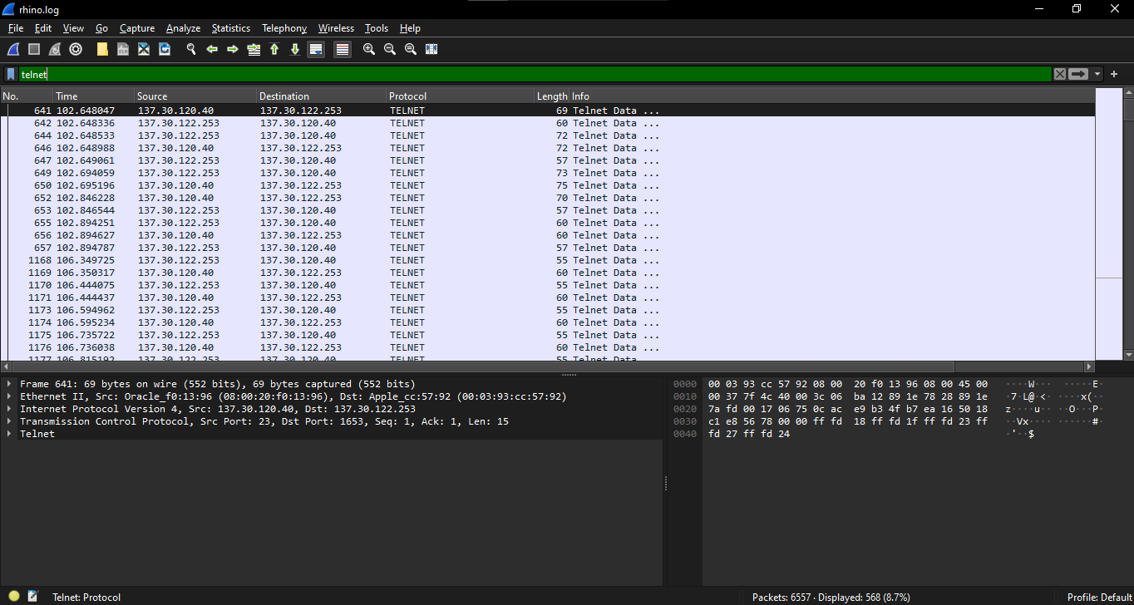

Saving telnet packets

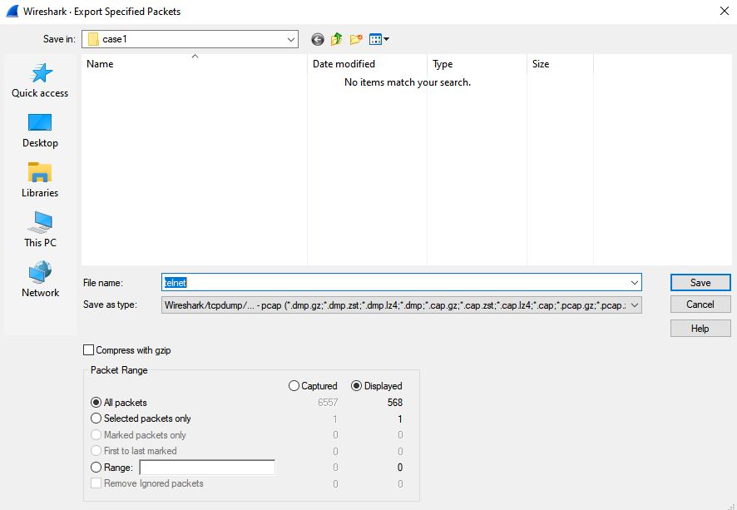

Applying ftp filter

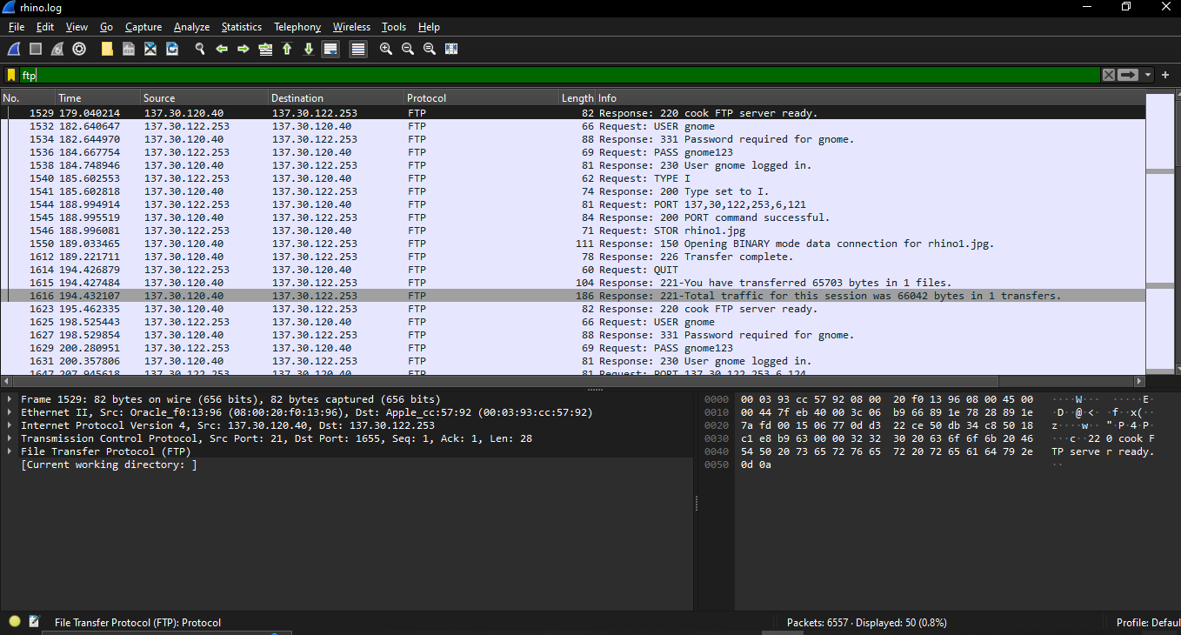

ftp has 50 packets

saving ftp packets

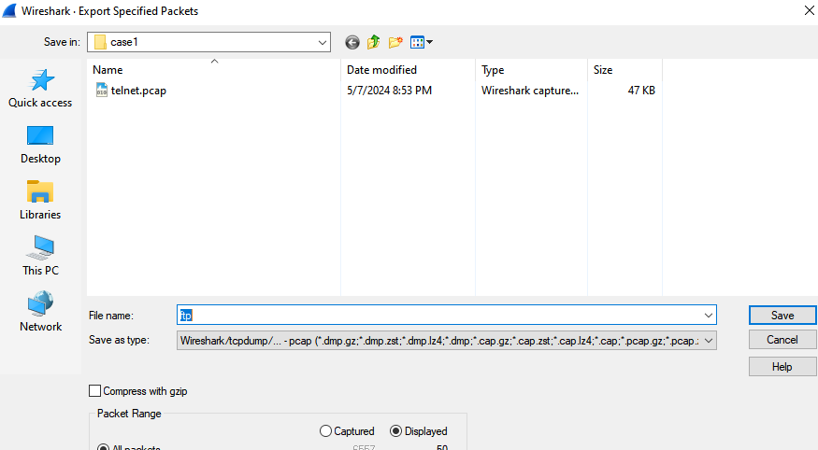

Examining telnet packets

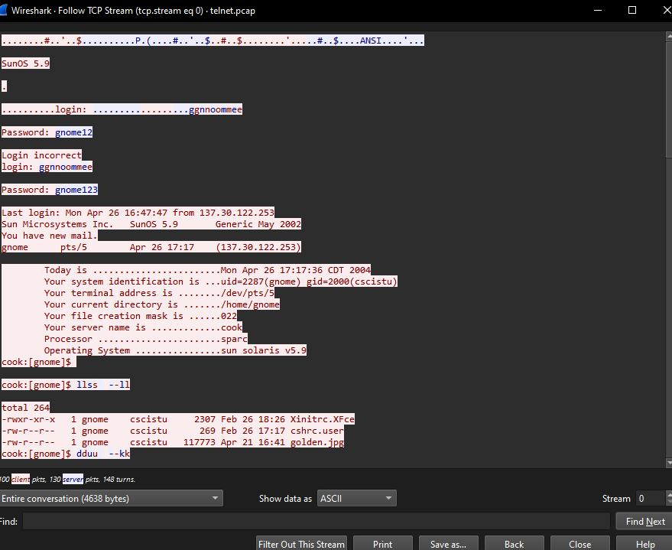

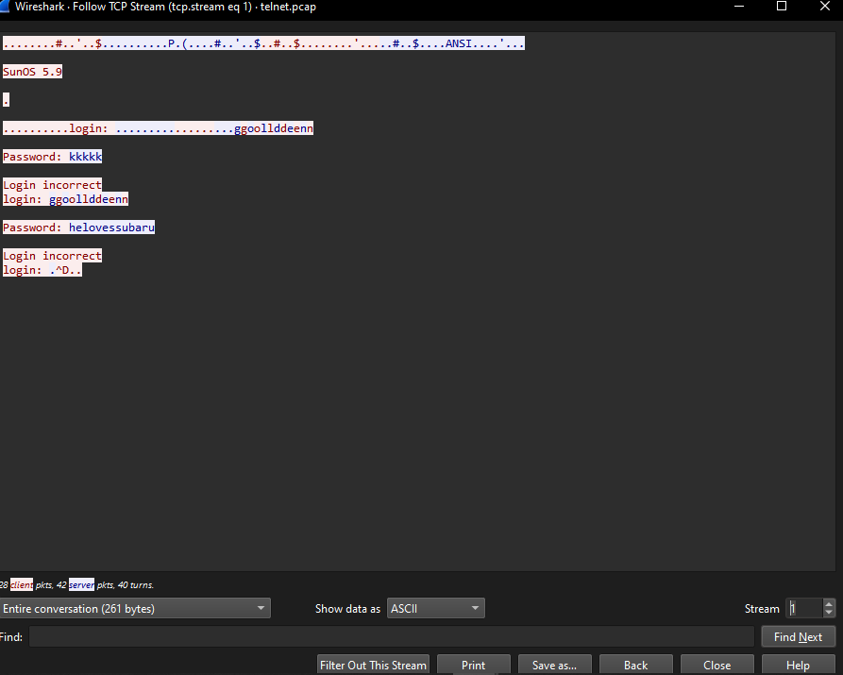

Flag is cscistu

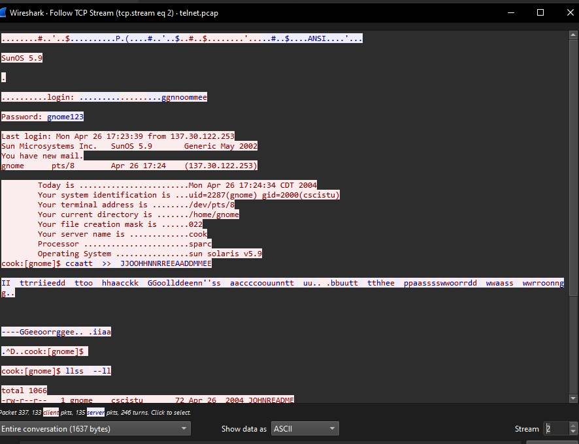

**Examing ftp packets**

Flag is contraband.zip

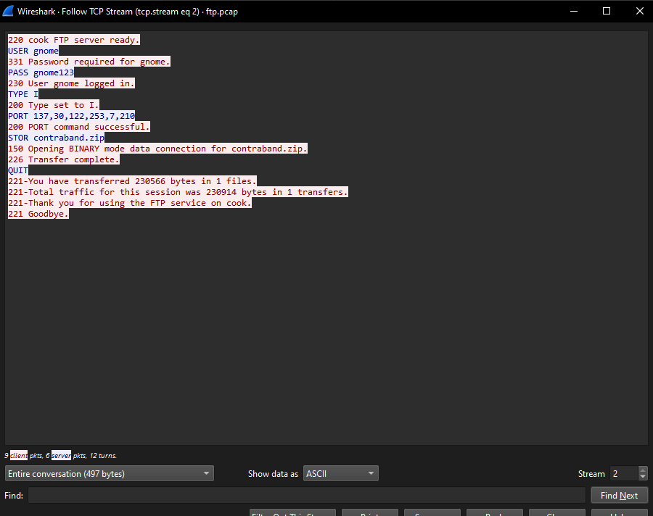

**Extracting Images from the FTP-DATA Traffic**

Applying ftp data filter

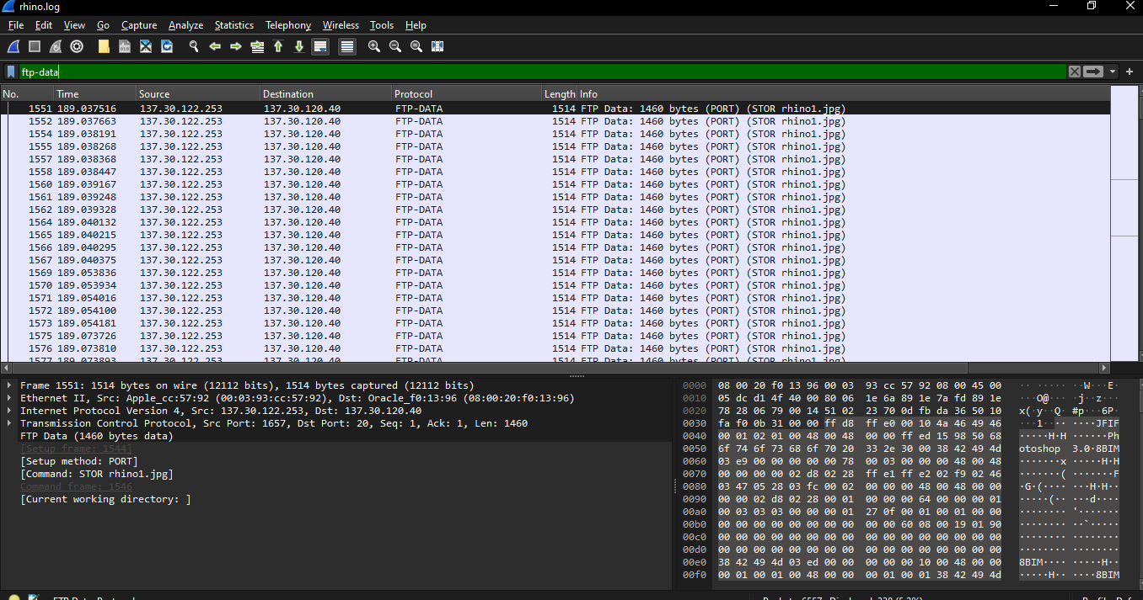

Extracting ftp data packets

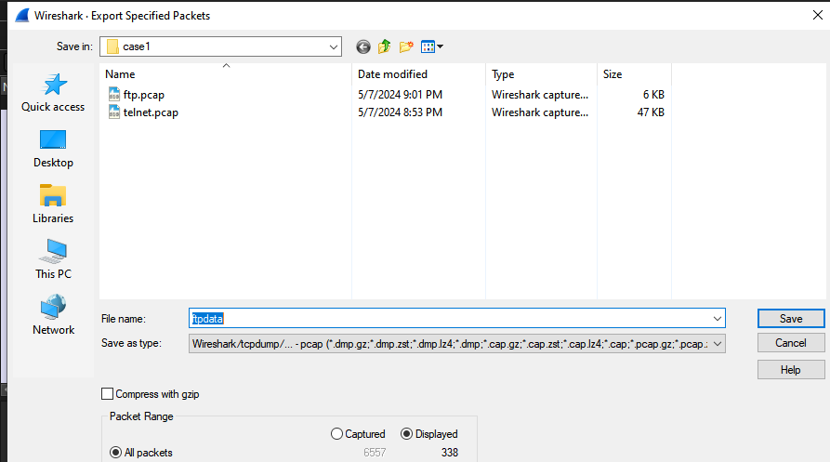

show as data raw in tcp stream

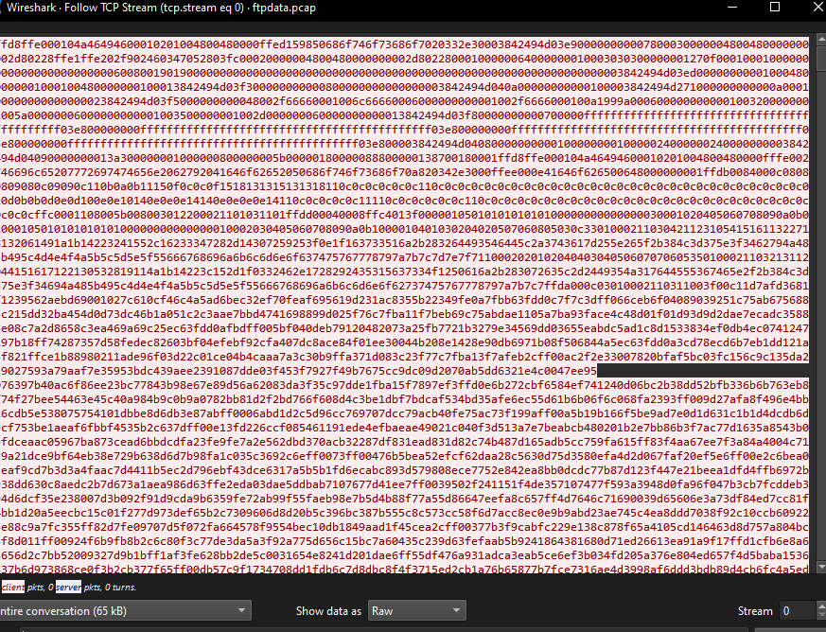

Saving as png file

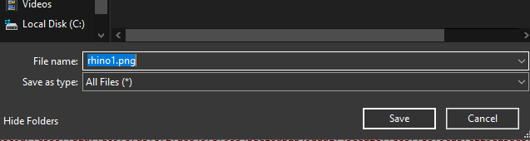

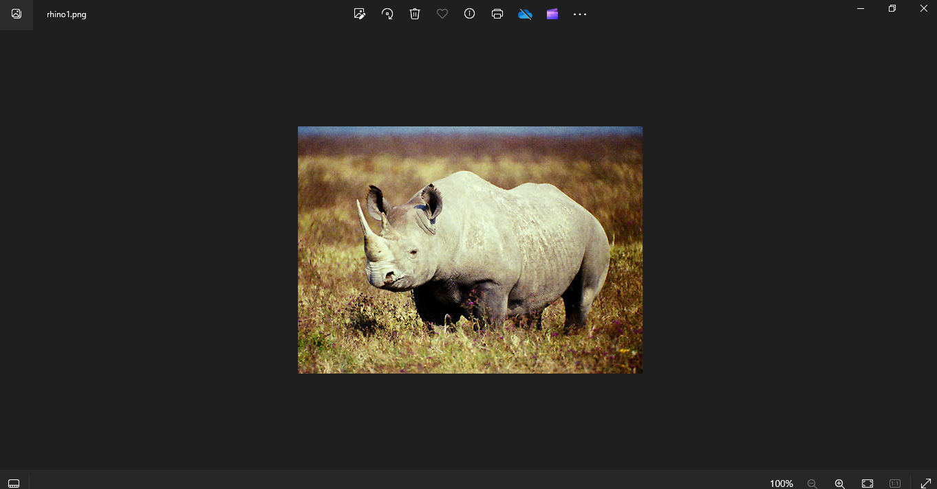

Hash

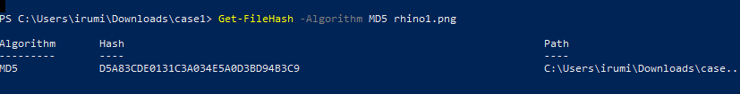

Flag is D5A8

**MD5**

Created ftp-data packet.

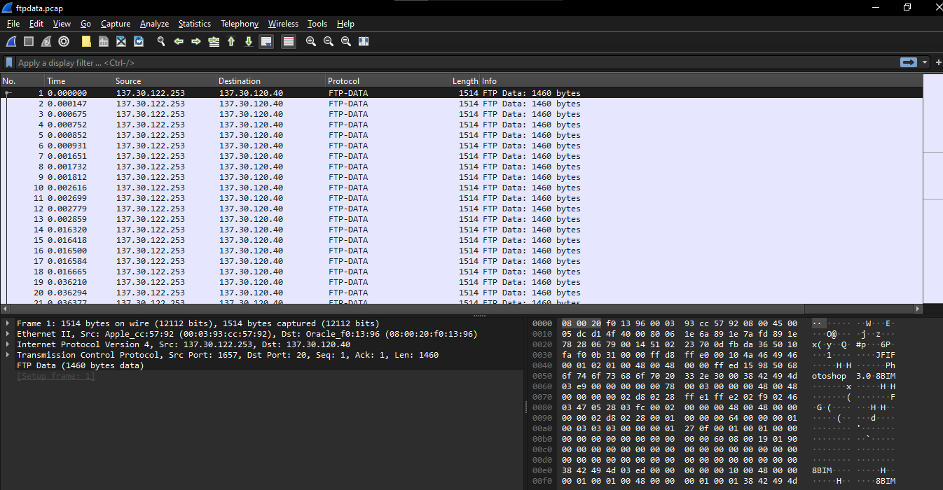

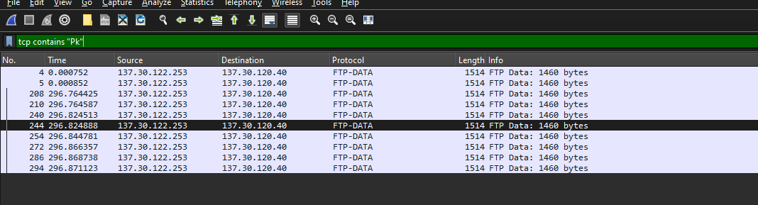

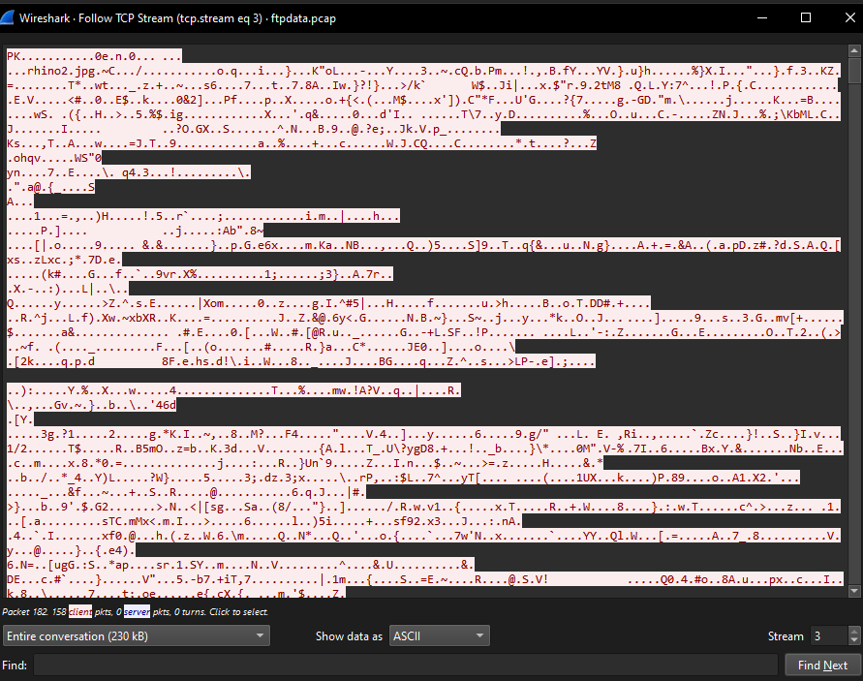

Save as zip



Used the website to get password

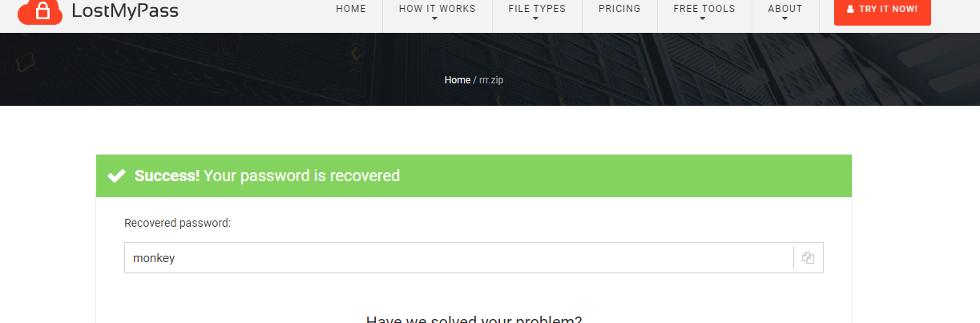

Extracting files

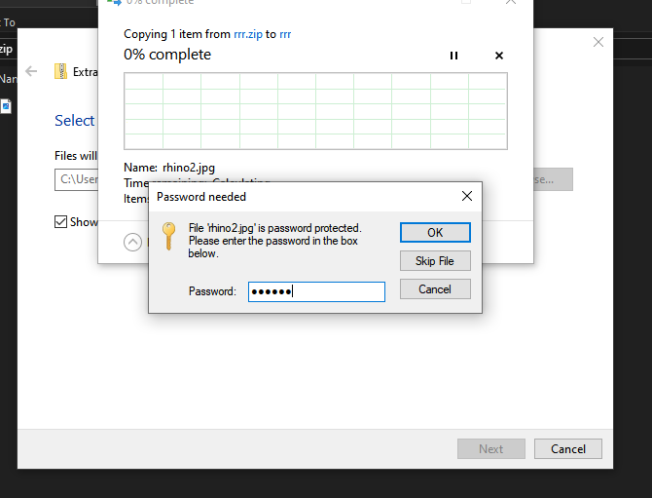

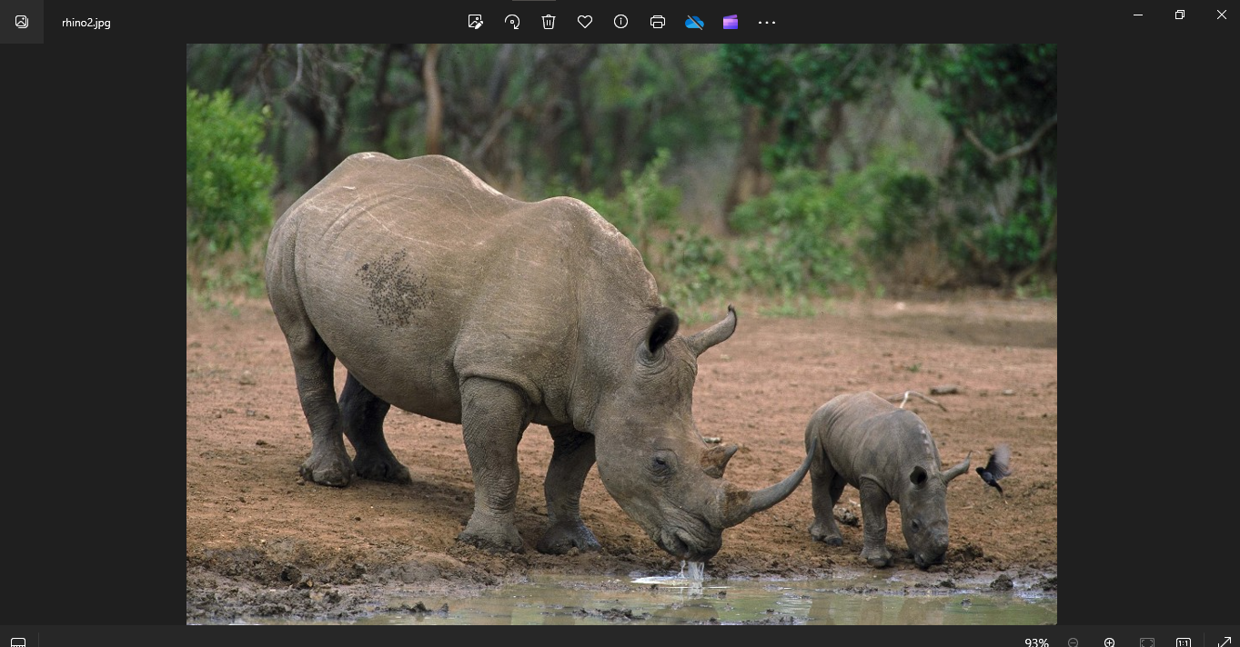

1. **Memory Analysis with Autopsy**

File extracted



Setting changes

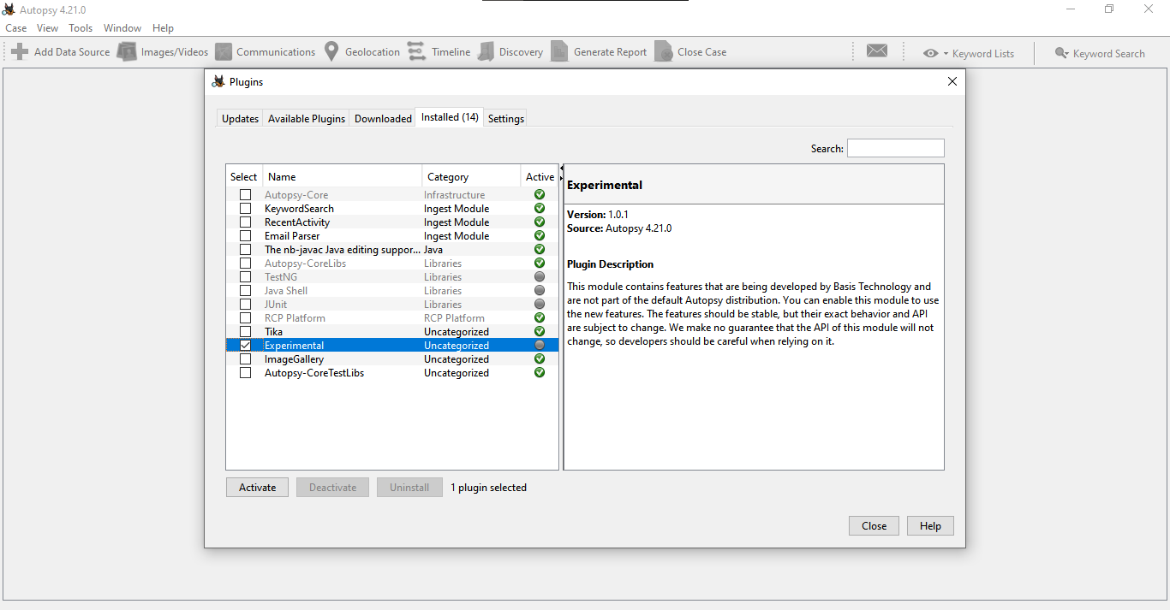

Creating new case

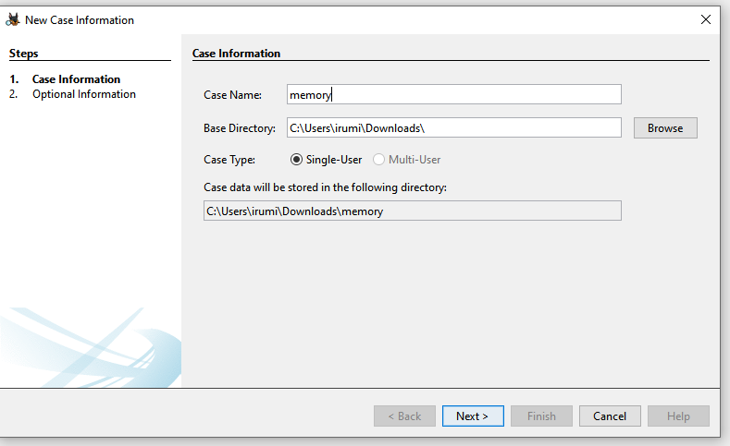

Adding data source

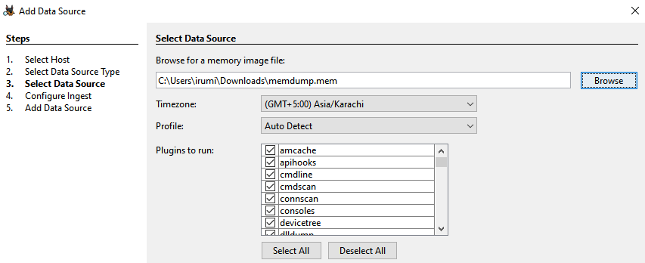

**consoles**

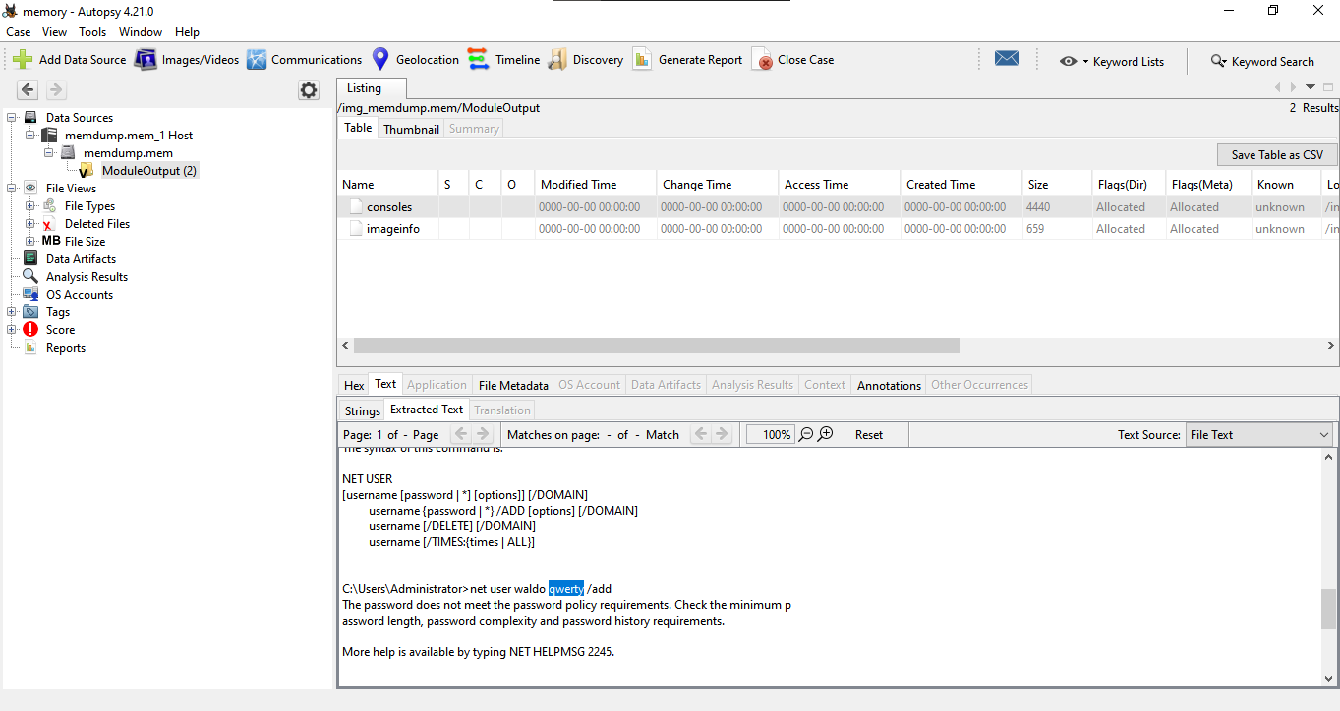

The flag is qwerty

**Netscan**

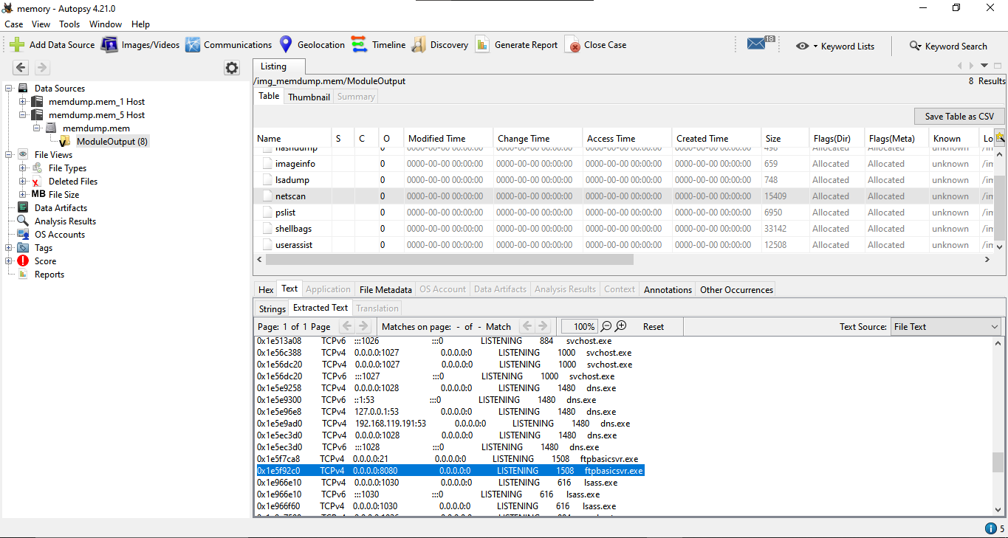

The flag is ftpbasicsvr.exe

**Pslist**

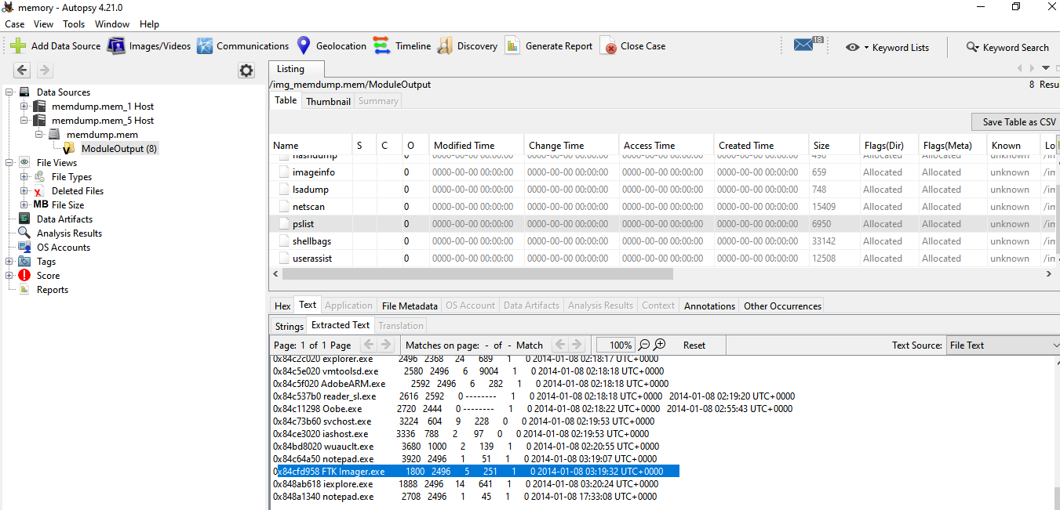

The flag is ftk imager.exe

**Shellbags**

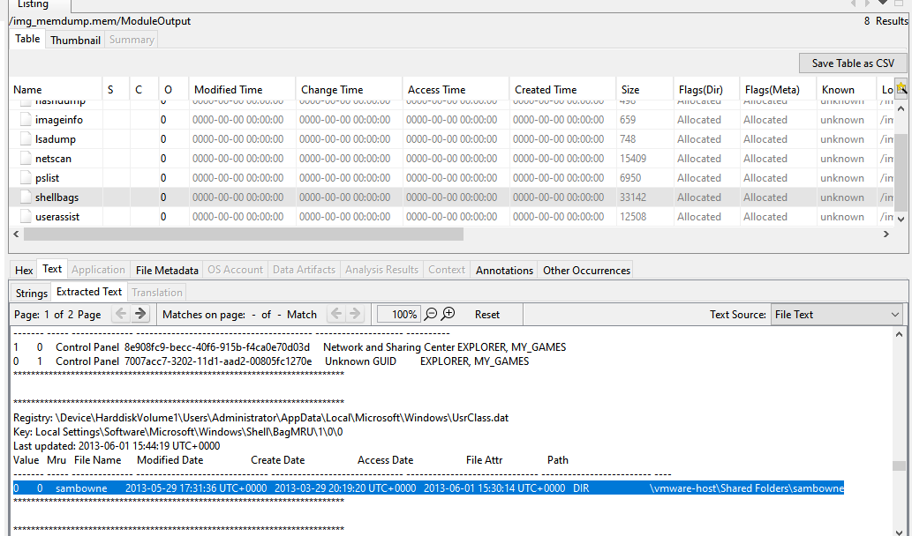

The flag is sambowne

**Userassist**

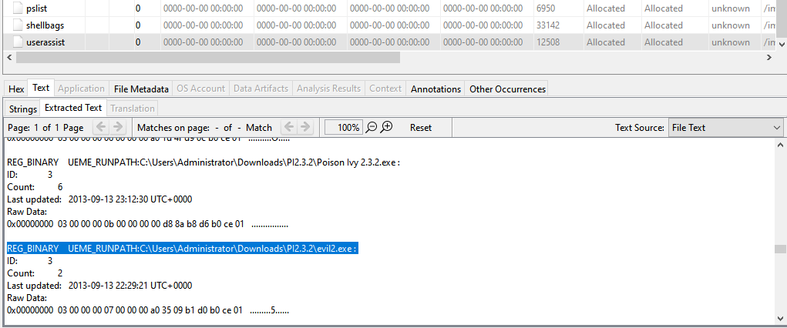

The flag is evil2.exe

**Probe Password**

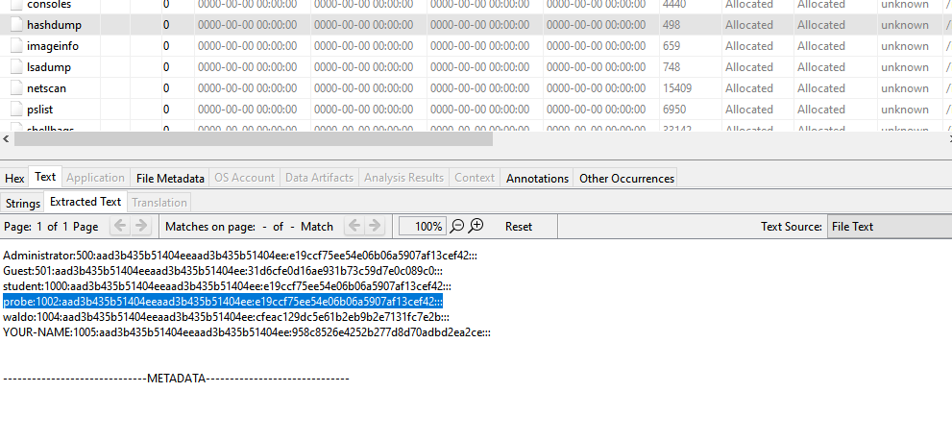

Decrypt using online tool

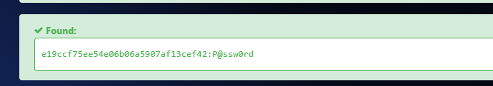

1. **Memory Forensics of LastPass and Keeper**

Created account on last pass and add a password

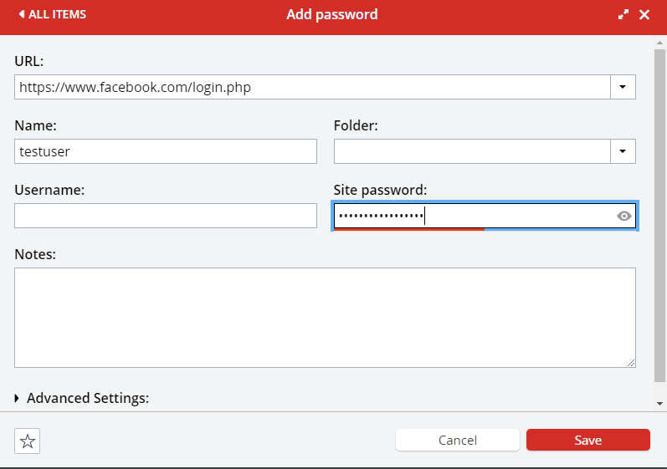

Find the chrome process related to last pass using process explorer

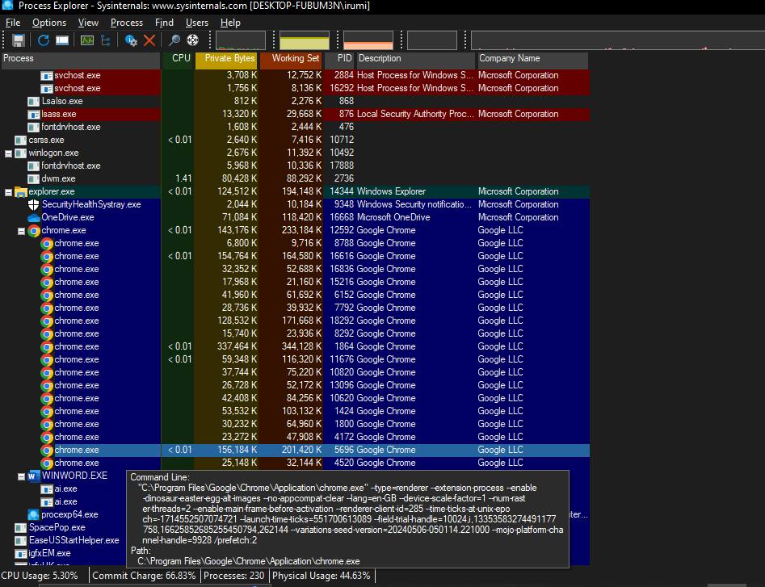

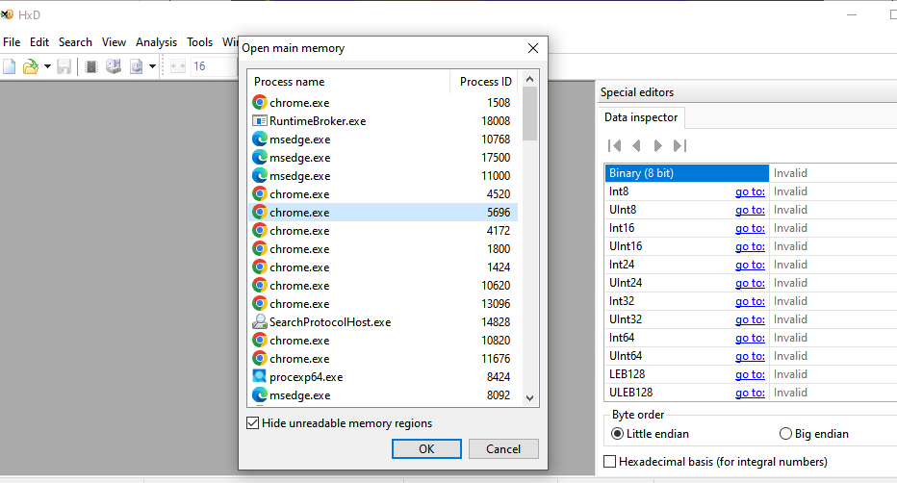

Searching keyword

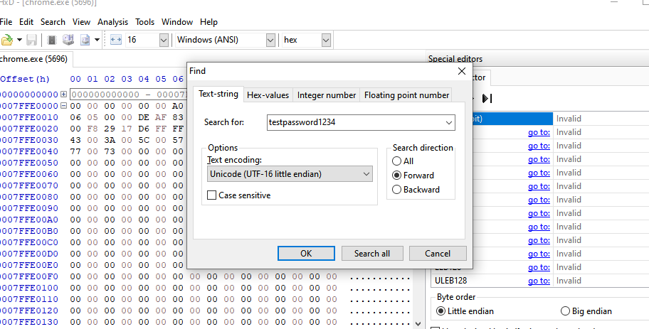

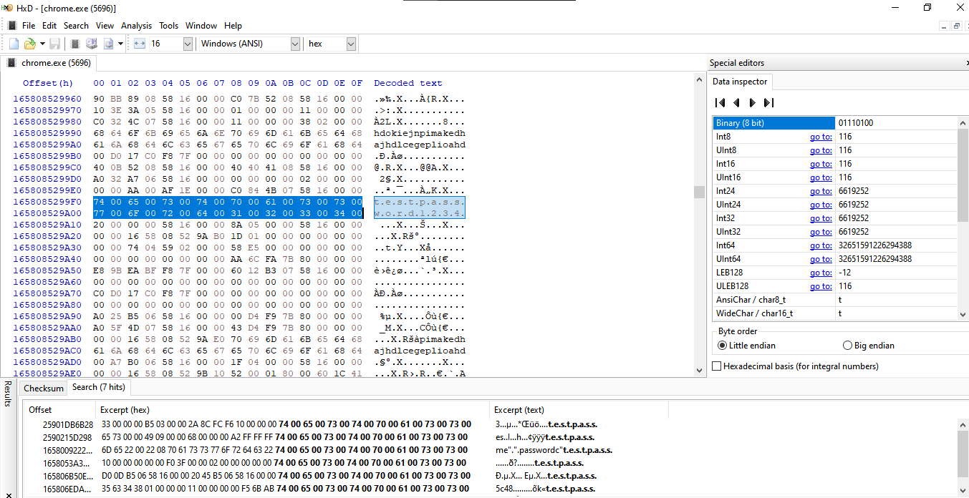

**Keeper**

Created account on keeper

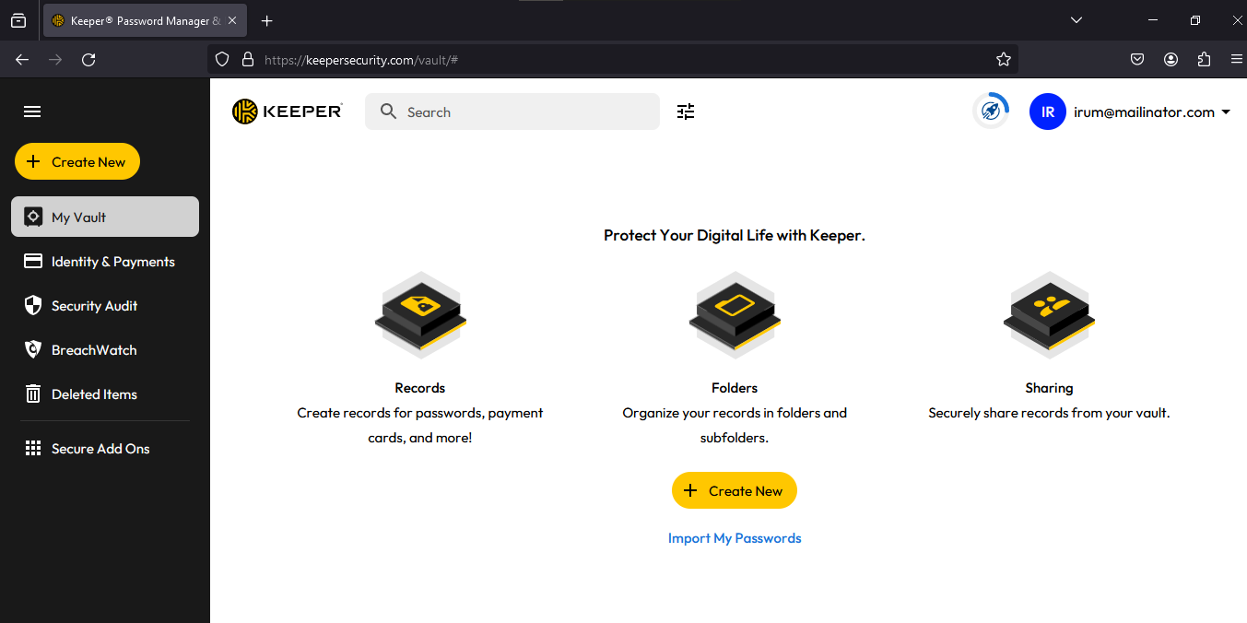

Add a new record

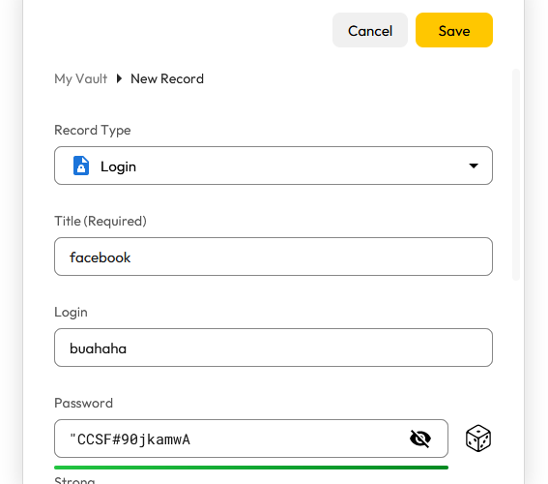

Finding process pid using process explorer

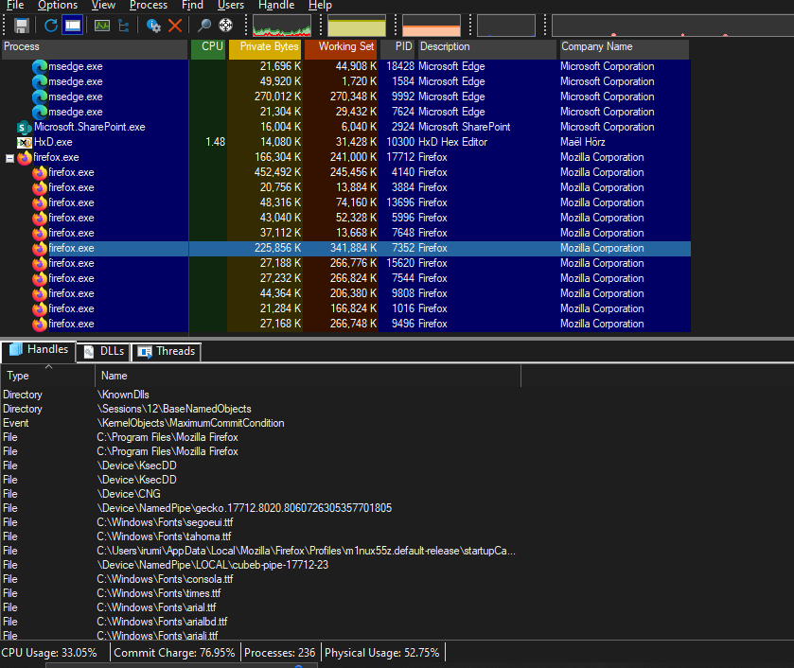

Searching keyword in hex

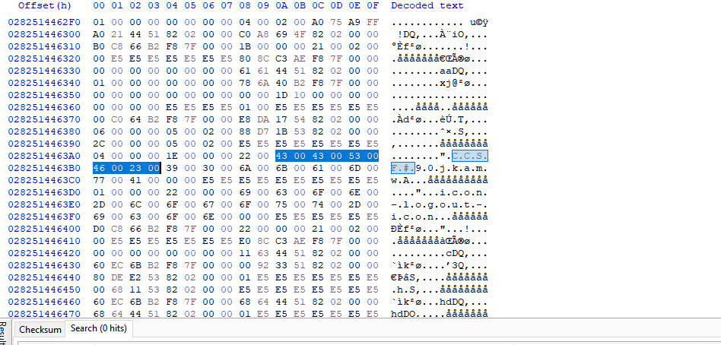

1. **Capturing and Examining the Registry**

**Viewing the Hive Files**

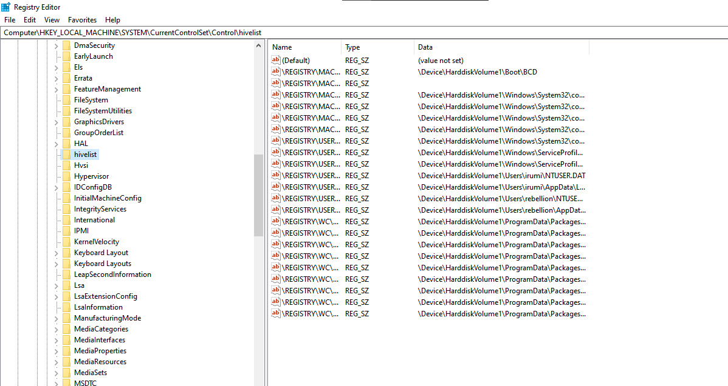

**Creating a Registry Image with FTK Imager**

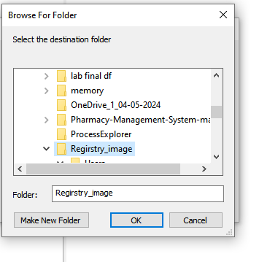

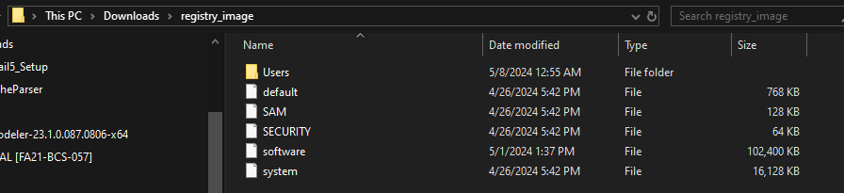

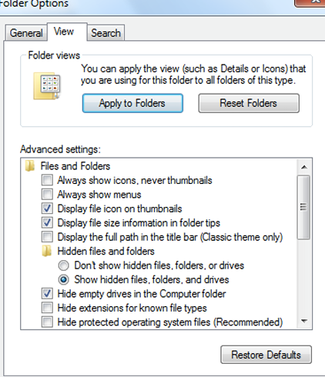

**Analyzing the Registry Image with Autopsy**

Creating new case

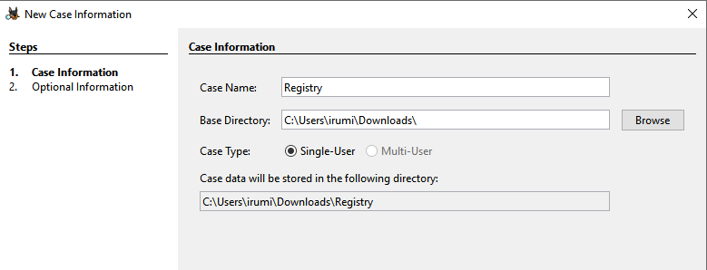

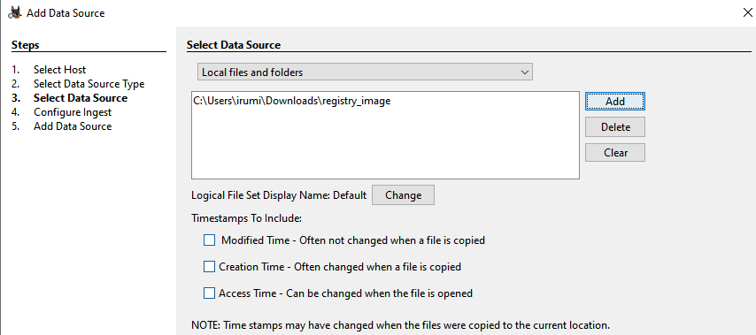adding data source

Found subkeys containing programs name

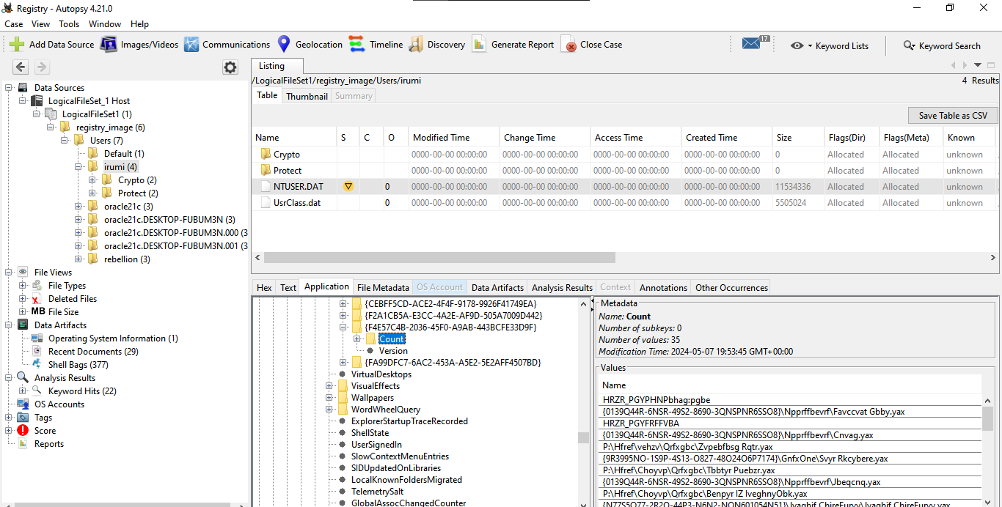

Decoded subkeys

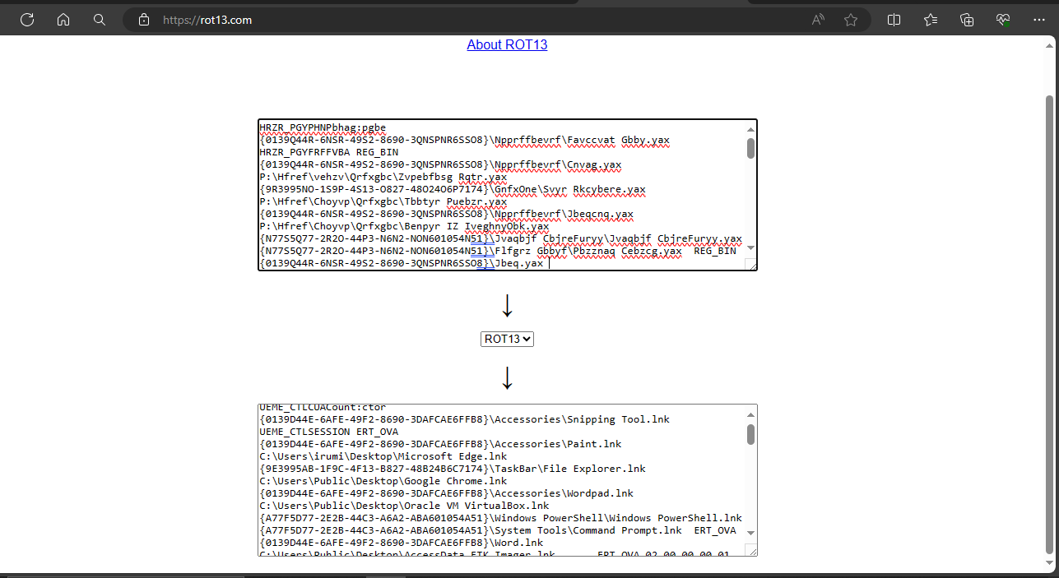

1. **Examining a Windows Disk Image**

Downloaded and extracted disk image



Verifying hash

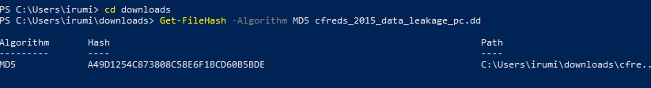

Calculating Checksum CRC -32

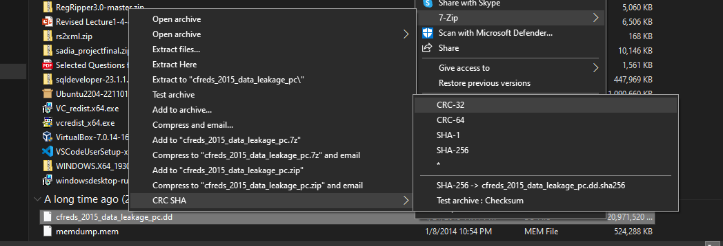

Flag:

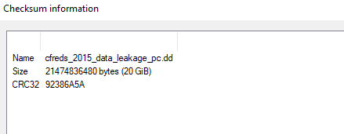

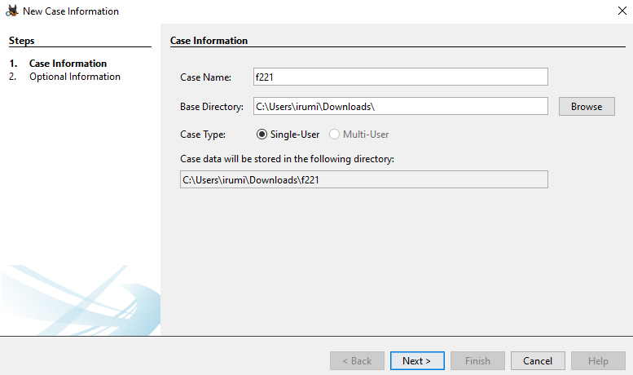Creating a New Case

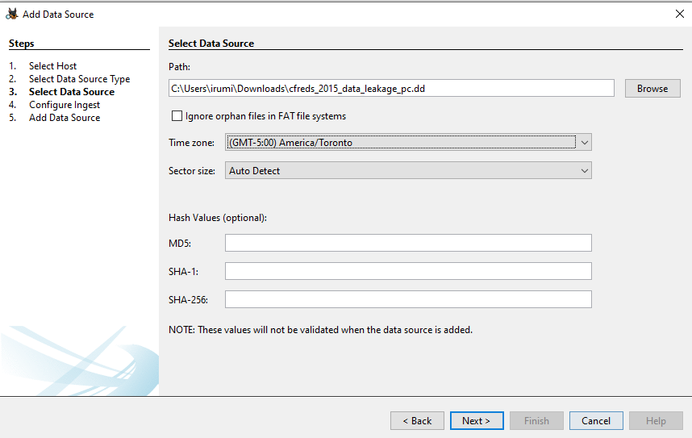Adding data source

**Most Recently Installed Program**

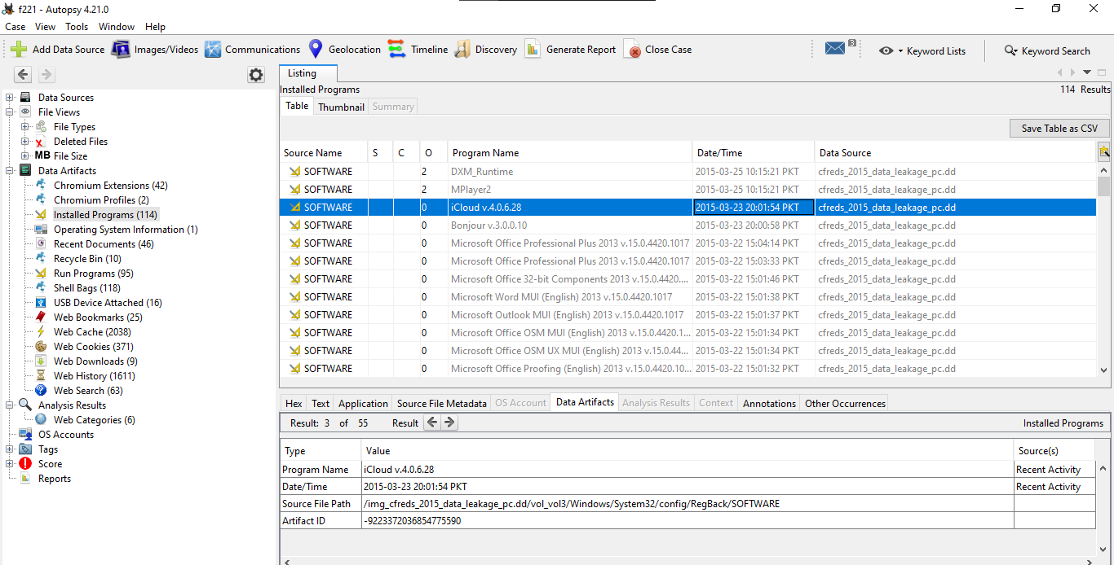

The flag is icloud

**Most Recent Document**

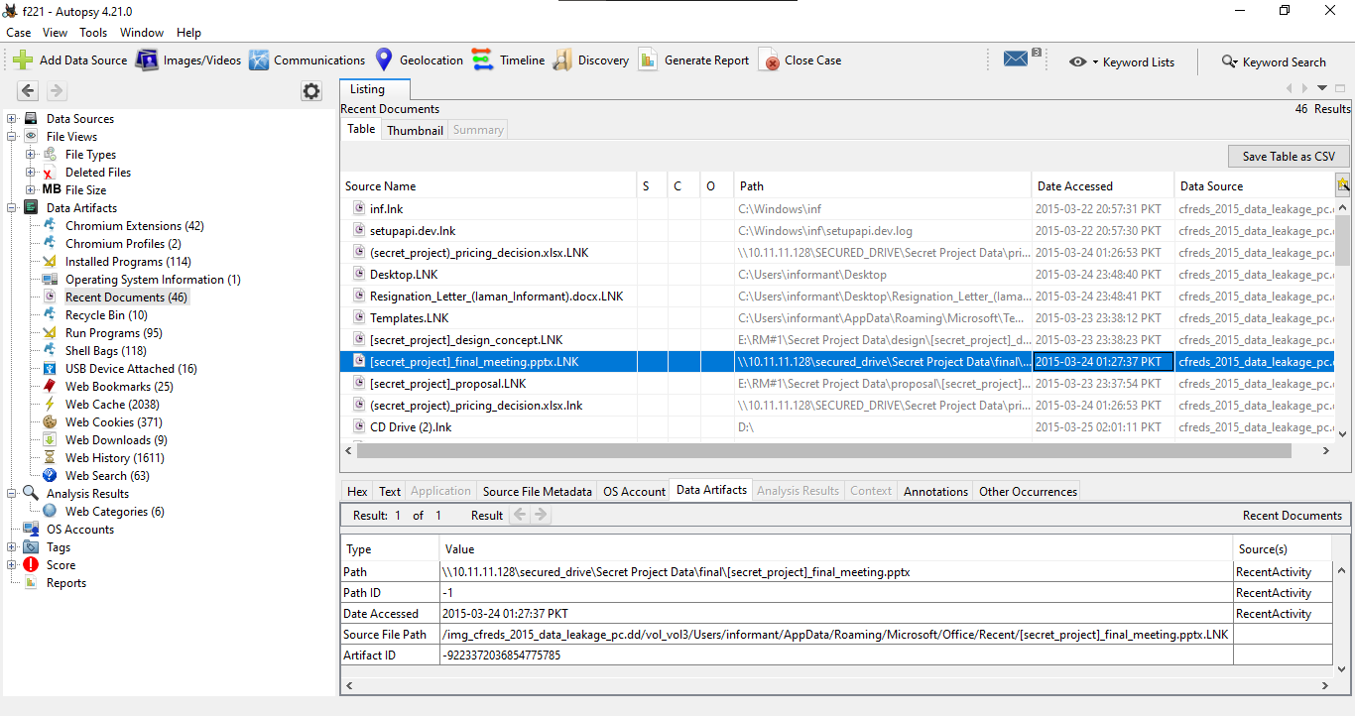

The flag is secret_project final

**Times**

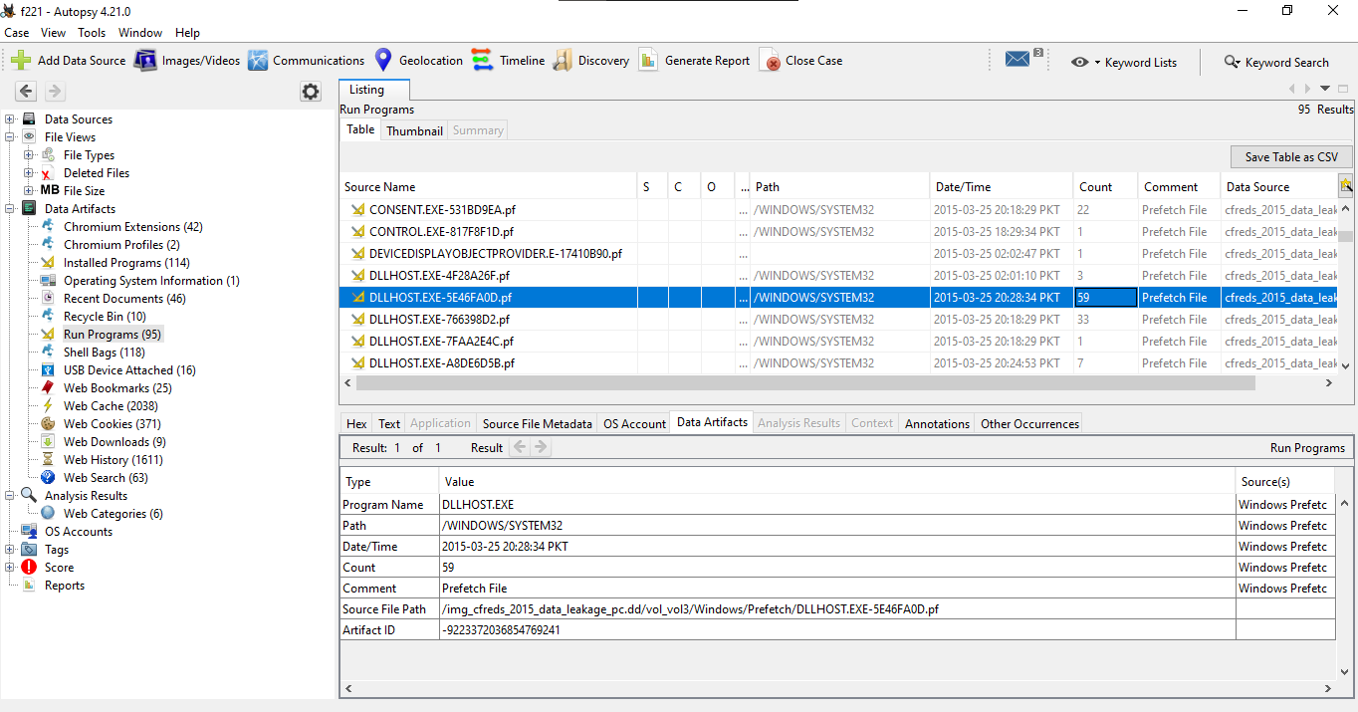

The flag is DLLHOST.EXE

**Search**

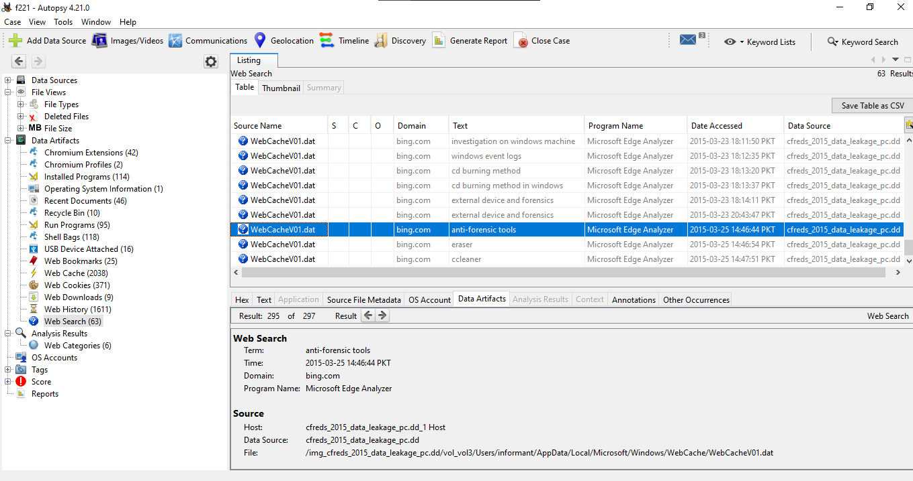

The flag is anti-forensic

1. **Email forensics.**

**Traffic data review**

Opening the file in Wireshark to analyze

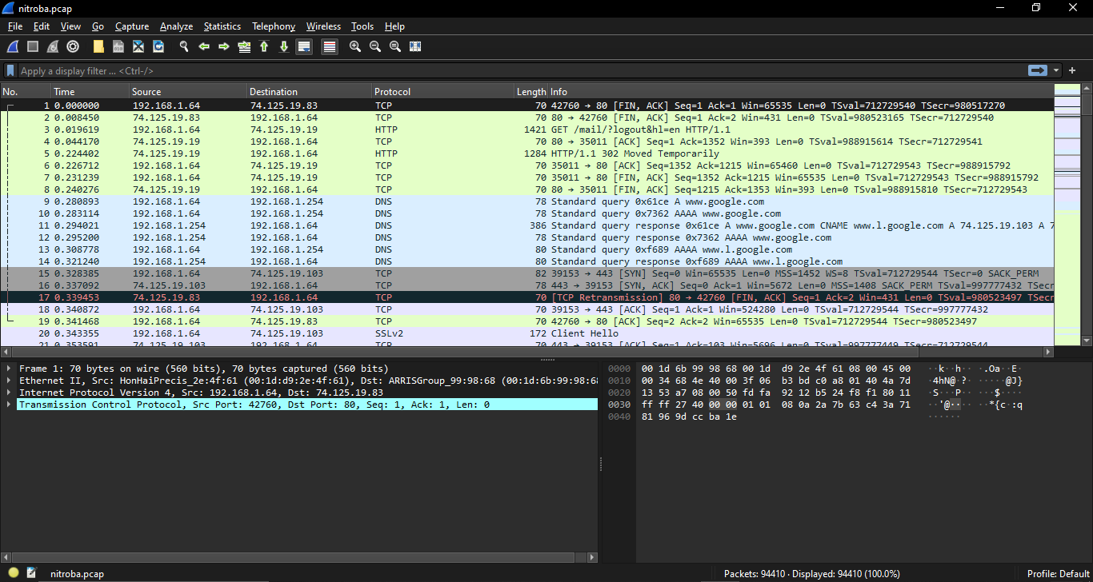

* 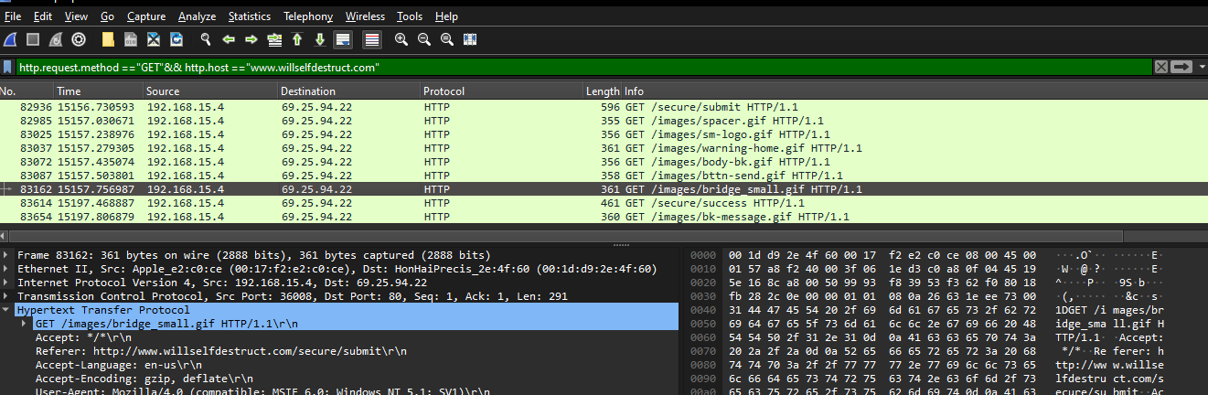**Which IP accessed www.willselfdestruct.com ?**

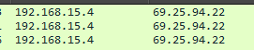

* **Does the IP post harassing comments to the website? YES**
* **Does the HTTP post contain the harassment message? Yes**

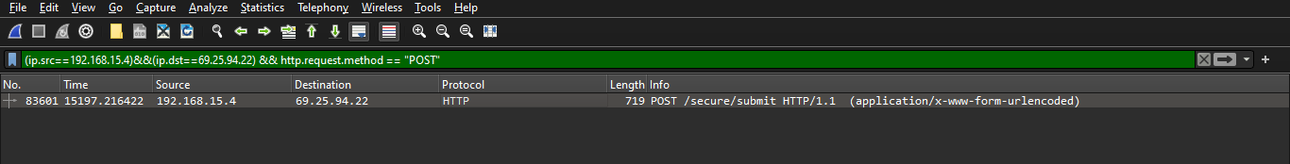

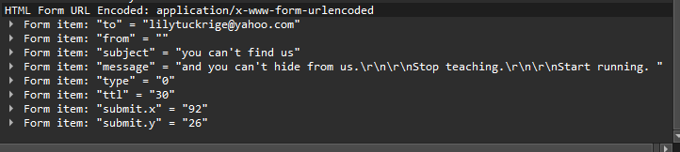

* **is the IP associated with any suspects?**

Found the suspect mac address.

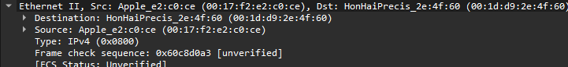

Searching all packets suspect mac address

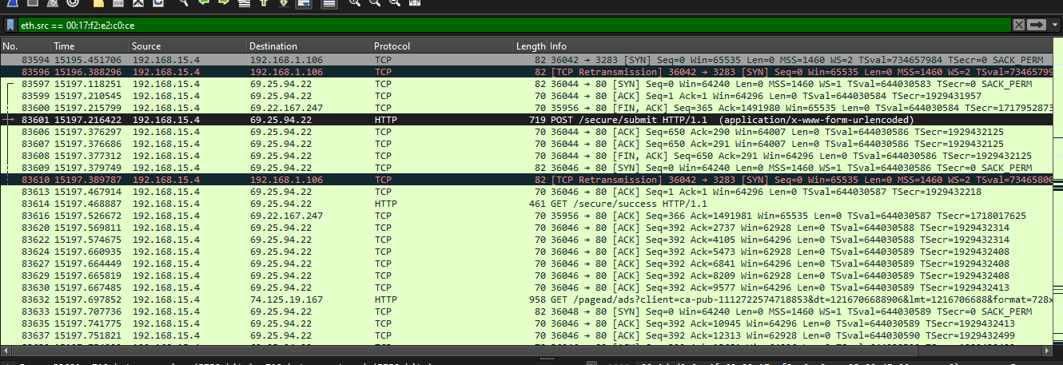

To find the suspect account apply this filter

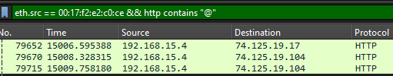

Found the email id in cookies

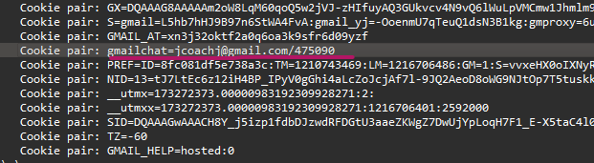

* **Is the suspect in faculty’s class?**

Yes he is from the class as jcoach is familiar with Johnny Coach.

* **When did the suspect use www.willselfdestruct.com?**

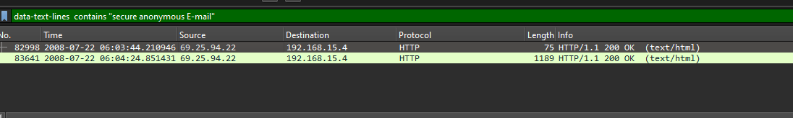

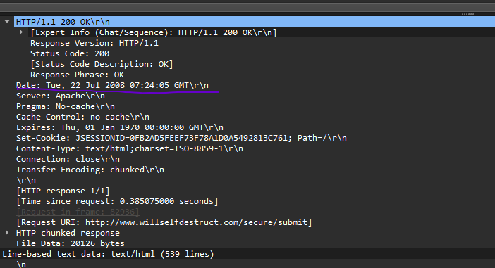

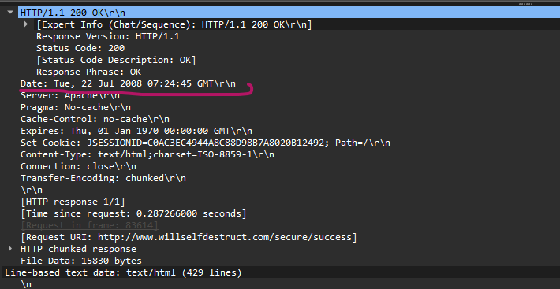

1. **Android Studio Emulator**

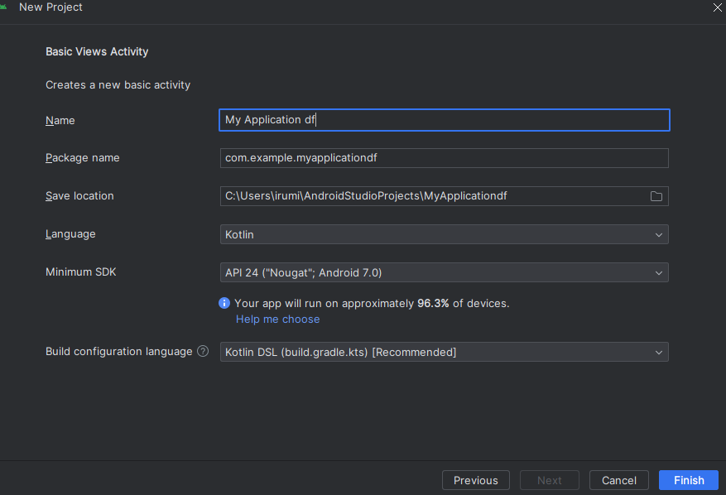Creating a new project

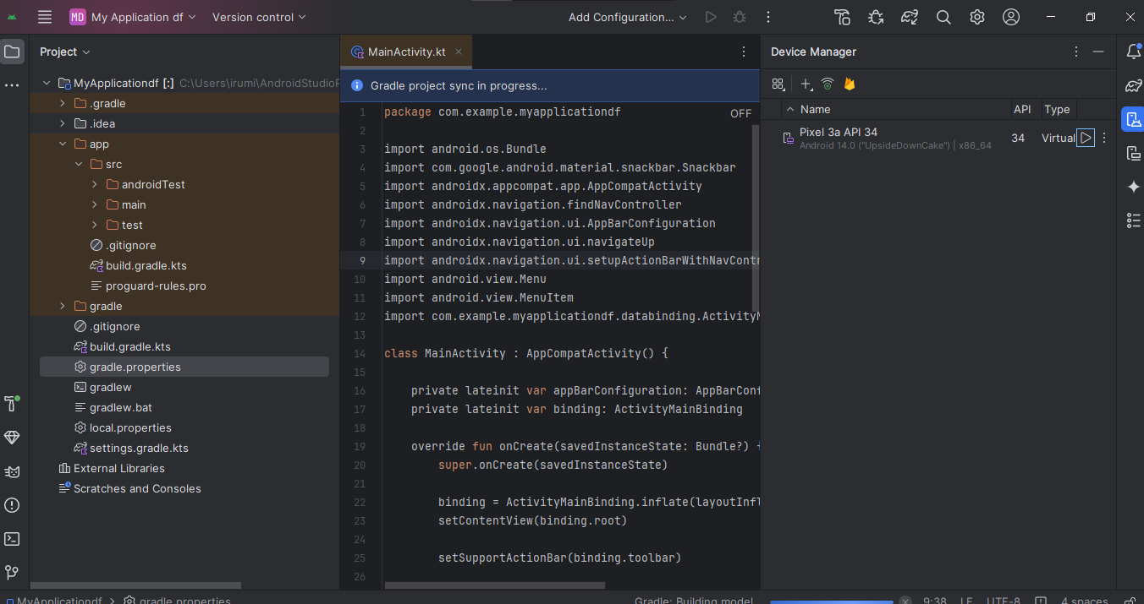

Creating device

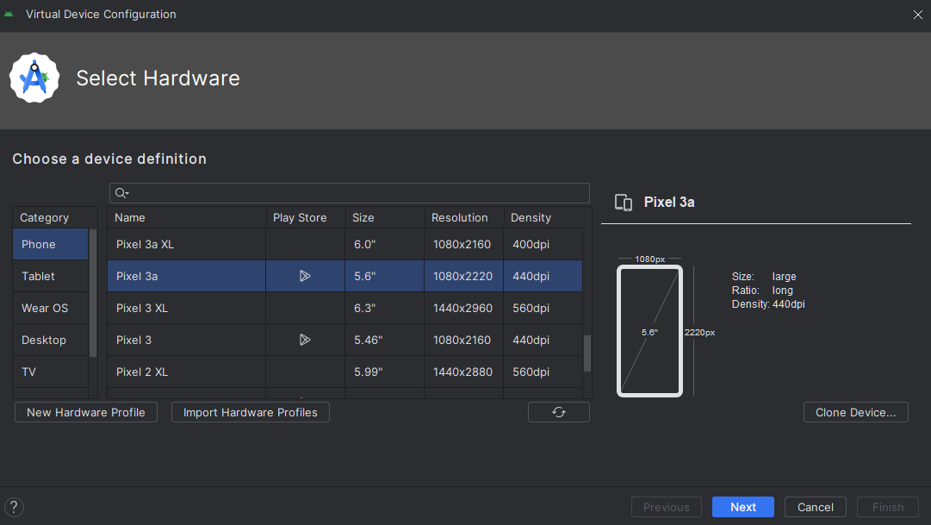

Selecting android 10 google play

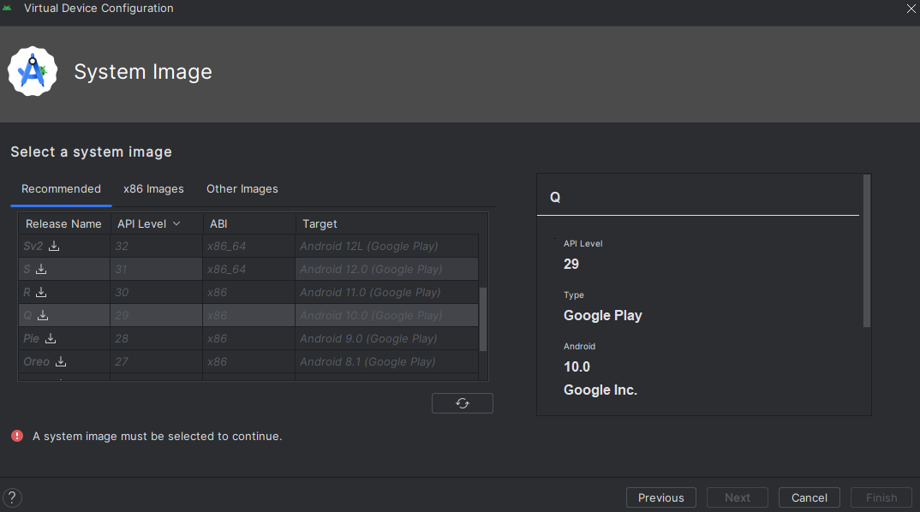

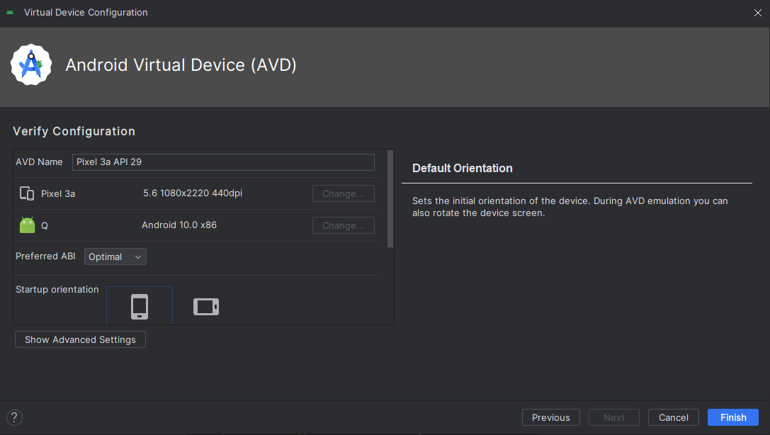

The device has been created.

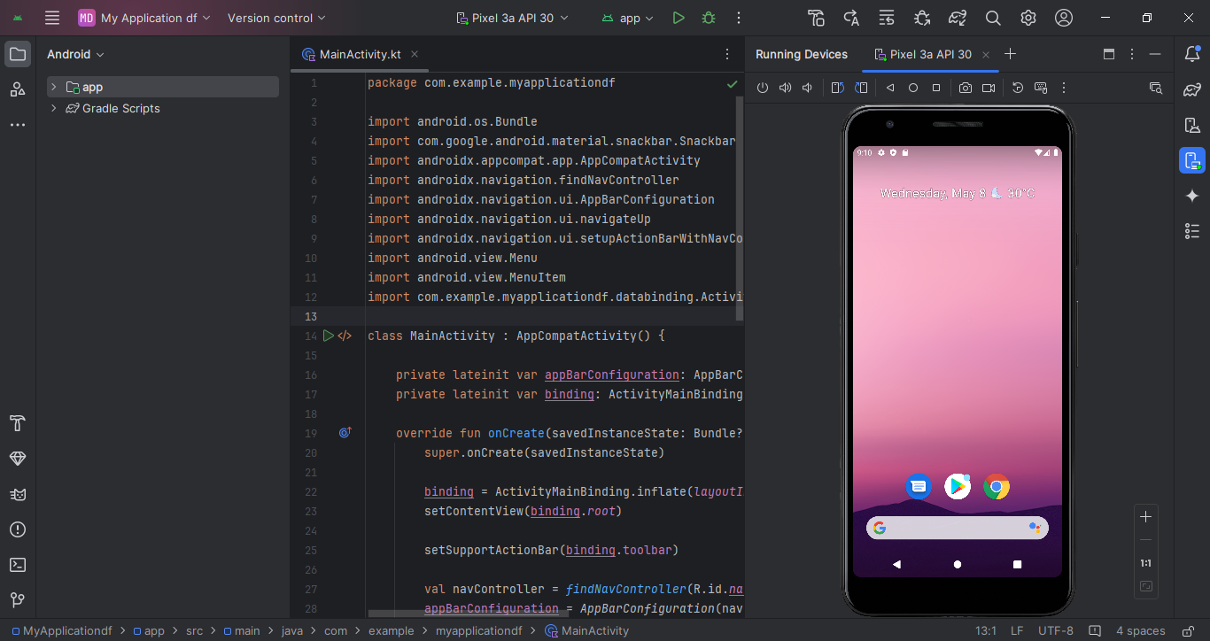

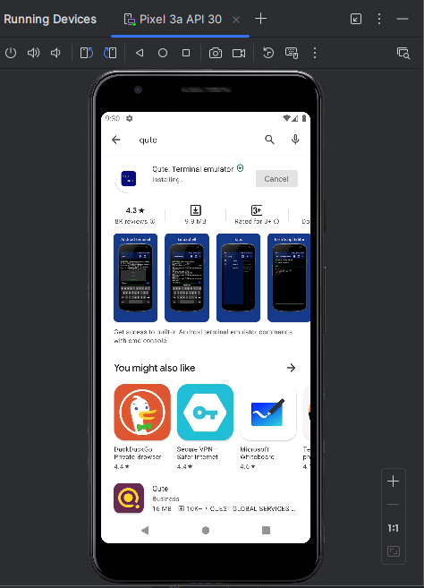**Installing Qute: Terminal Emulator**

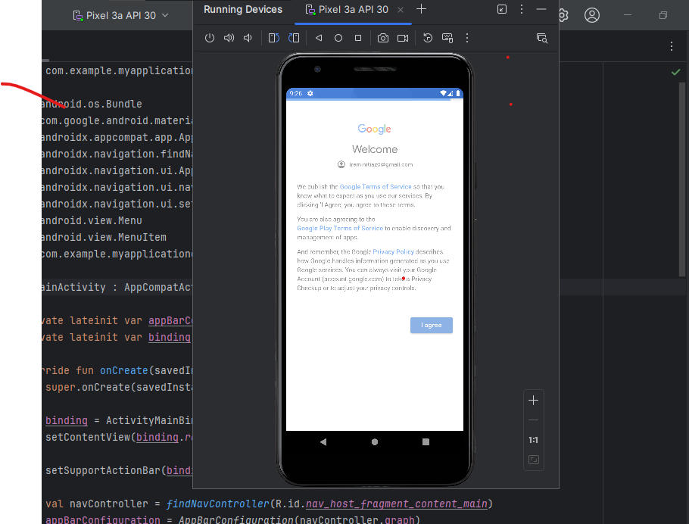

**Operating System**

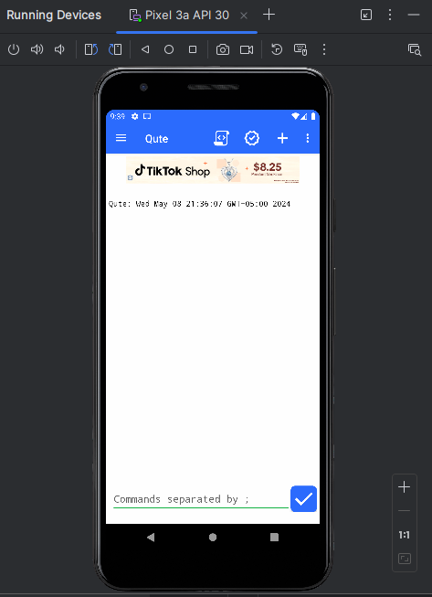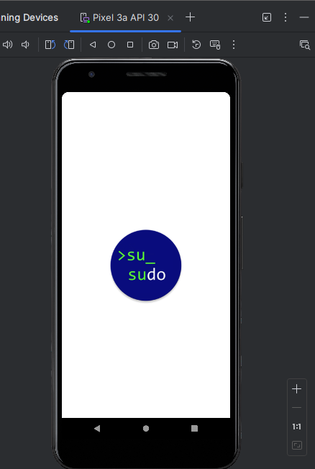

**Command executed**

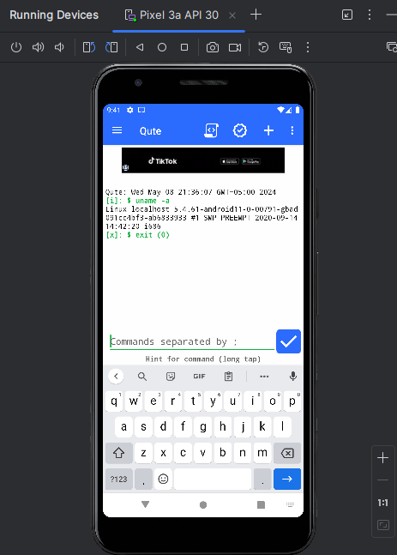

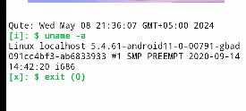

Flag is linux

1. **Rooting Android Studio's Emulator**
2. **Making a Rooted Android Emulator**

Downloading rootAVD

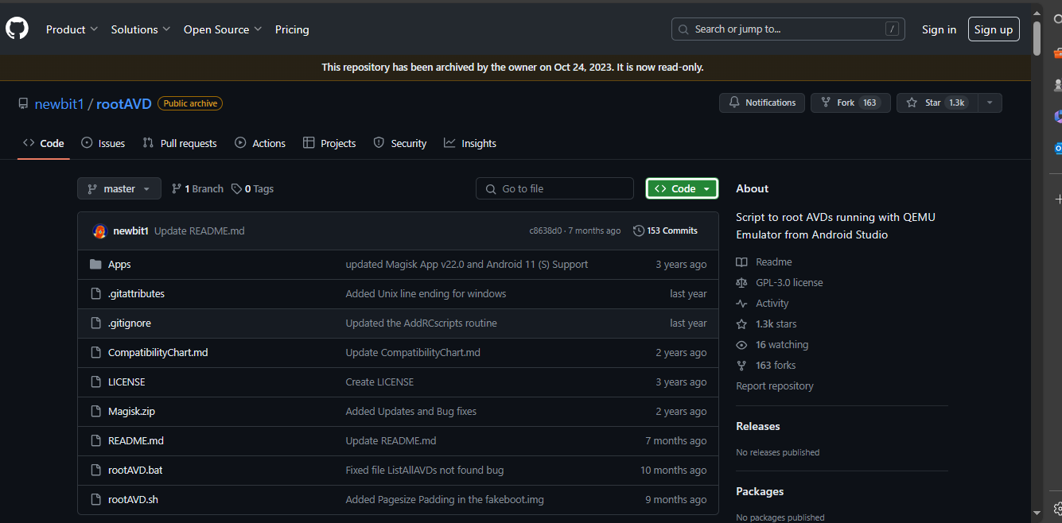

Making a rooted android emulator

Creating a new device

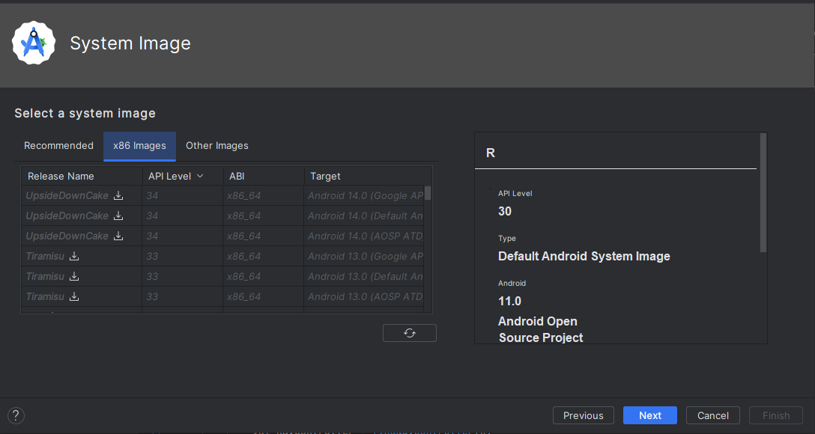

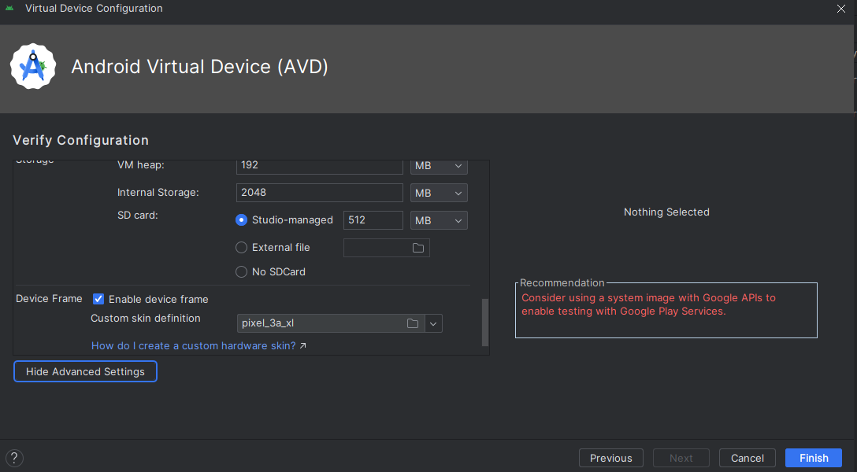

Device created

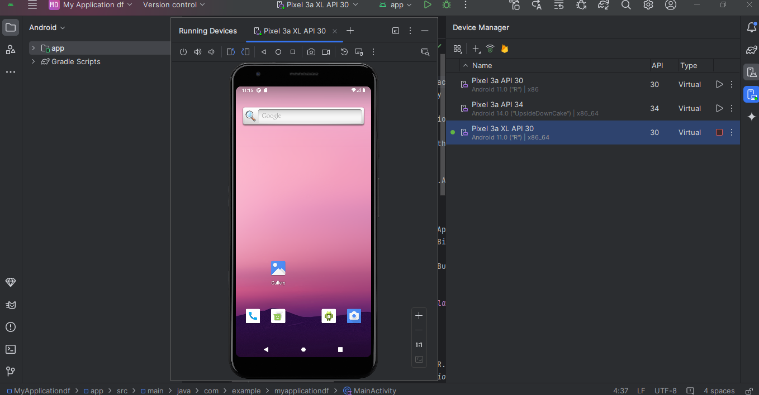

Commands executed for listed devices

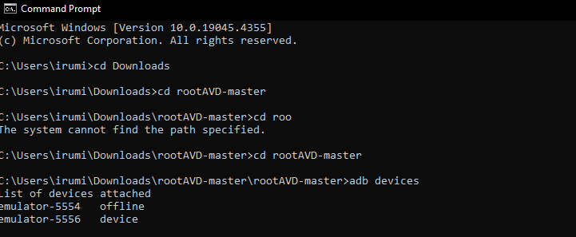

Flag = root

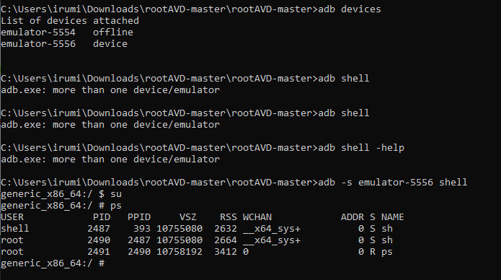

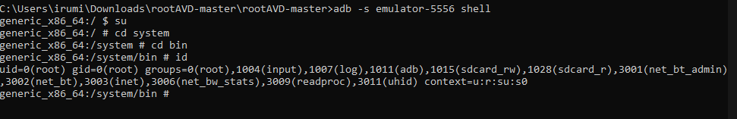**Id** : flag = su

1. **Forensic Acquisition from Android**

Starting emulator

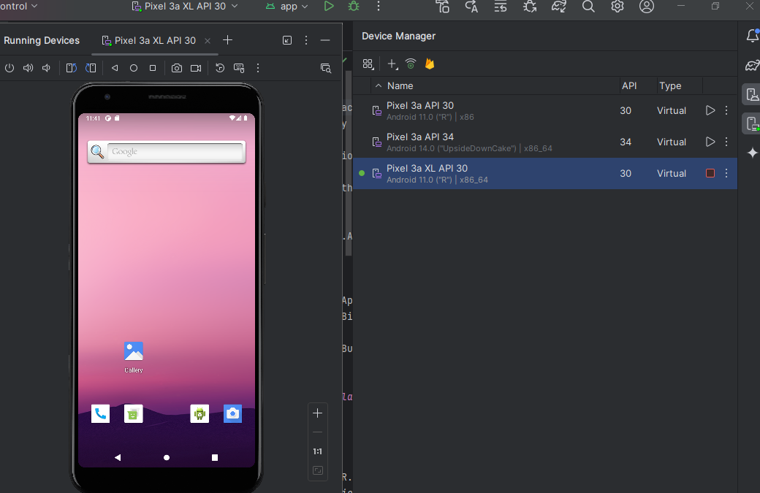

Send message and call

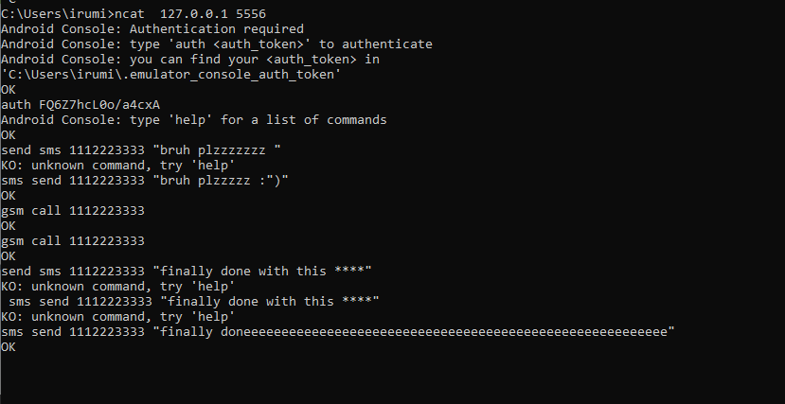

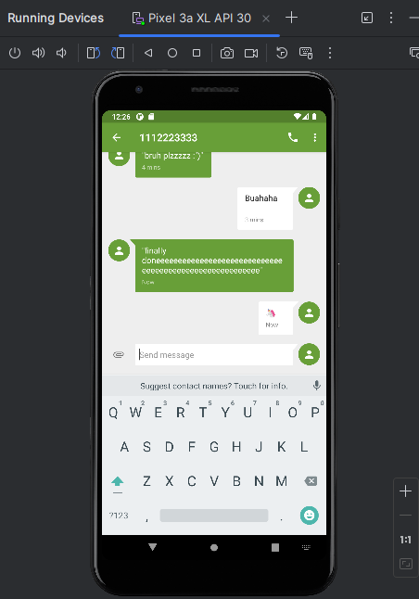

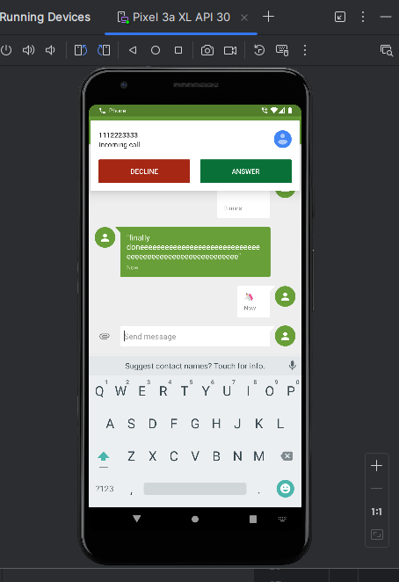

Collecting user data

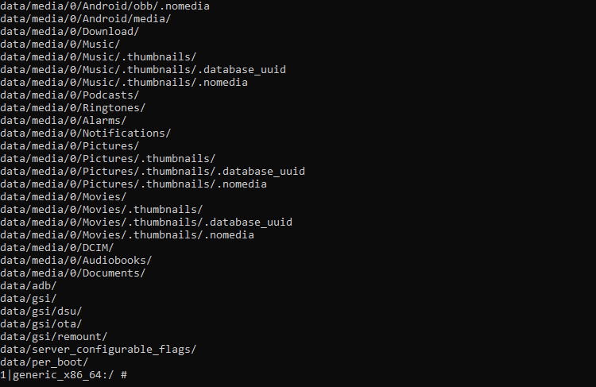

Pulling the file



Extracting file

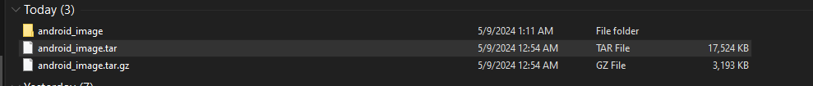

Creating new case in autopsy to analyze the extracted data

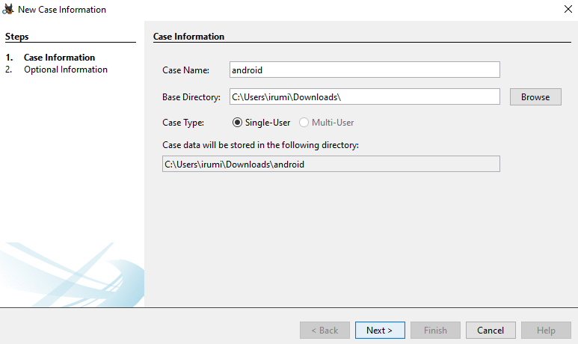

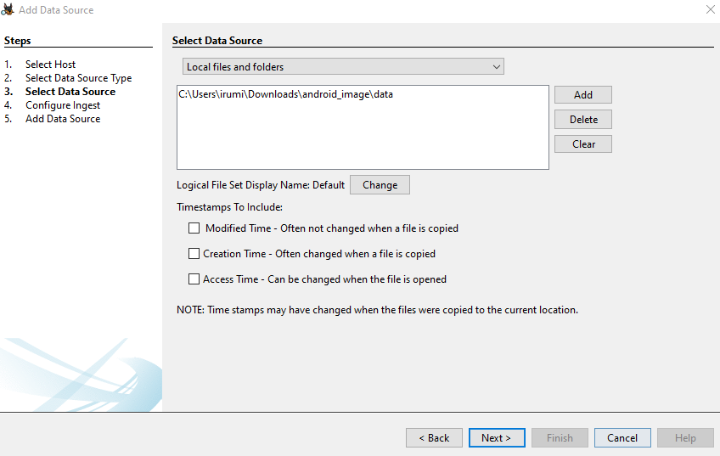Adding data source

Analyzing the data in autopsy

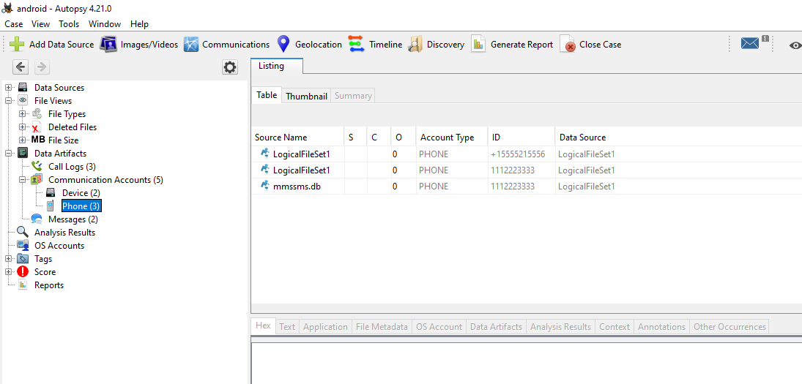

Flag is mmssms

messages

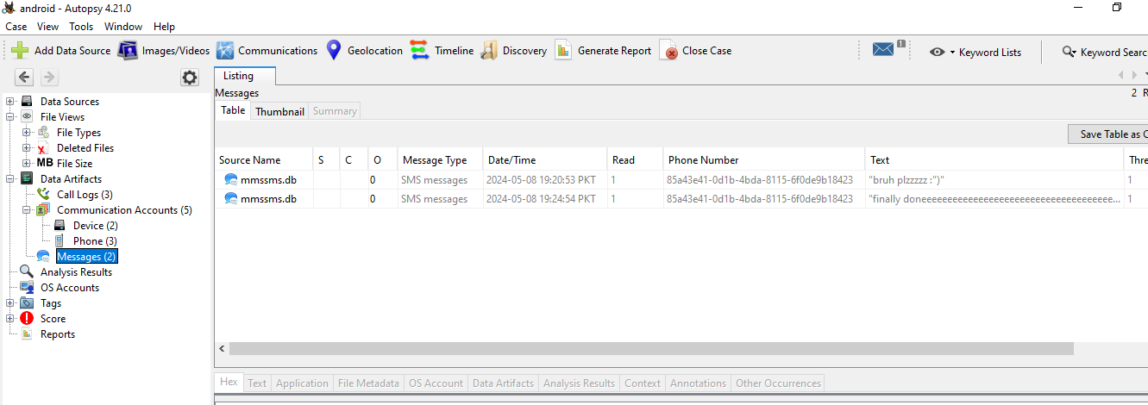

1. **Android Analysis with Autopsy**

Verifying hash

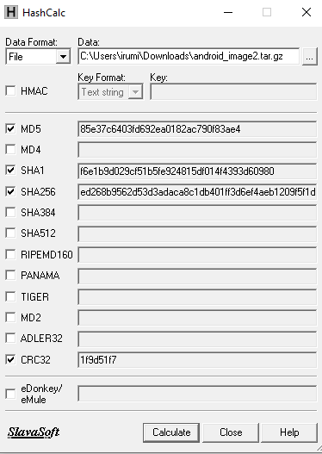

Creating new case

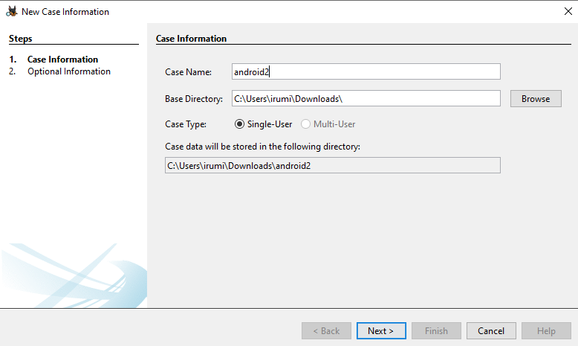

Adding android file as data source

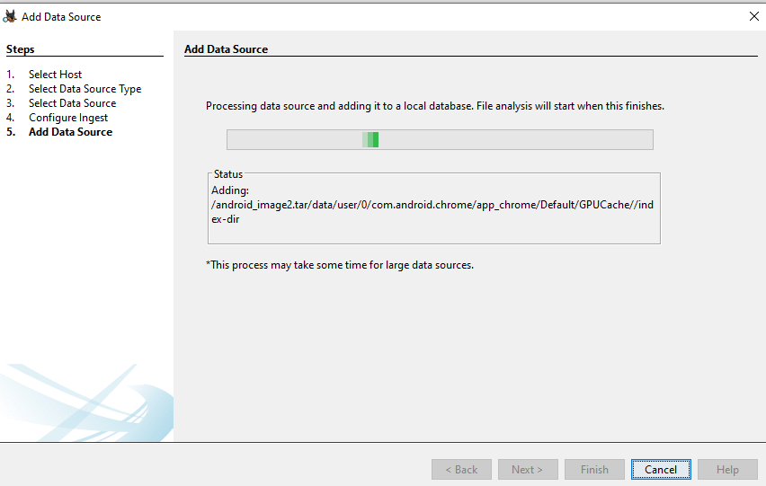

**Newest App**

(What is the most recently installed app? The flag is com.u360mobile.usna

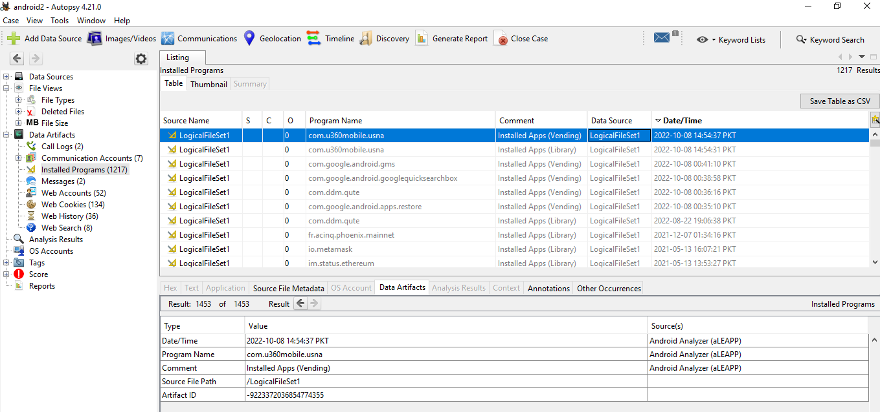

**Website**

What website was viewed at 14:52:39 PDT on Oct 8, 2022?

The flag is http://www.kittenwar.com

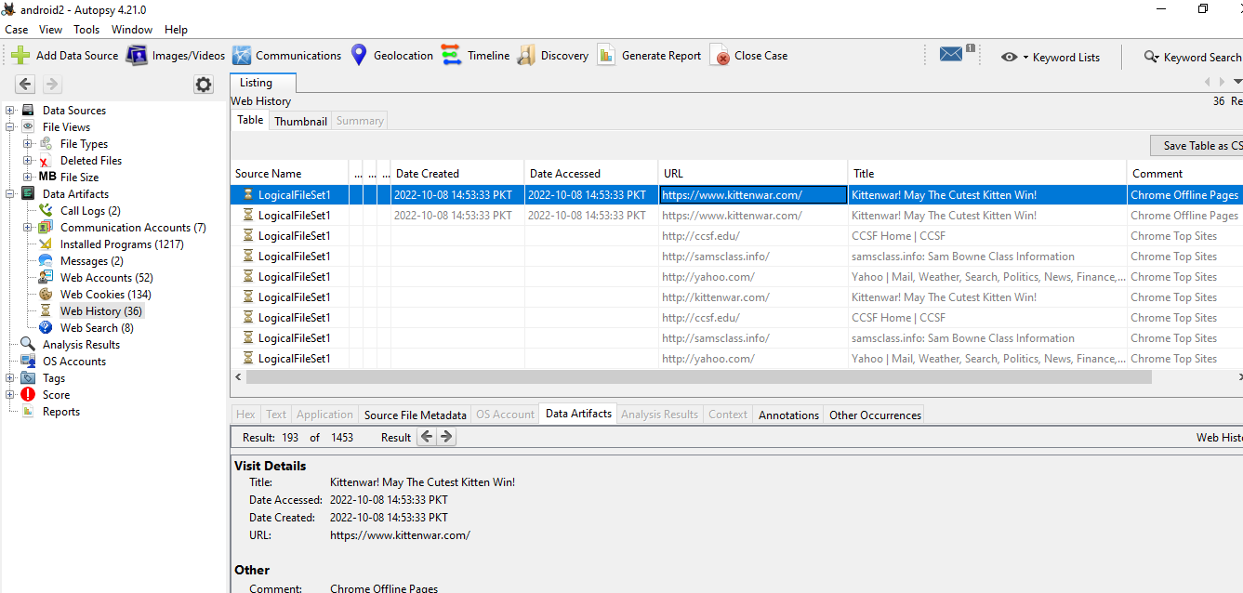

1. **iPhone Analysis with Autopsy**

verifying hash

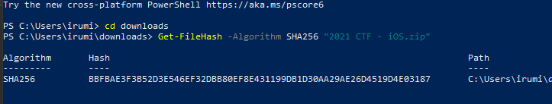

creating new case in autopsy

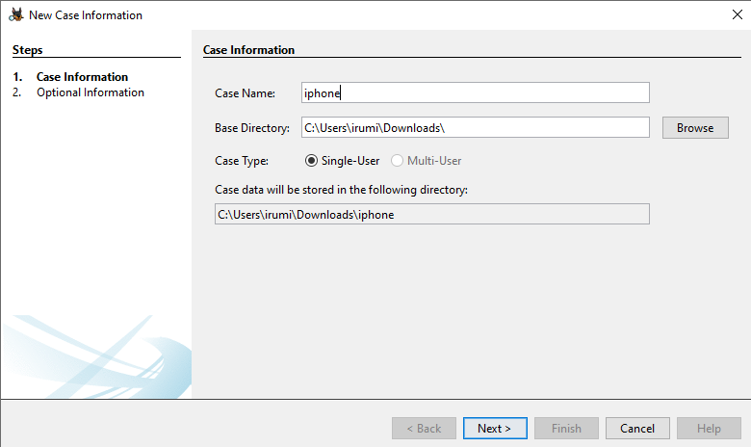

Adding iPhone file as a data source

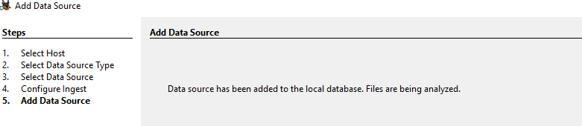

**Phone Number**

find the name of the device paired via Bluetooth.

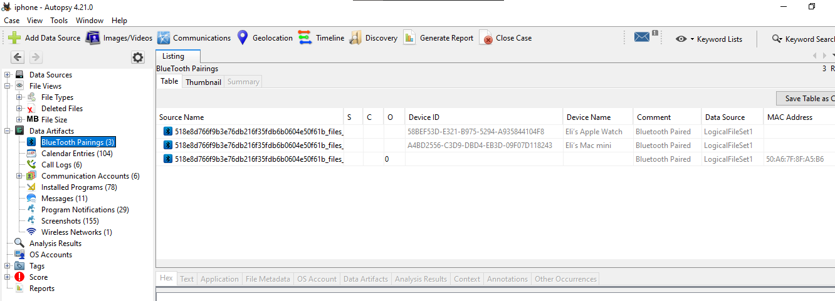

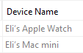

**Latitude**

Examining the GPS data, what was the most northern latitude of the phone?

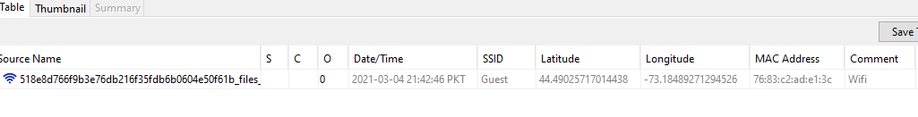

**SMS**

Examining the Messages, what code did SIGNAL send the phone?

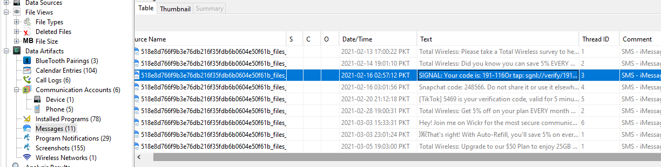

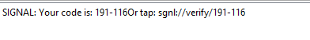

**Signal Contact**

Examining the Program Notifications, find the person named Johnathan who sent Snapchat (also called pikaboo) messages to this phone. What is that person's last name?

Jonathan chipps

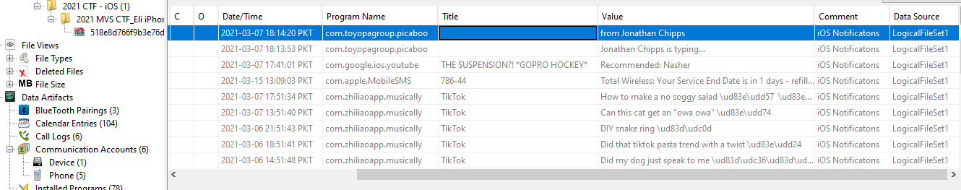

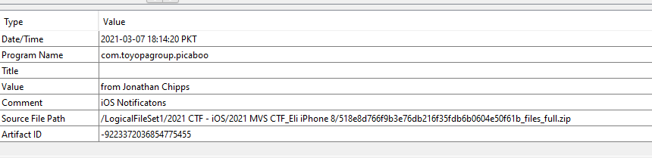

1. **Windows and linux machines**

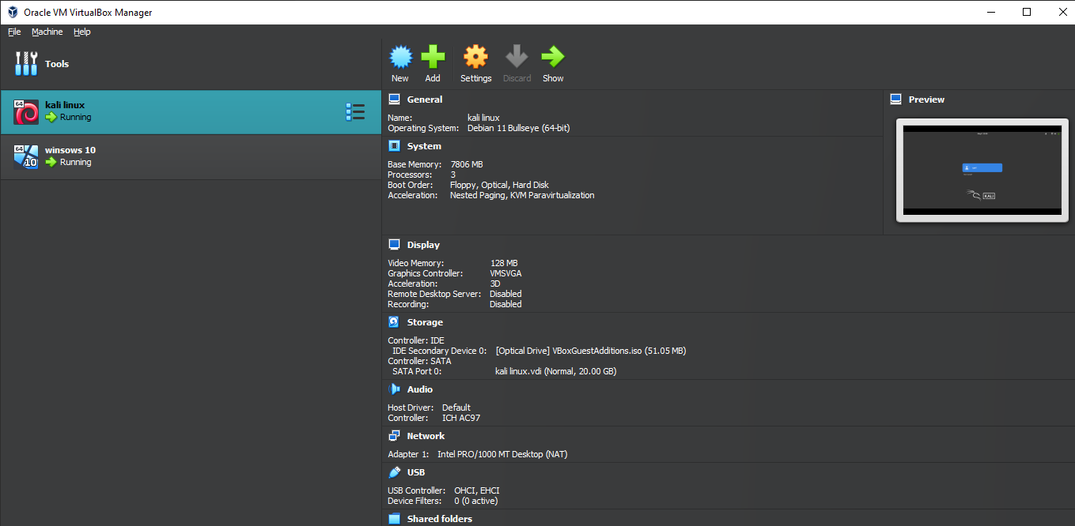Setting up both machines in virtual box

**Windows Flag**

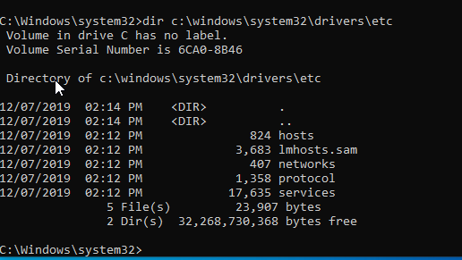

Flag is hosts

**Linux Flag**

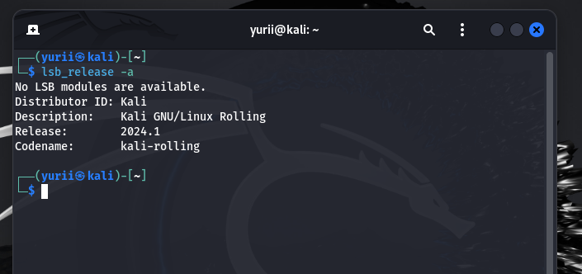

The flag is kali.

1. **Velociraptor Server on Linux**

* **Task 1: Installing Velociraptor on Linux**

**Preparing the Server**

Creating new directory

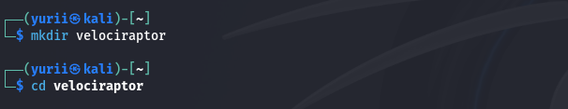

Installing velociraptor

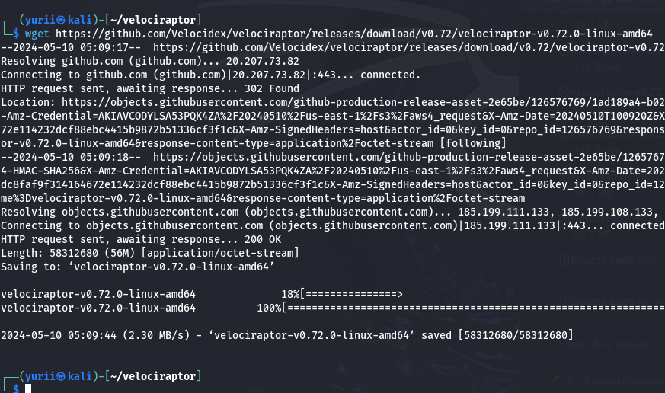

Adding permission to execute

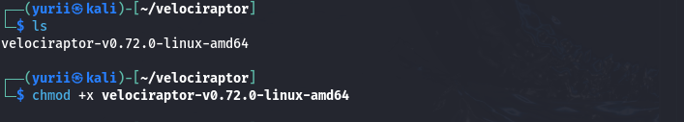

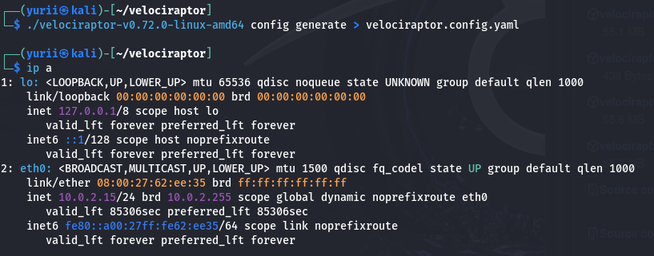Executing commands and finding the server ip address

**Editing the Config File**

Opening in mousepad

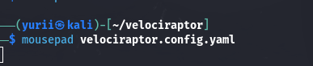

Editing the config file adding ip address to localhost

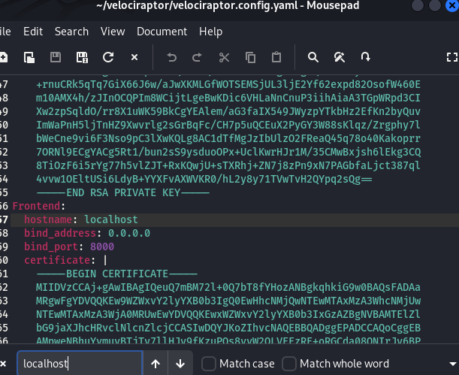

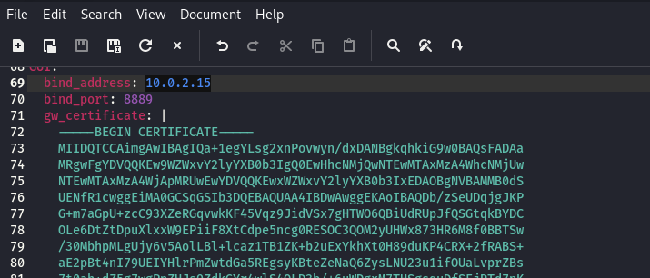

**Creating the Administrator User**



**Starting the Velociraptor Server**

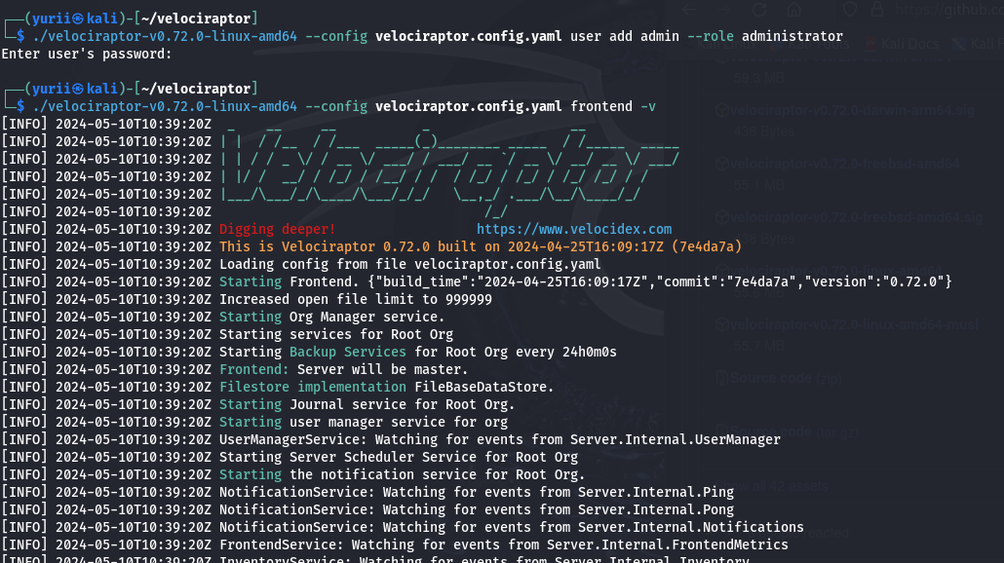

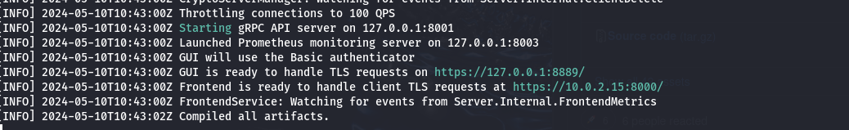

**Viewing the GUI**

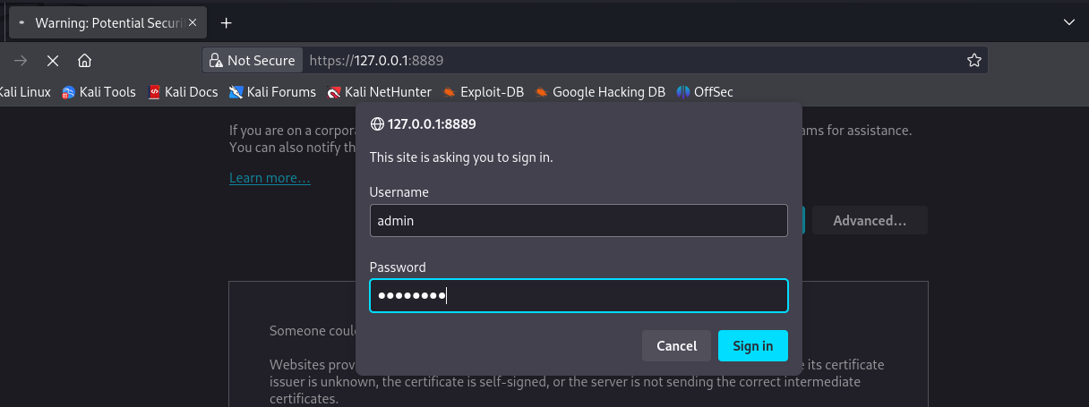

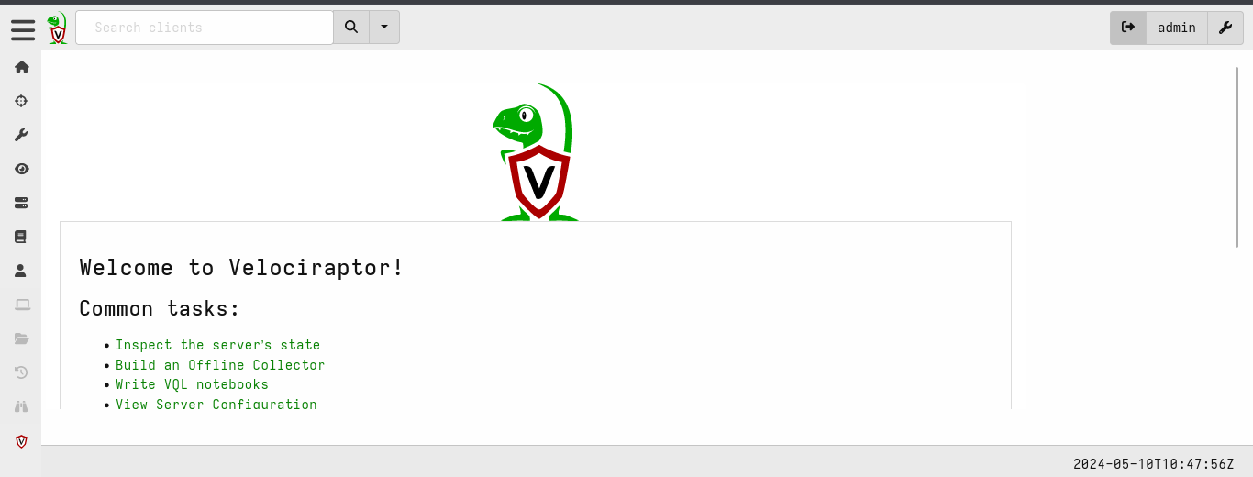

Flag

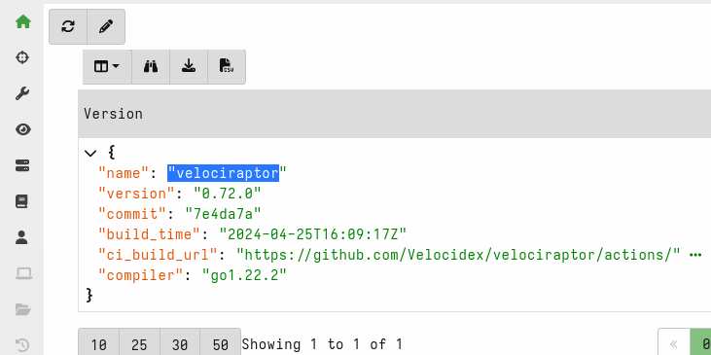

* **Task 2: Adding a Windows Client**

**Preparing a Client Config File**

Adding use_self_signed_ssl : true in config file

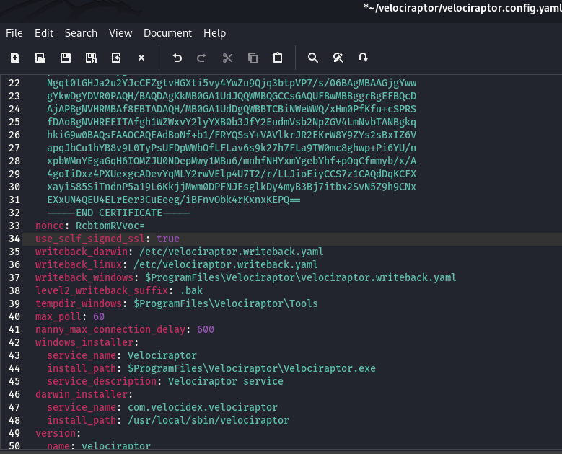

**Preparing a Windows Client Installer**

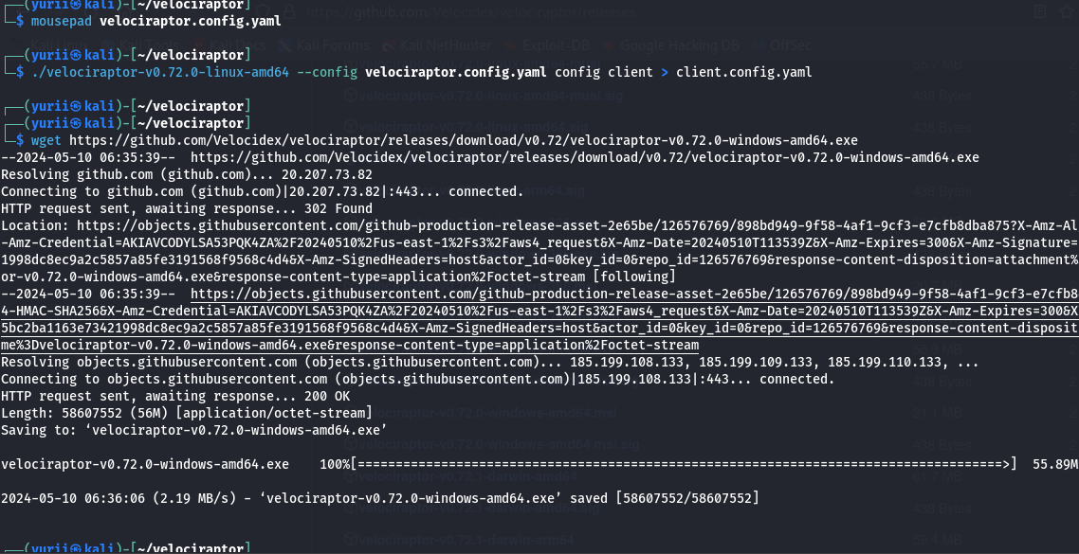

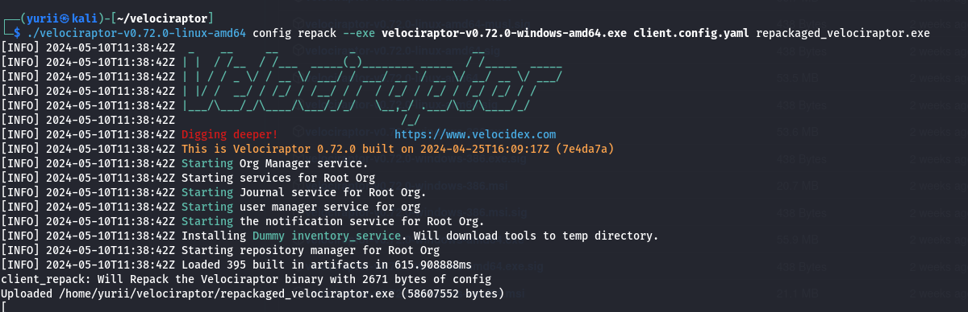

Updating

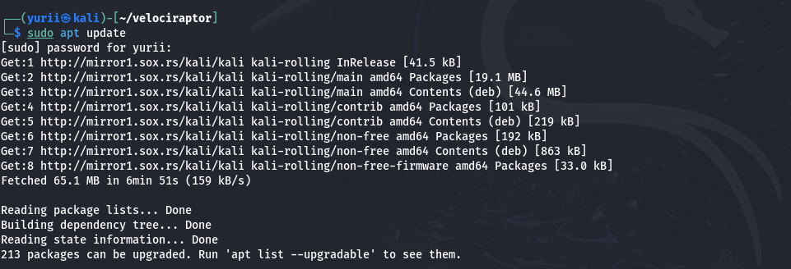

Upgrading ssh server

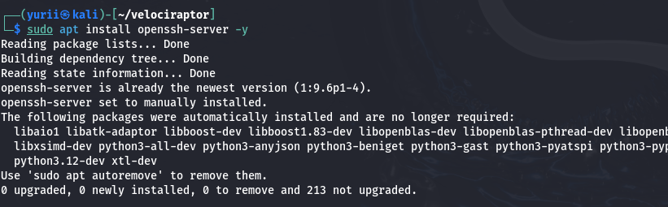

**Moving Client to the Windows Machine**

Using ncat commands also veryfing hash

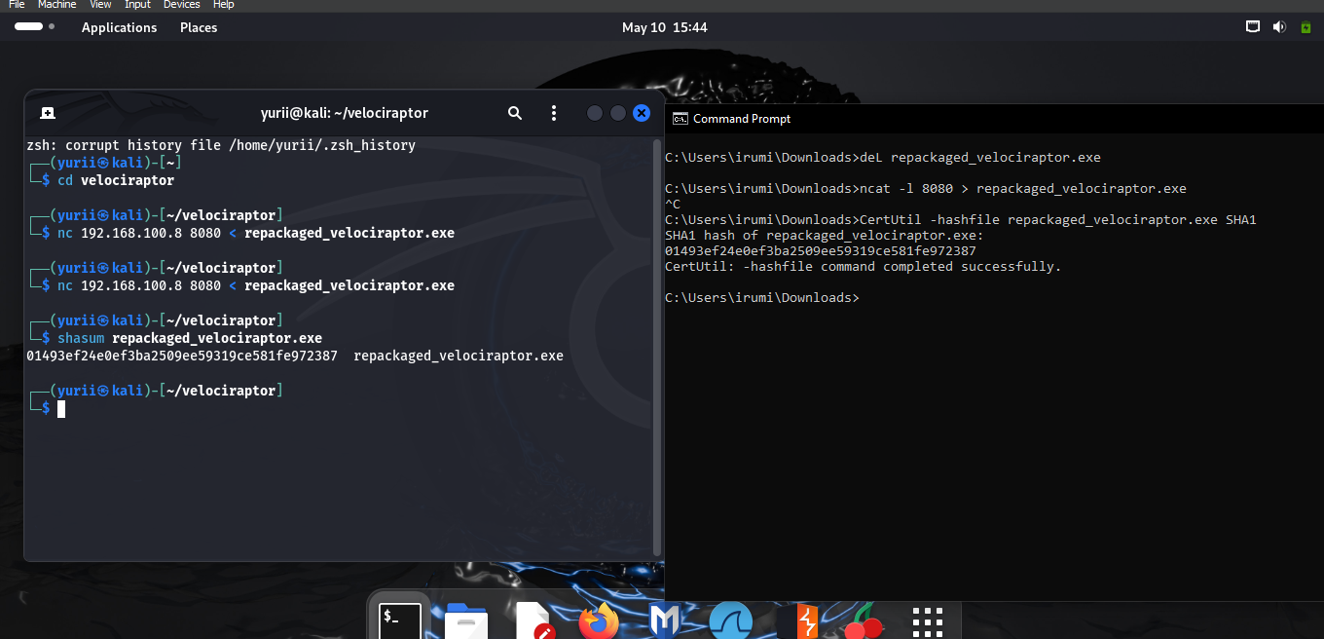

Adding repackaged file to exclusion while scanning so firewall does not block it

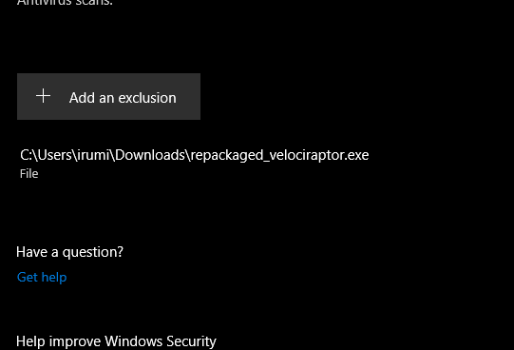

Running repackaged file

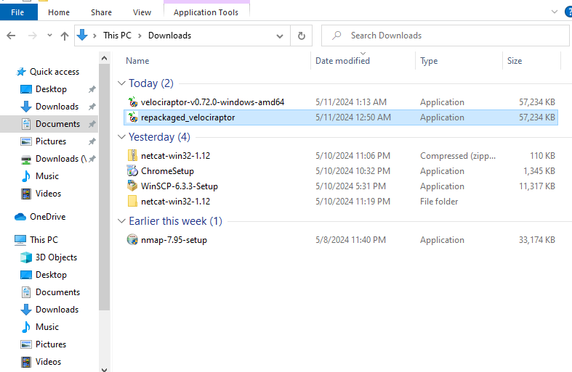

Show all clients on gui

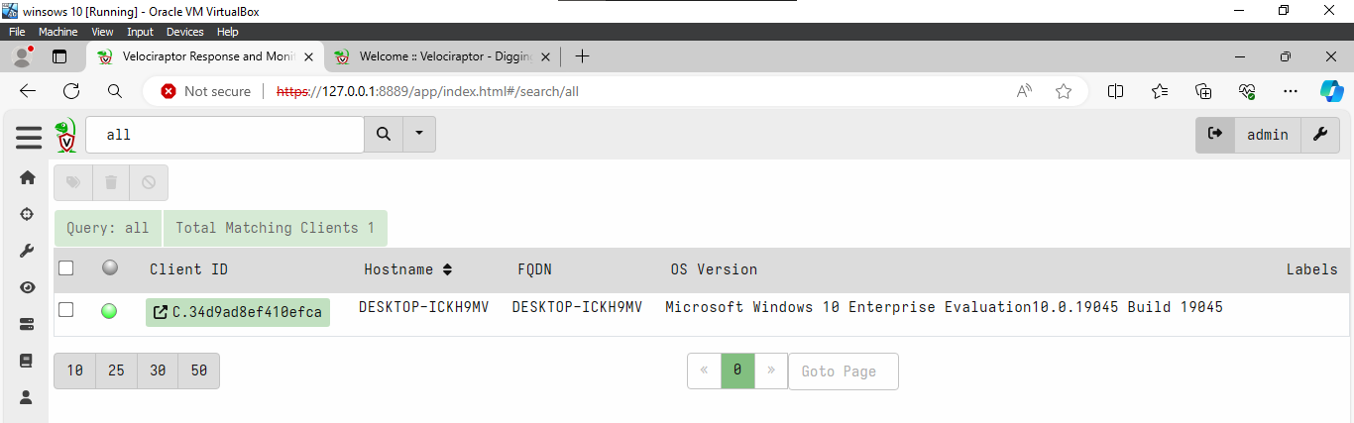

**Agent Name**

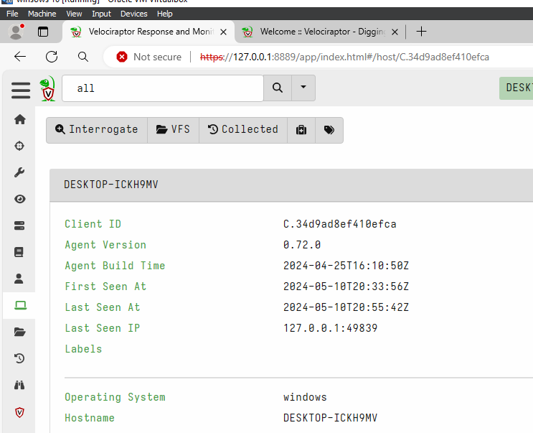

**Ntfs file system**

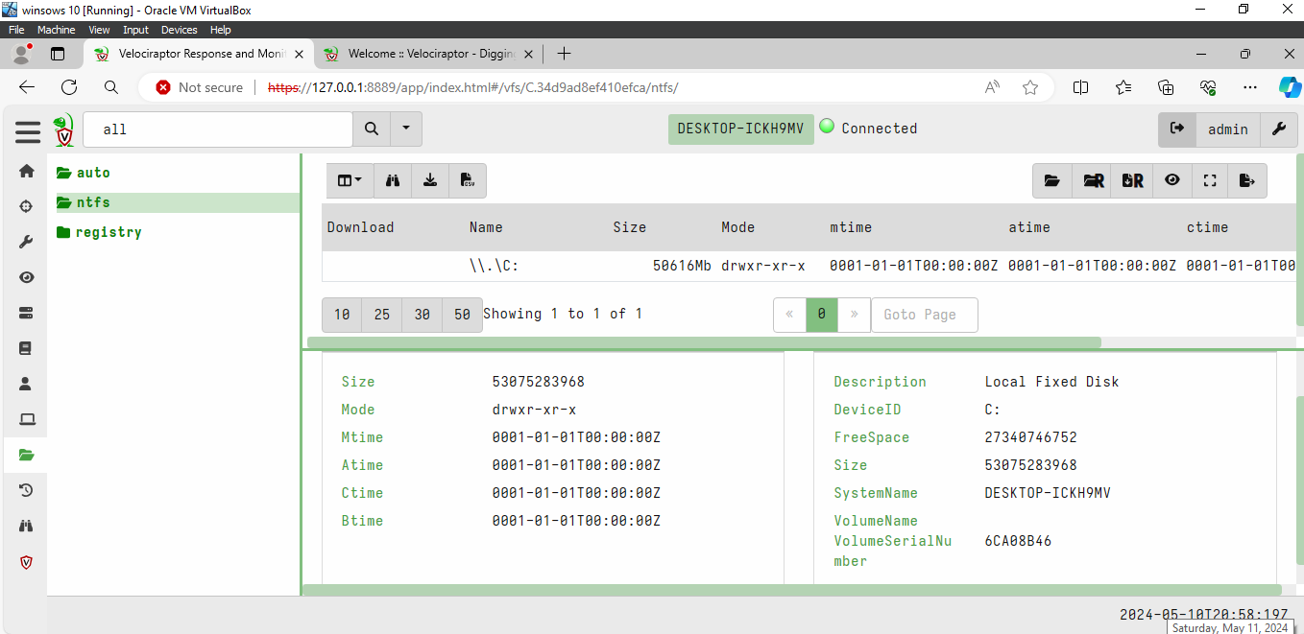

**Registry Information**

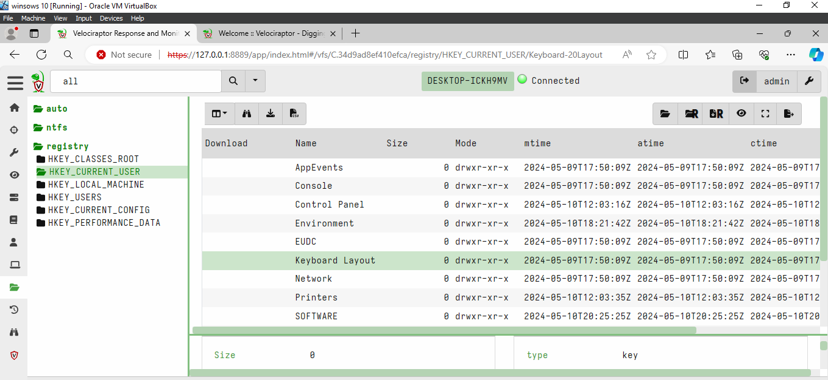

**Exploring the File System**

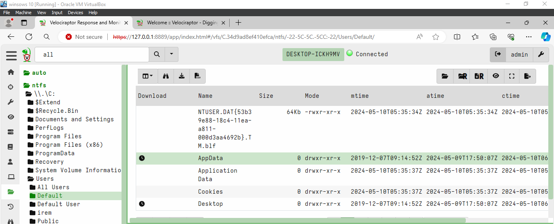

**Collecting an Artifact**

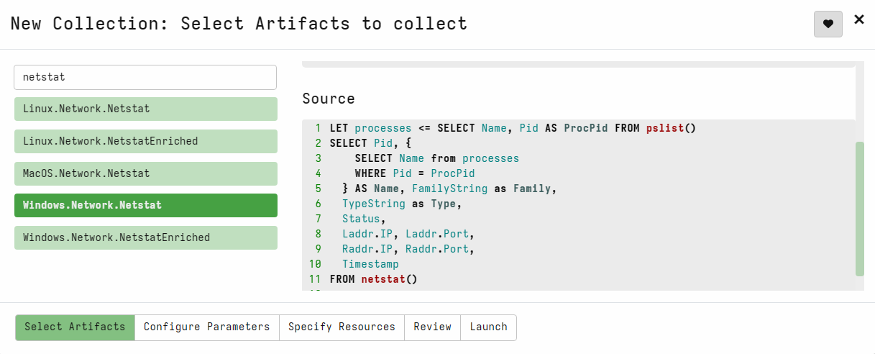

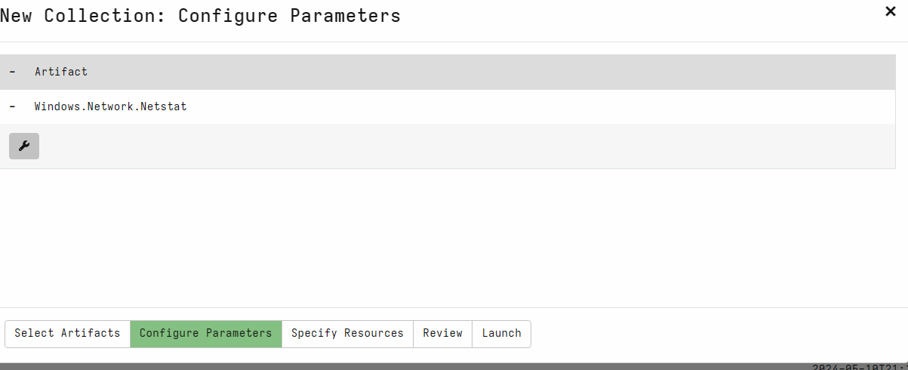

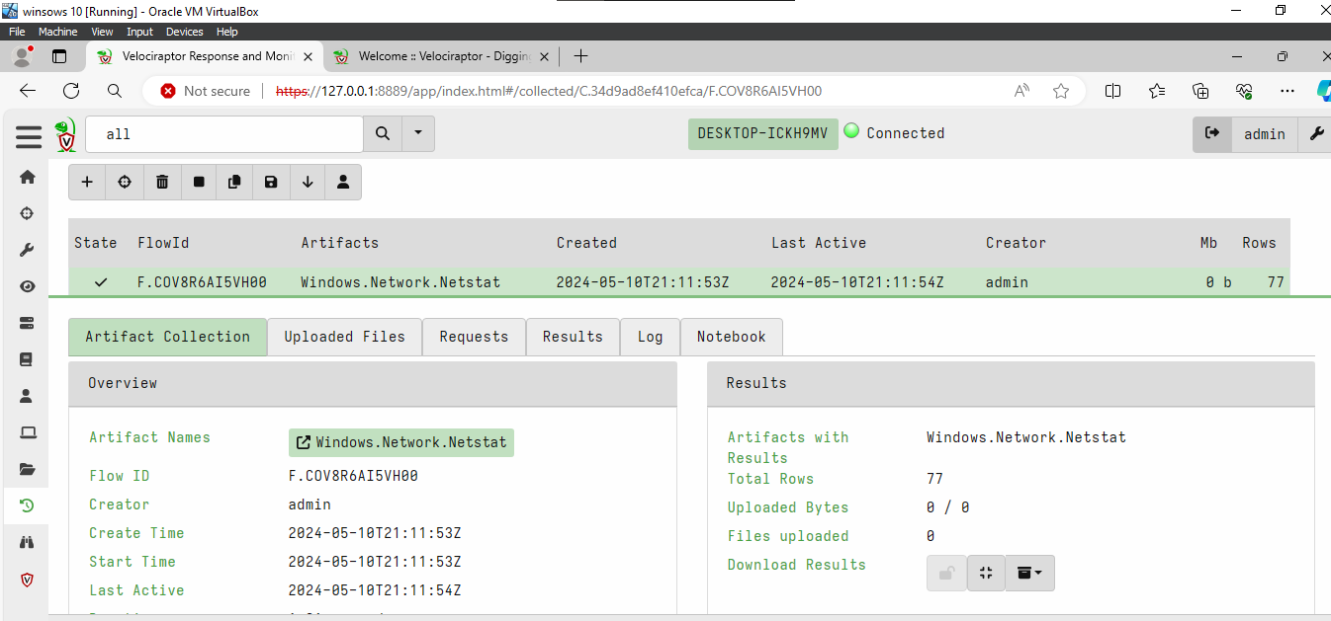

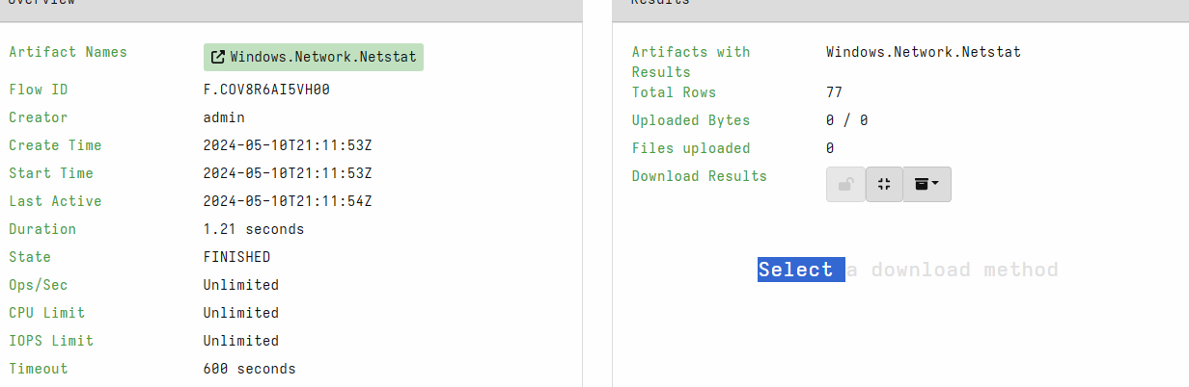

**DestPort**

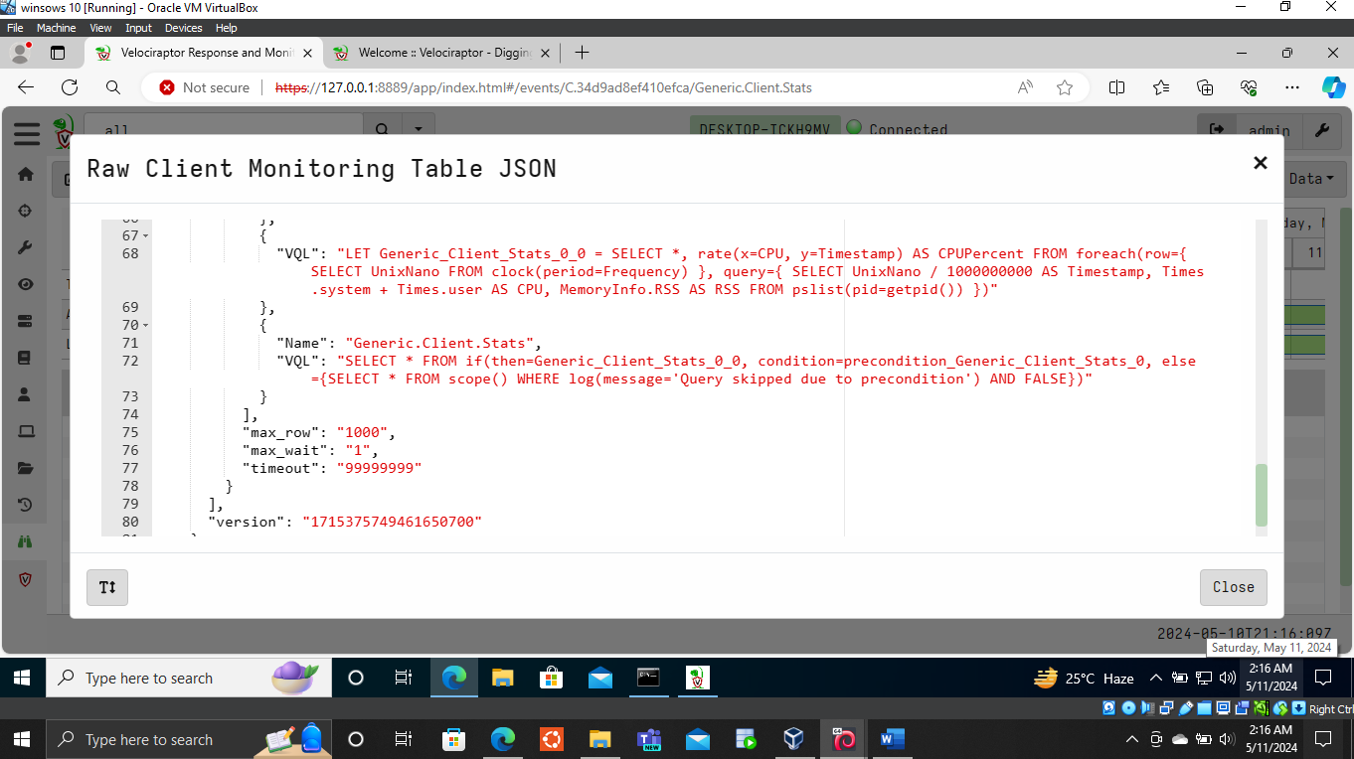

1. **Investigating a PUP with Velociraptor**

* **Task 1: Infecting the Windows Machine**

Adding c in exclusion so I can launch attack easily

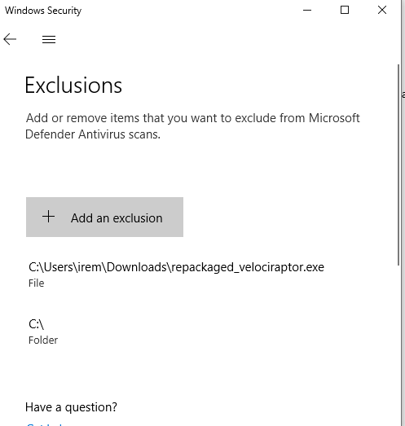

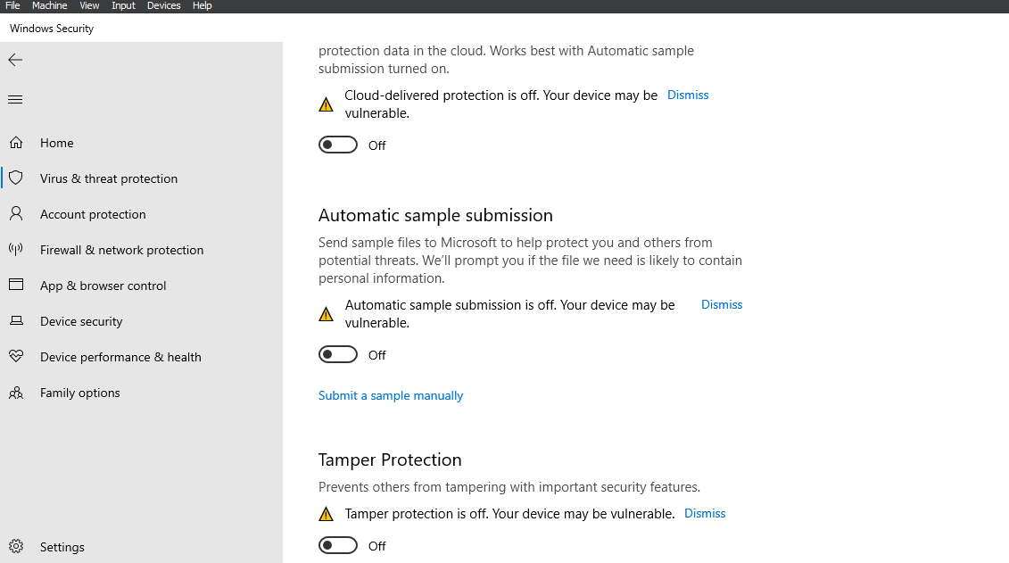Turning off all protections

Installing c++ in windows machine

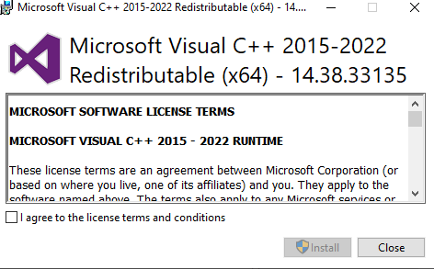

Extracting

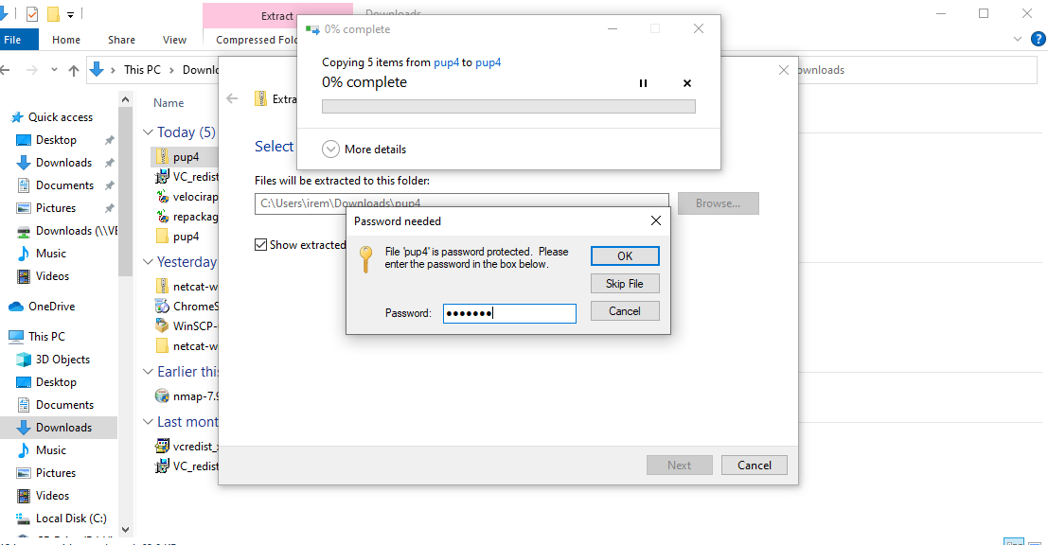

**Launching attack**

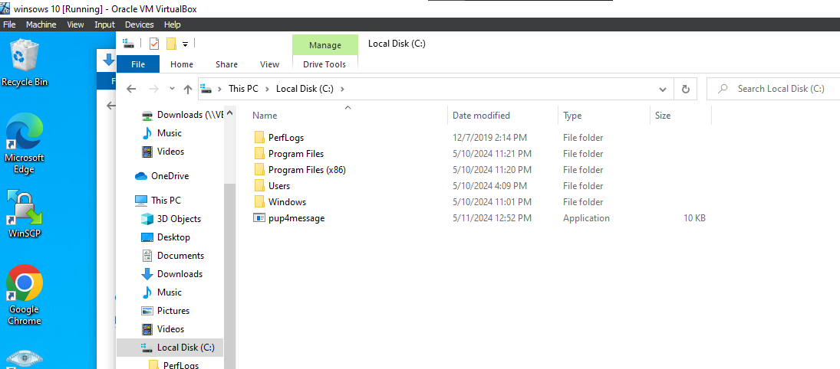

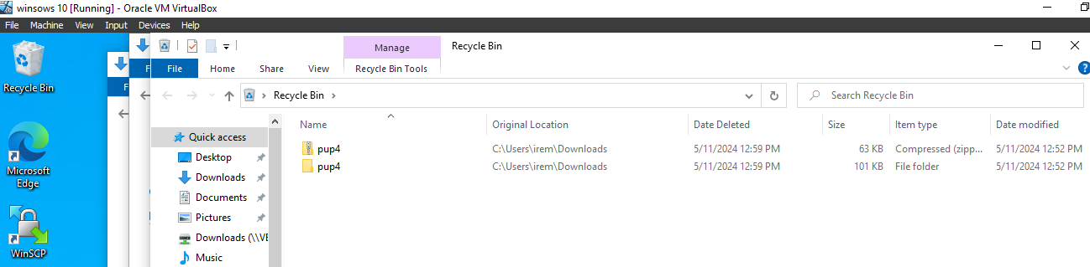

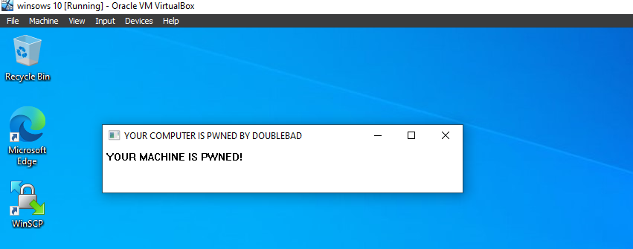

* 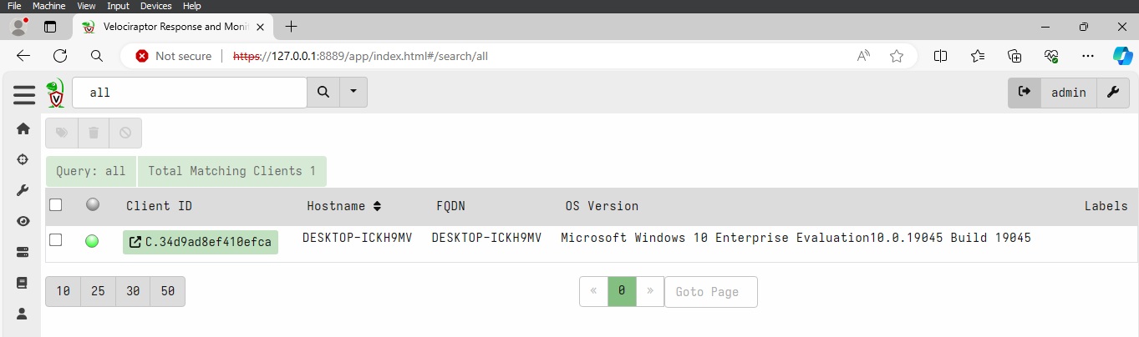**Task 2: Investigating the Incident with Velociraptor**

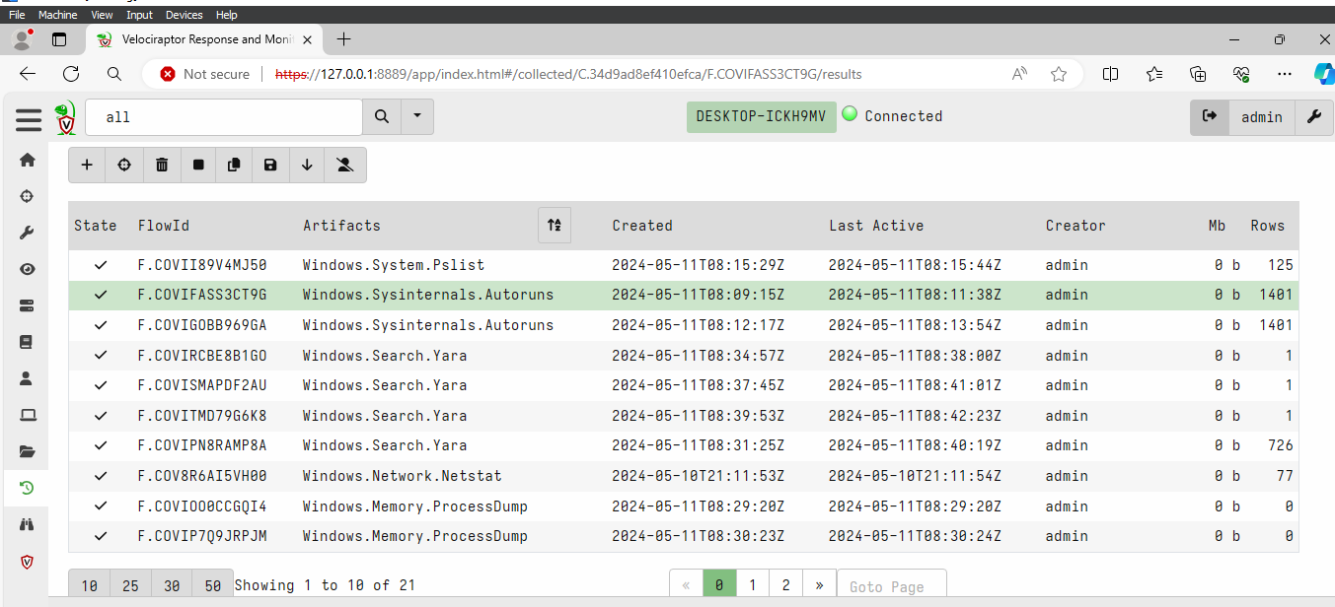Collecting artifacts

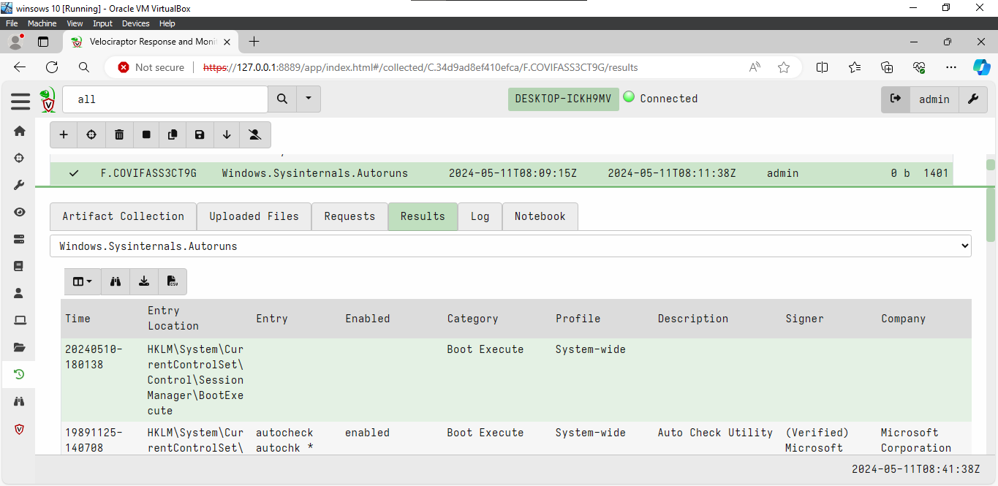**Run keys.**

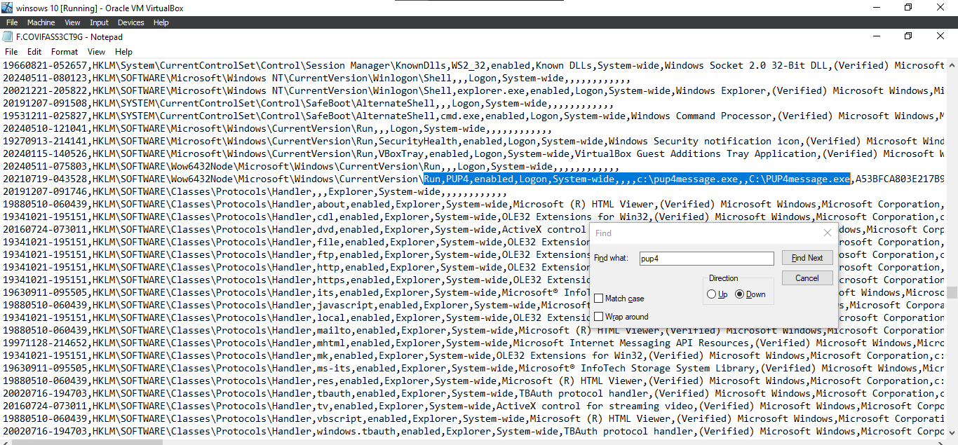Converting in csv format and opening in notepad for search

**MD5 of EXE**

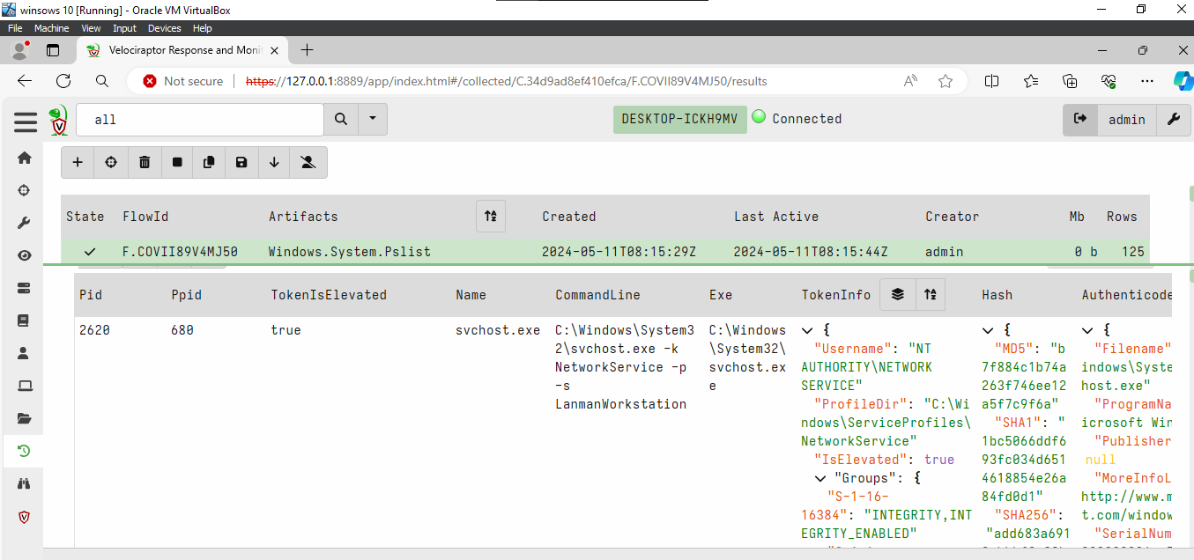Collecting artifacts of pslist so many result so converted to csv

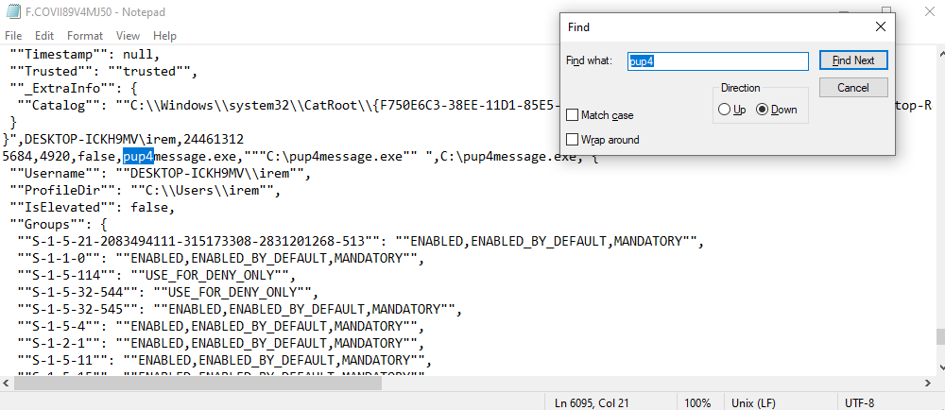Opening in notepad and searching for pup4

Finding the md5

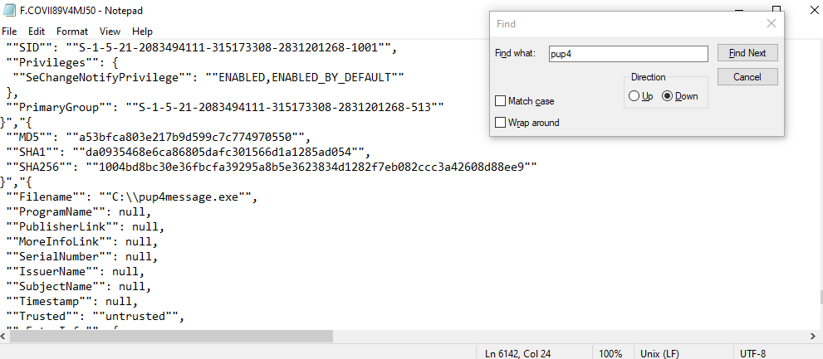

Flag



**Yara**

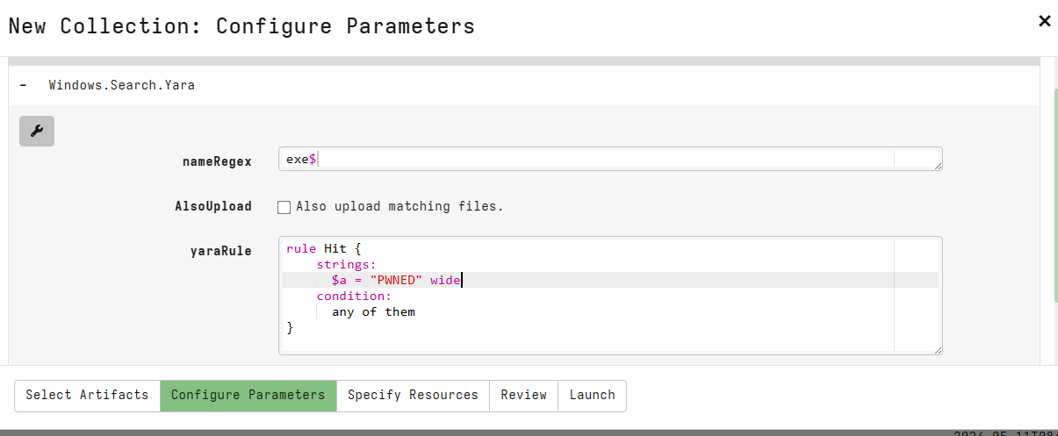Setting parameters

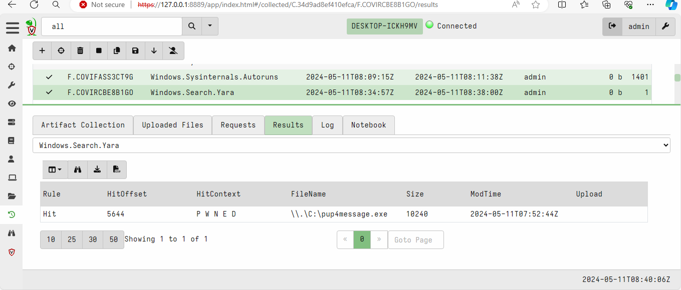Found the flag

* **Task 3: Remediation**

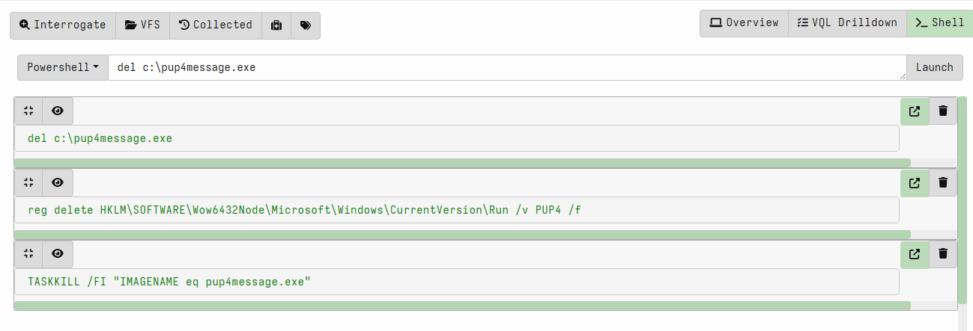Launching commands to remove the malware

**Flag:**

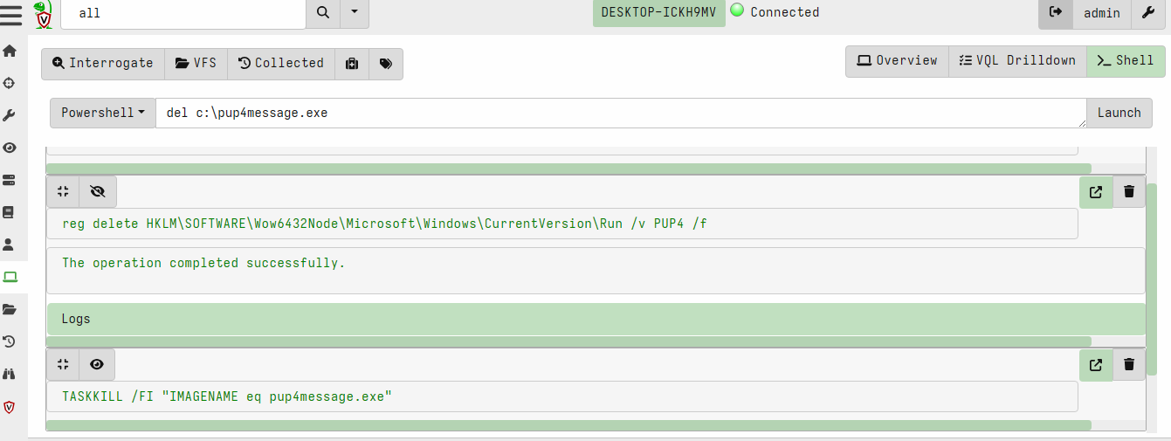

Launching commands using cmd

As for me velociraptor commands worked it is already removed from the system

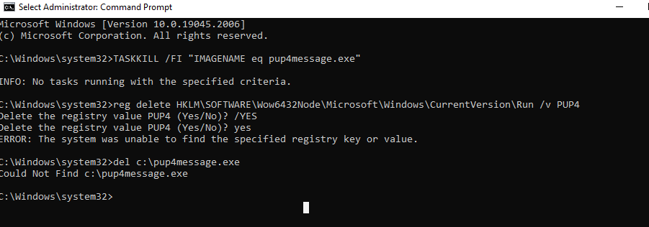

1. **Investigating a Bot with Velociraptor**

* **Task 1: Infecting the Windows Machine**

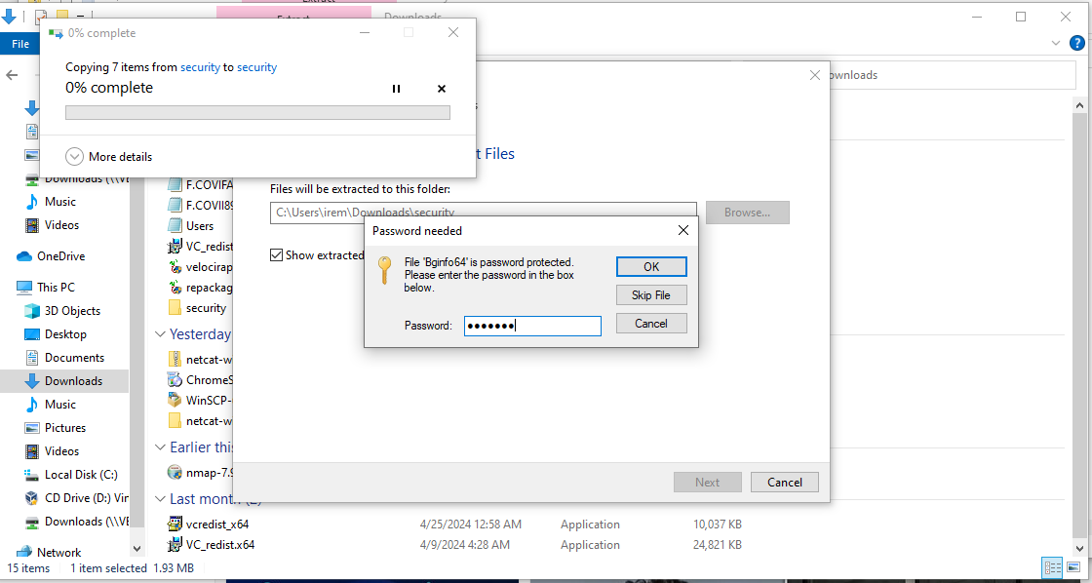

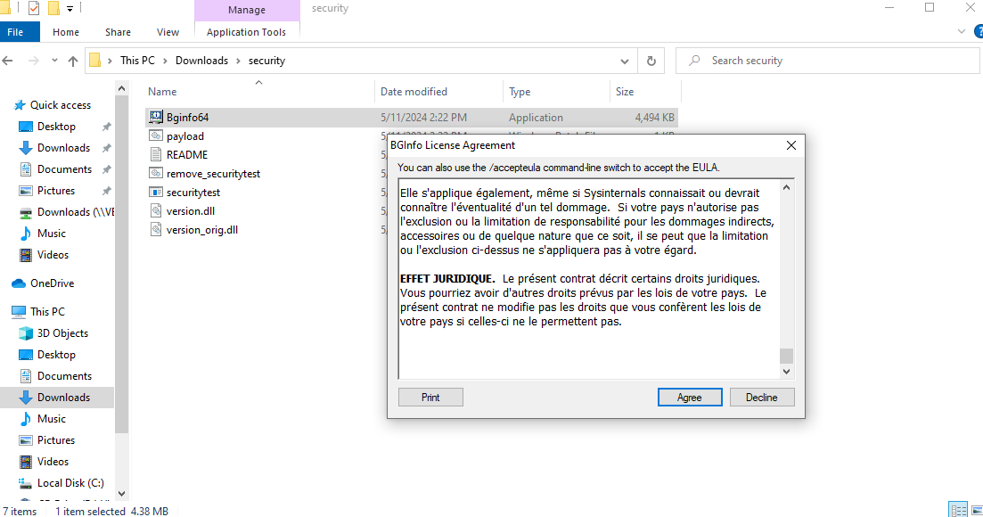

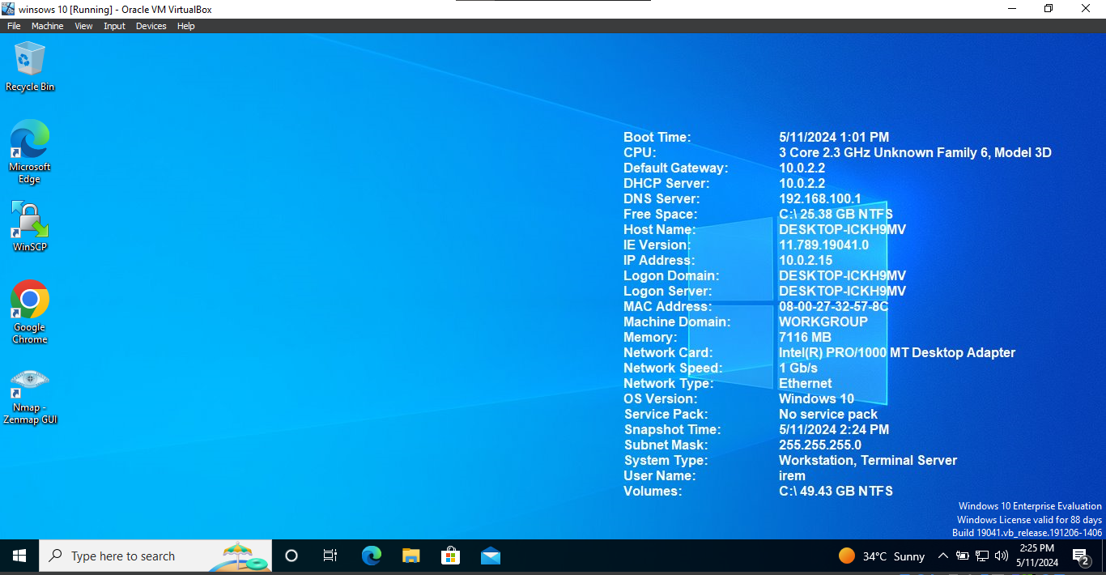

* **Task 2: Investigating the Incident with Velociraptor**

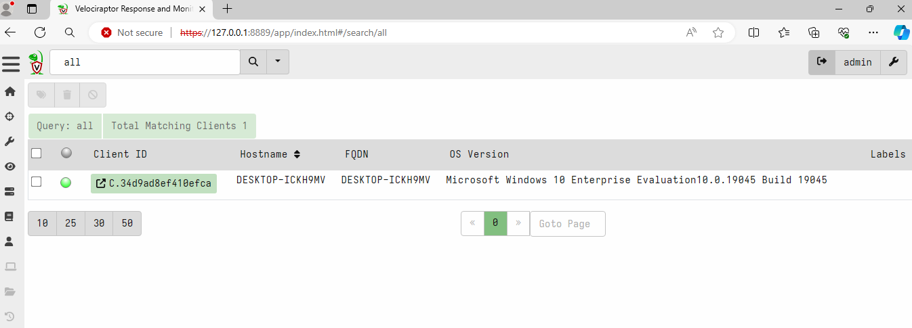Connecting with client using velociraptor gui

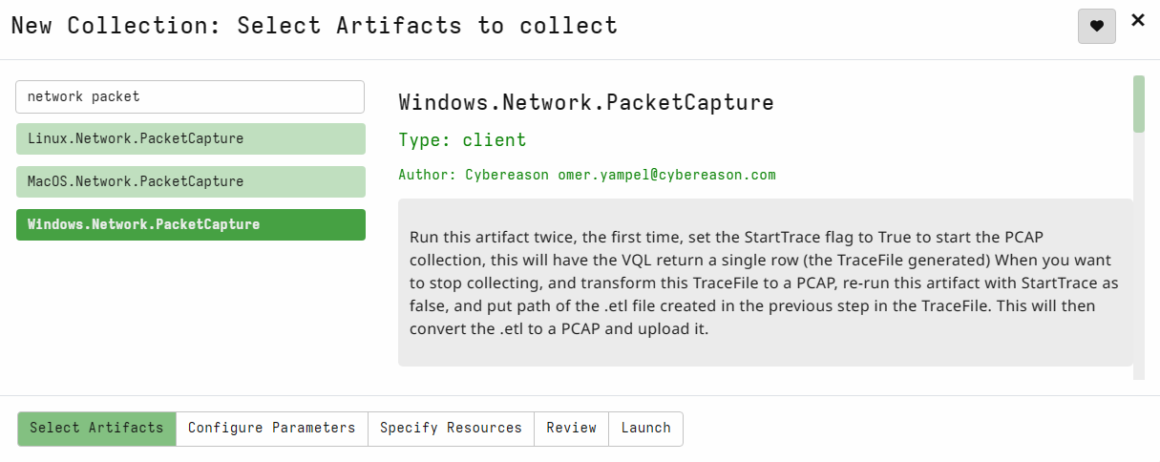Capturing Network Traffic Remotely and Finding Beacons

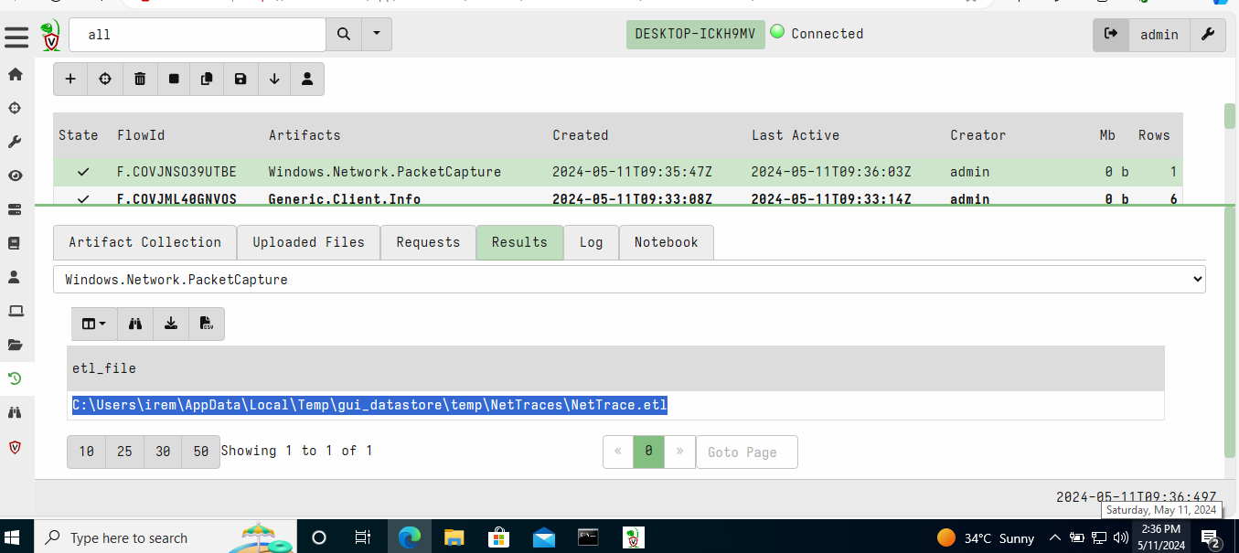copying the link found

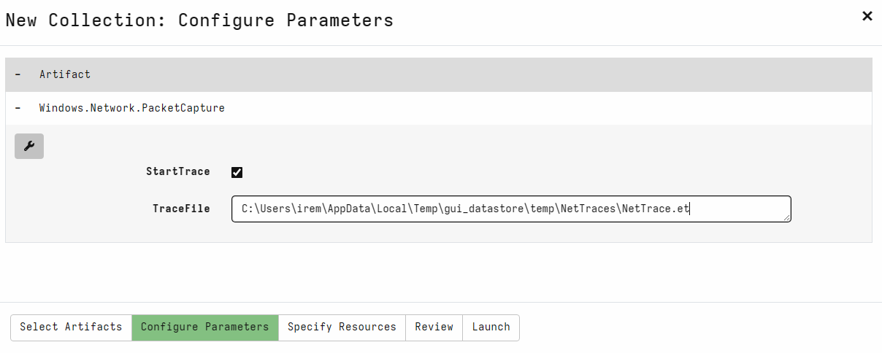configuring parameters of network packet

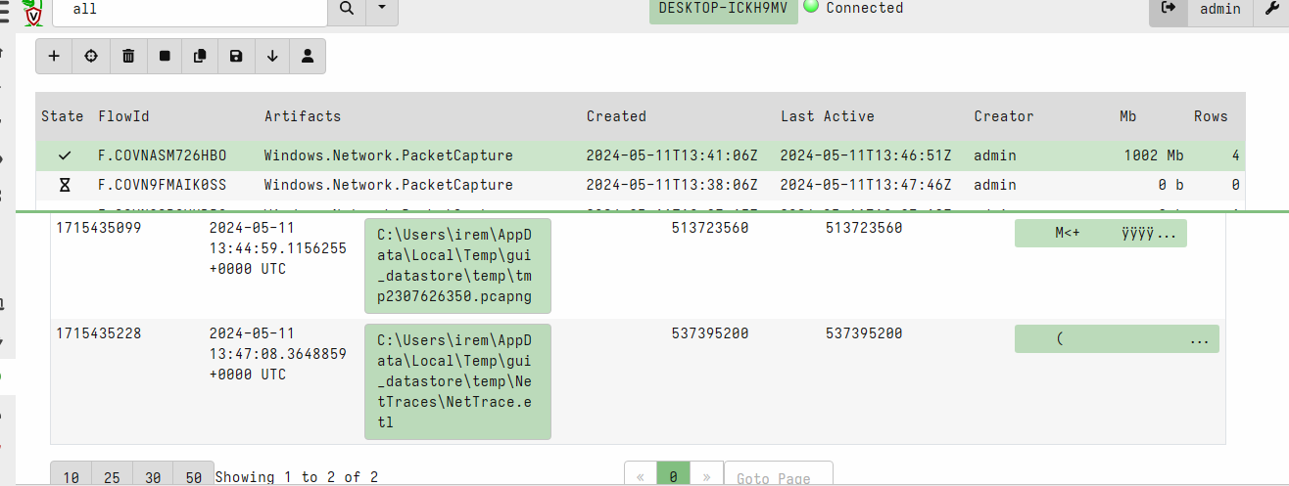

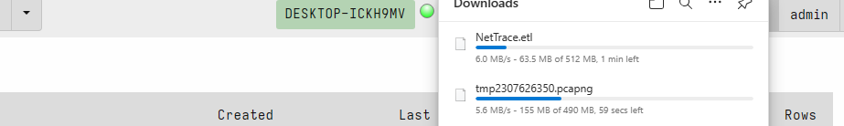

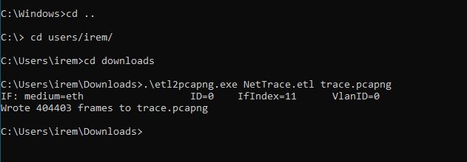

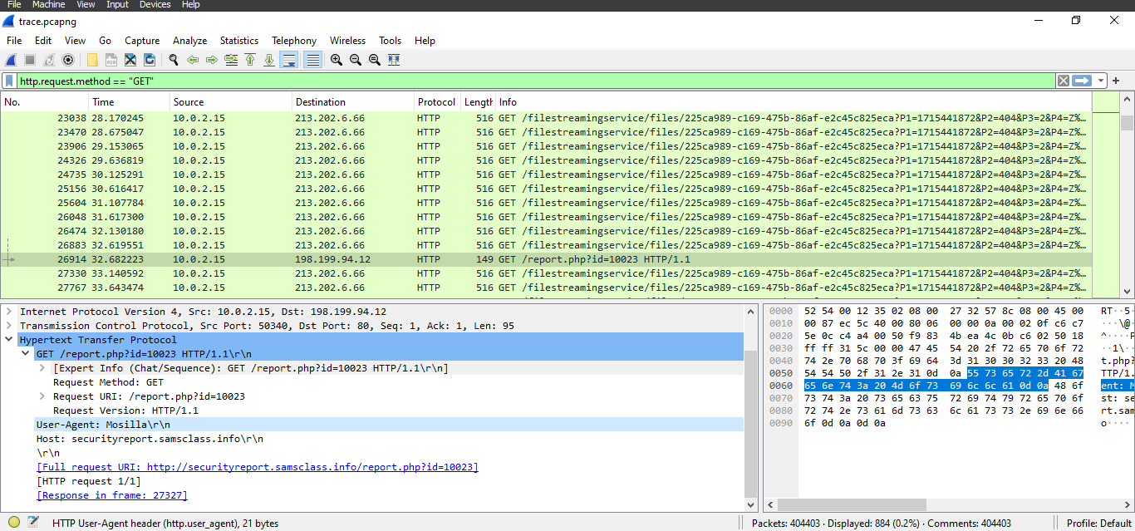**User-Agent**

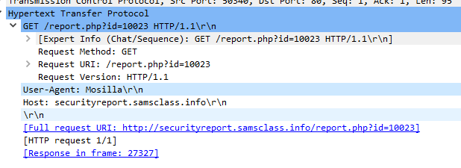

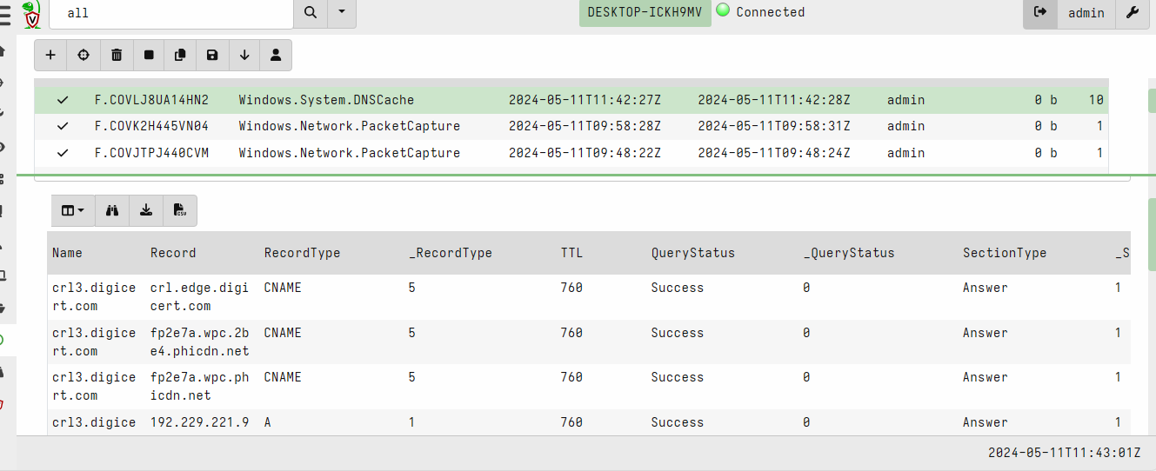**DNS Cache**

**Flag is ttl**

**Beaconing EXE**

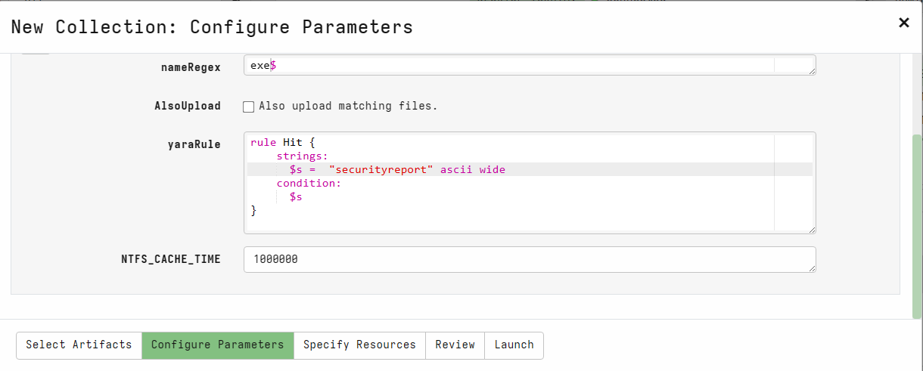

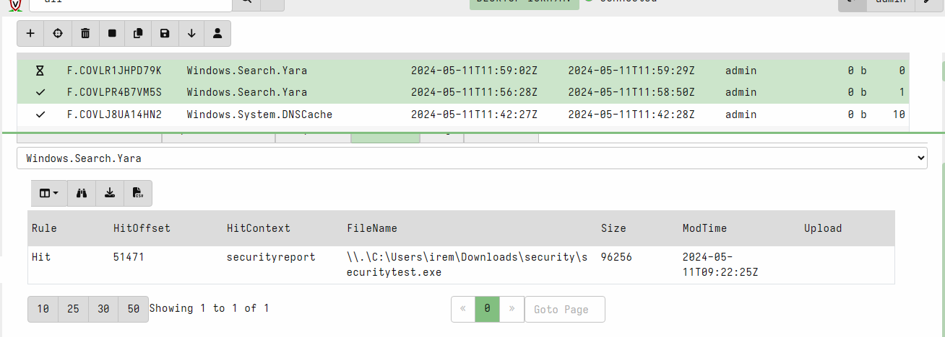**flag :**

* **Using Sysmon to find a Persistence Mechanism**

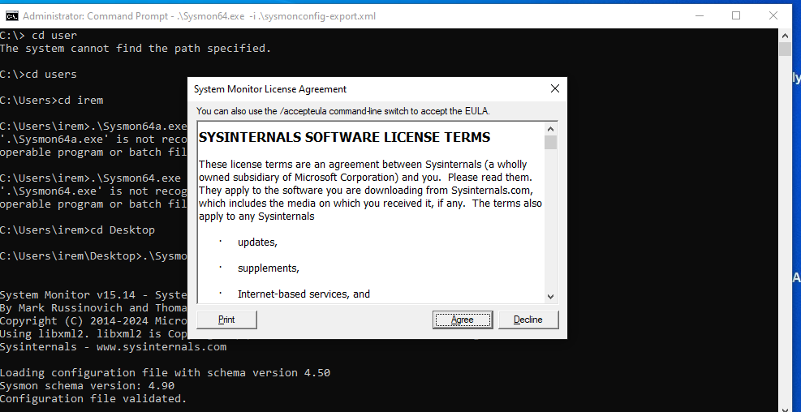installing sysmon

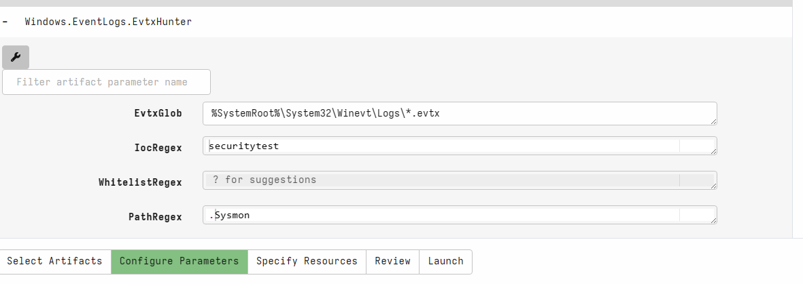

configuring parameter of event log artifact collector

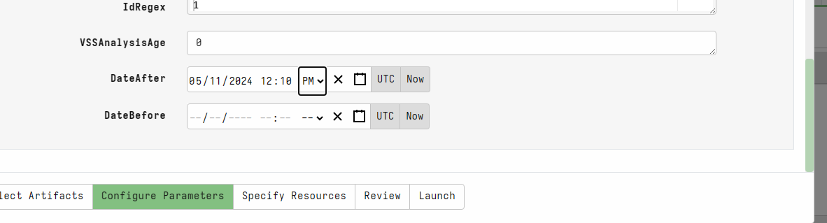

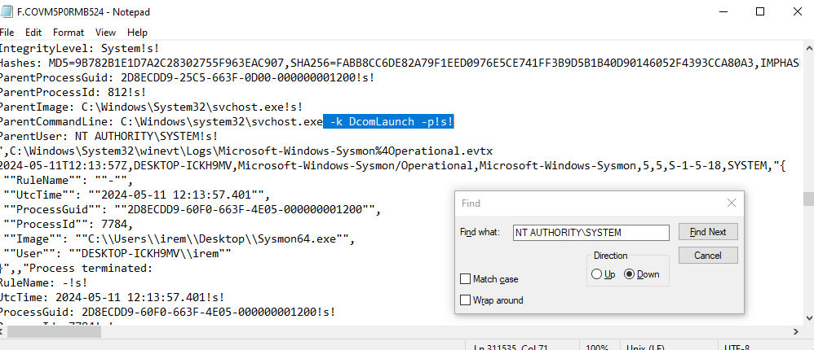

Flag is DcomLaunch

**Scheduled Tasks**

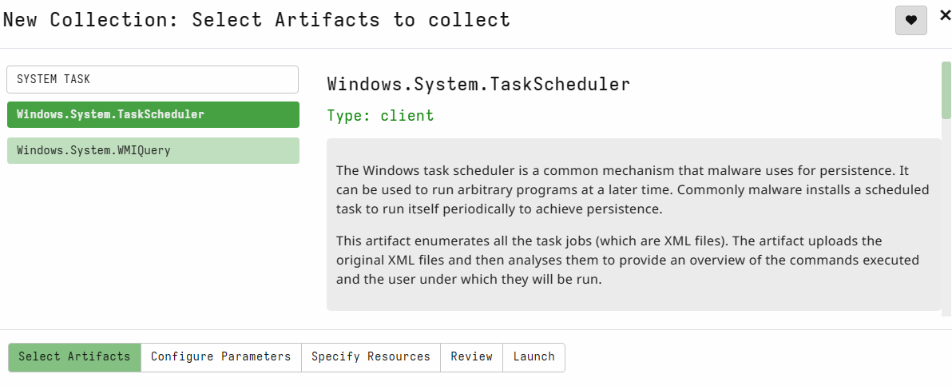

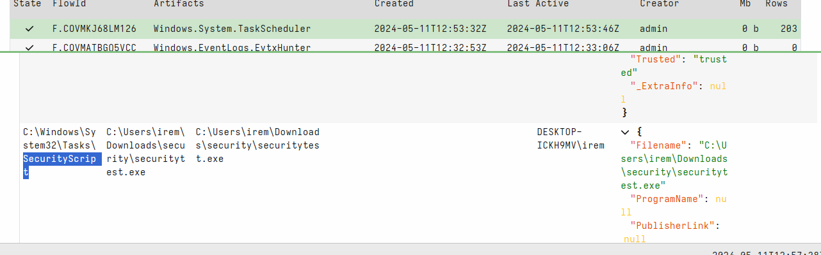

**Hunt**

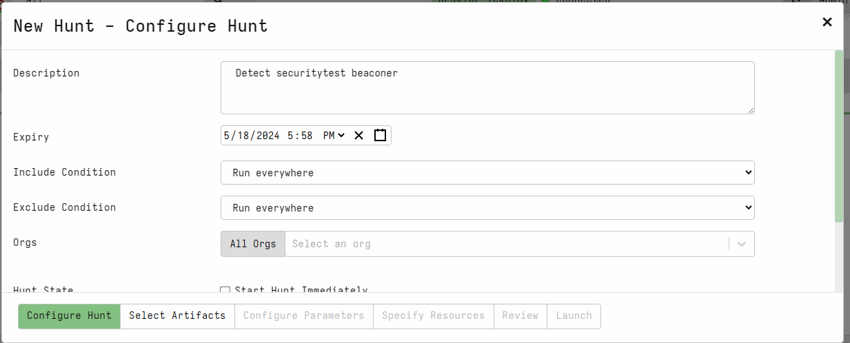

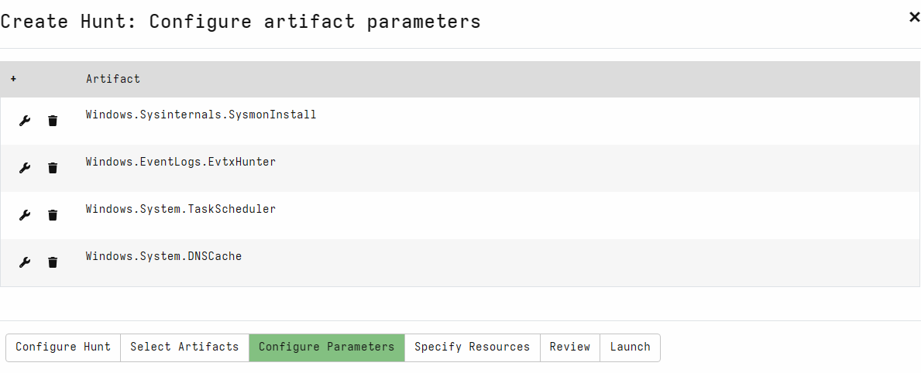

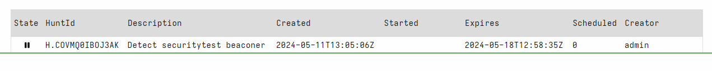

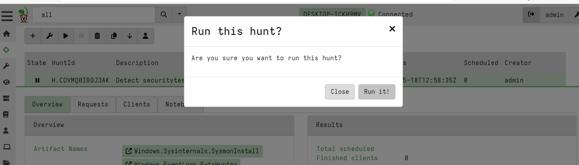

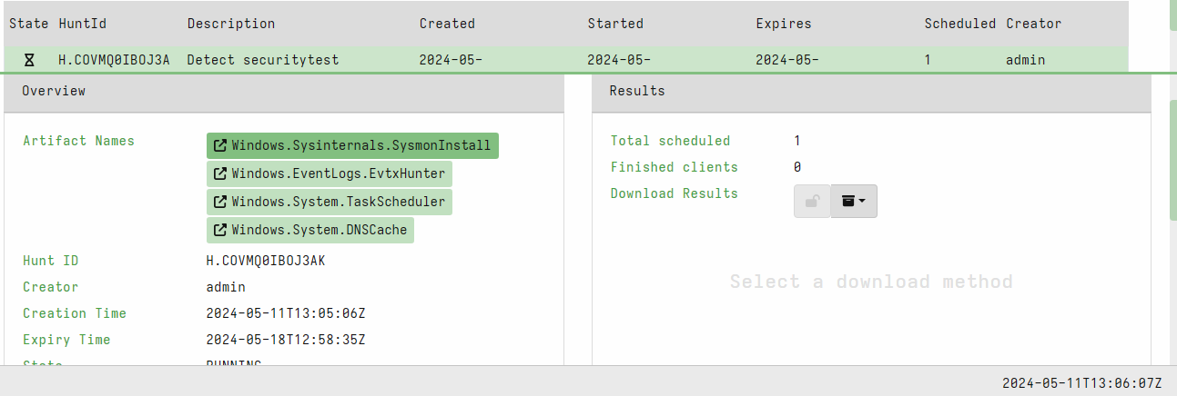

**Task Scheduler/Analysis**

**Flag: ospath**

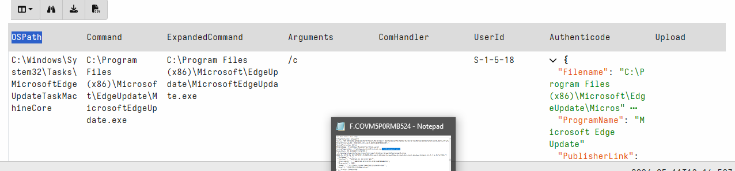

**Remediation**

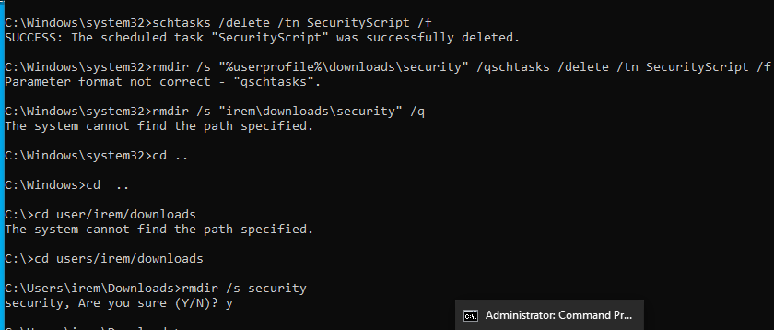

1. **Investigating a Two-Stage RAT with Velociraptor**

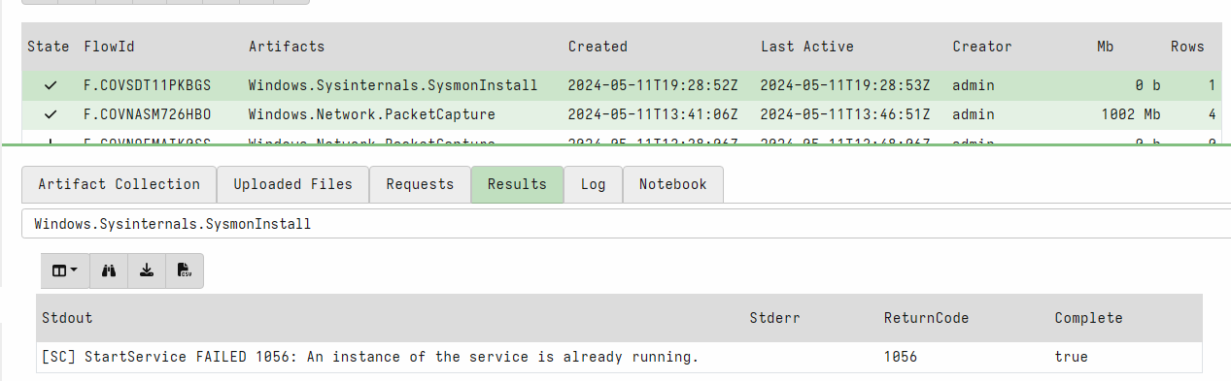Installing Sysmon on the Windows Machine

Infecting the Windows Machine

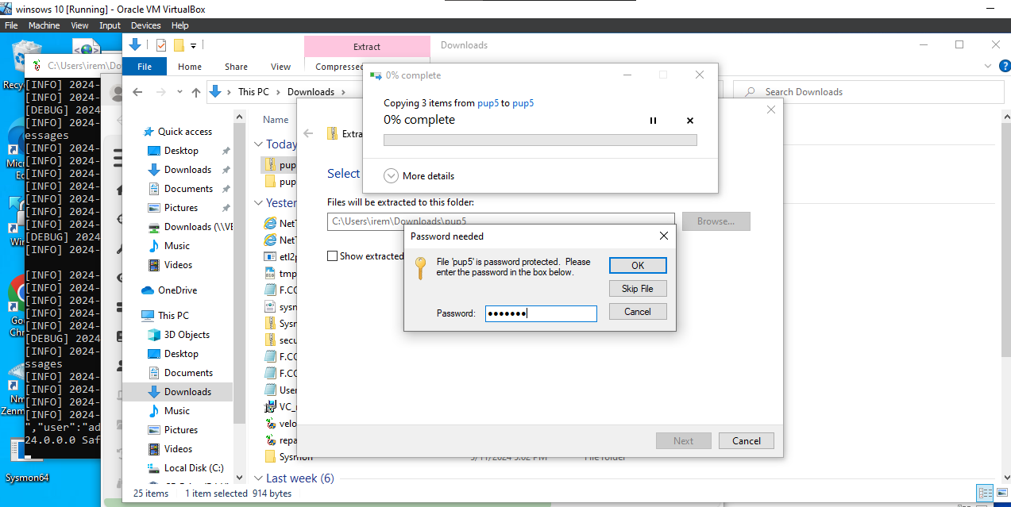

**Auditing Network Connections**

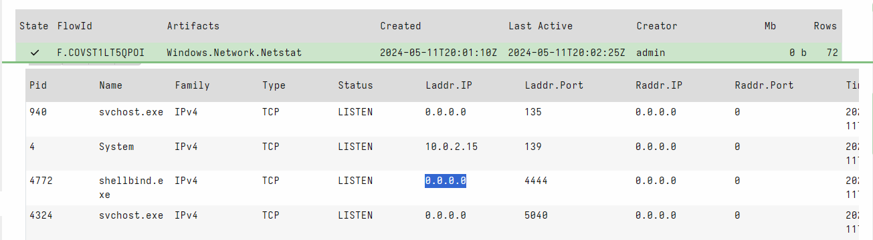

**Auditing Autoruns**

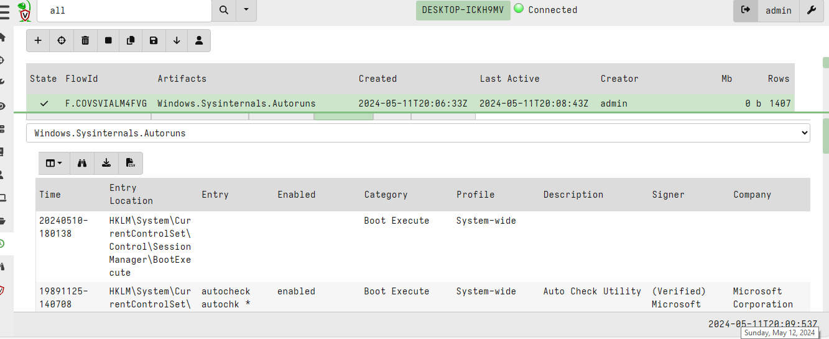

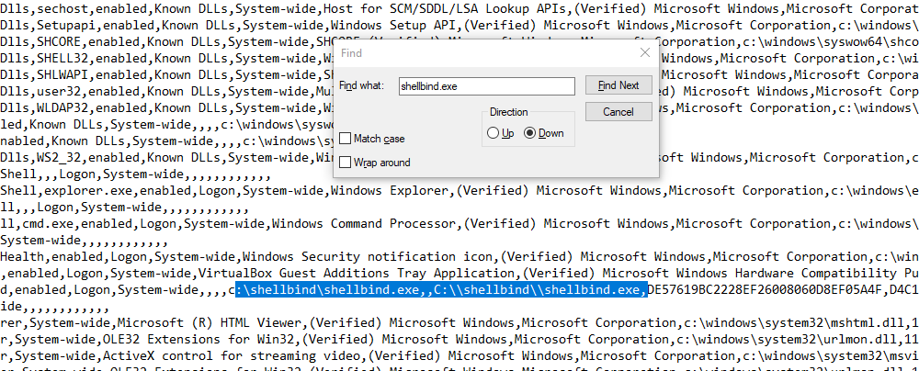

**Creation Time**

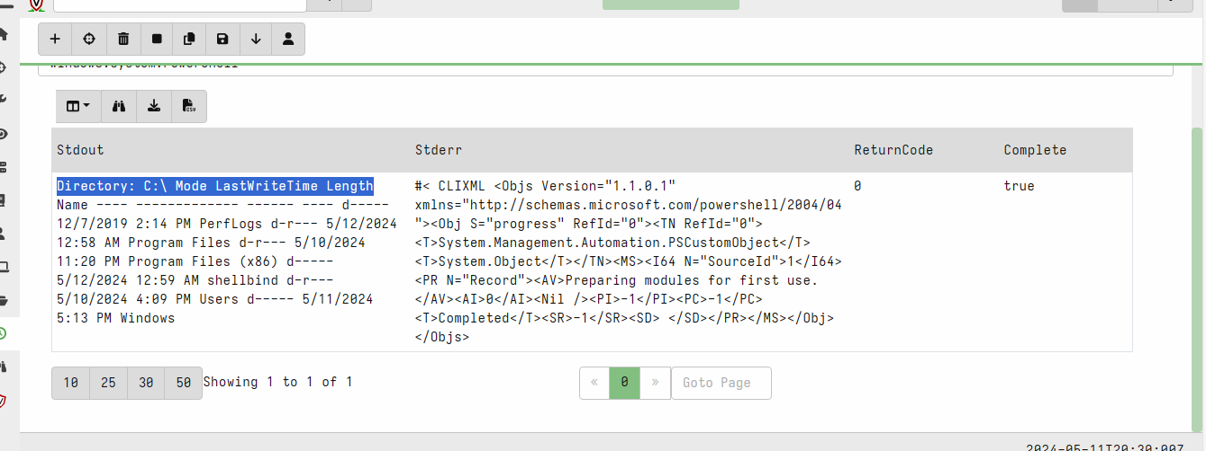

**Prefetch**

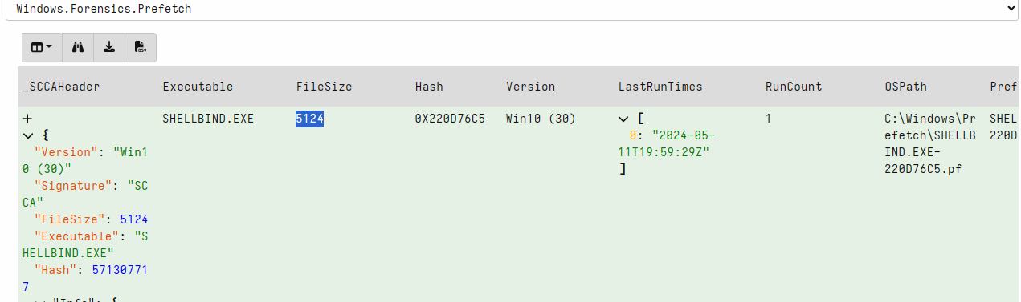

**Sysmon Logs**

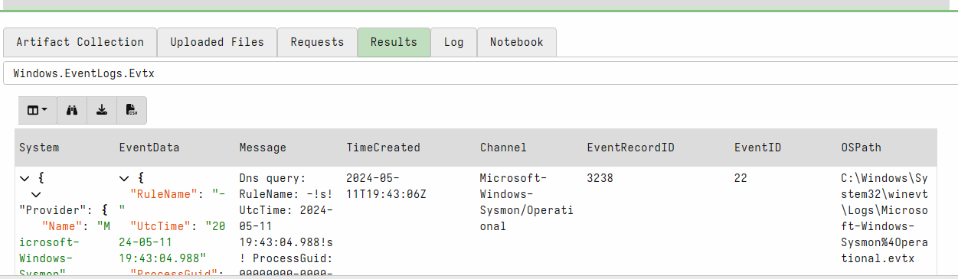

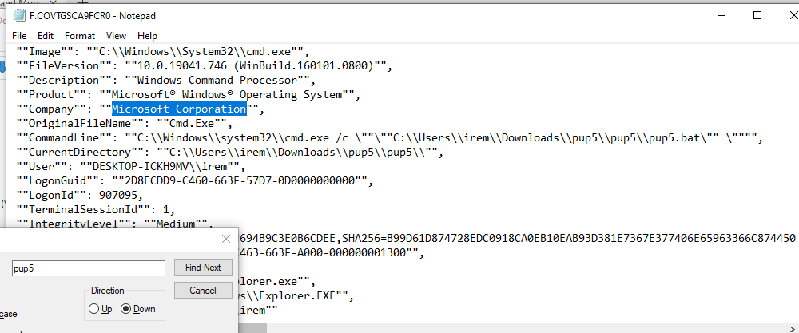

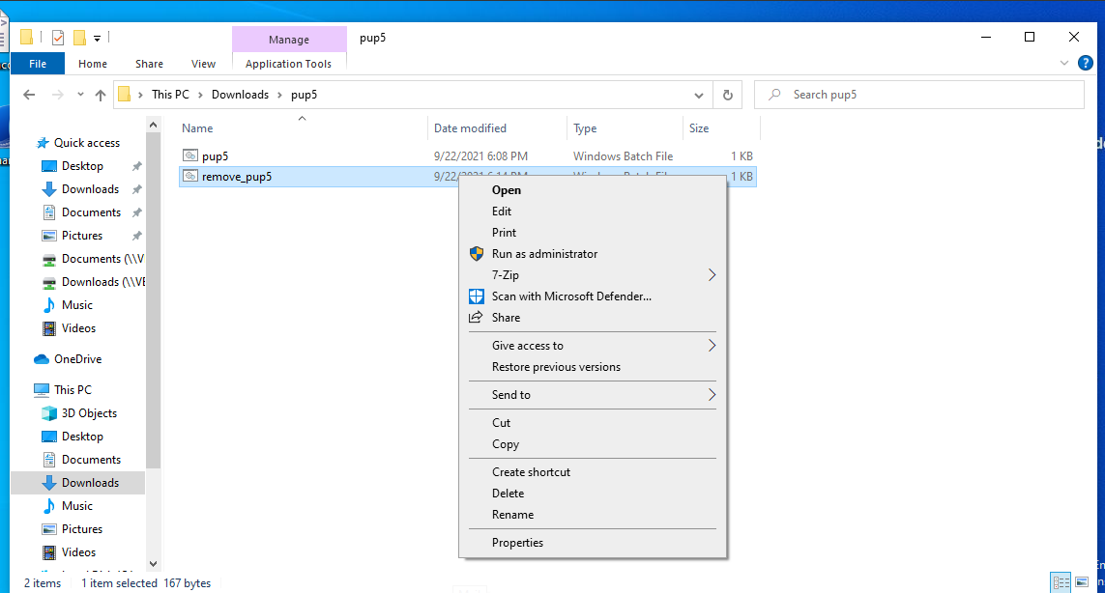**Remediation**